PROSCI versus Kotter’s Change Management Approaches

An Individual Assignment

Table of contents

- Introduction………………………………………………………………………………………………………3
- Definitions…………………………………………………………………………………………………………3
2.1 Change Management…………………………………………………………………………………..3
2.2 PROSCI organizational change management process…………………………………..3
2.3 Kotter’s 8-steps Change Management Approach………………………………………….5
3. Comparisons………………………………………………………………………………………………………..6
3.1 Similarities……………………………………………………………………………………………………..6
3.2 Differences…………………………………………………………………………………………………….7
4. Recommendations……………………………………………………………………………………………….8
5. Conclusion…………………………………………………………………………………………………………...9
6. Research summary………………………………………………………………………………………………10
7. References ………………………………………………………………………………………………………….11

- Introduction
As change management plays a crucial role in the project management, it is important for project managers to choose the most appropriate change management approach (Hornstein, 2015). PROSCI and Kotter’s 8-steps change management approaches are two of the most popular models. This report will define and compare the PROSCI and Kotter’s change management approach, analyze their similarities and differences, and provide recommendations for selecting the change management approach.

2. Definition
2.1 Change Management
Change management is a systematic method to handle the change from both the organizational and the individual aspects (Creasey, 2007).

2.2 PROSCI organizational change management process
The introduction of PROSCI organizational change management process happened in 2002. This process consists of three phases, through which project managers could manage the changes effectively. Each phase is supported by evaluations, templates and guidance to achieve the objective.
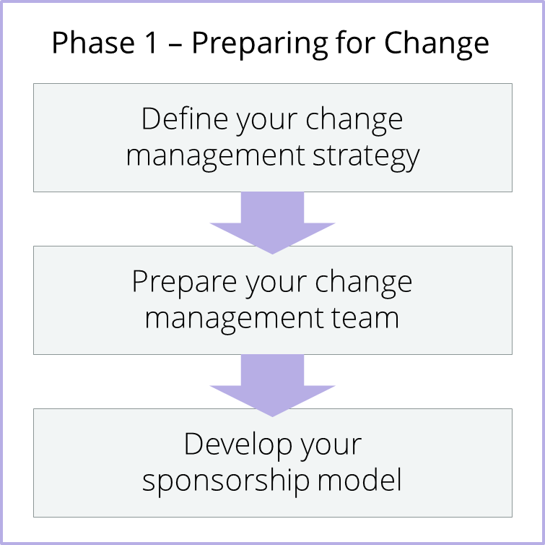
Graph 1
The Graph 1 demonstrates the first phase in PROSCI approach. It could benefit project teams in initiating the change management plans. It could help to address some important issues, such as the extent of change management the organization need and the stakeholders should be considered. Moreover, this phase requires the project manager to have situational awareness, which is crucial for designing a successful change management plans. The deliverables of this phase are change characteristics profile, organizational attributes profile, change management team structure, sponsor assessment, structure and roles (Hiatt & Creasey, 2003).
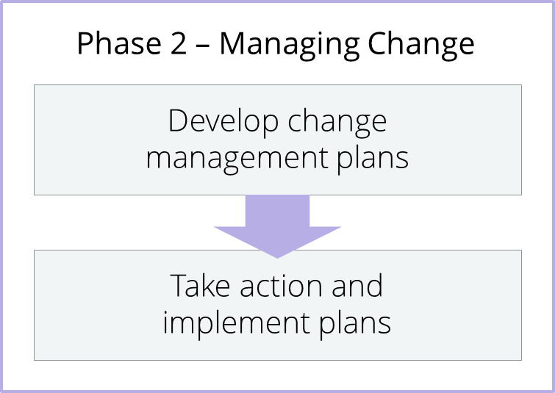
Graph 2
The second phase is illustrated in the Graph 2, which lay emphasis on developing the change management plans. These plans clarify the steps that project managers could follow to help the individuals influenced by the project. PROSCI provide five plans to support individuals, namely communication plan, sponsor roadmap, training plan, coaching plan and resistance management plan (Hiatt & Creasey, 2003).
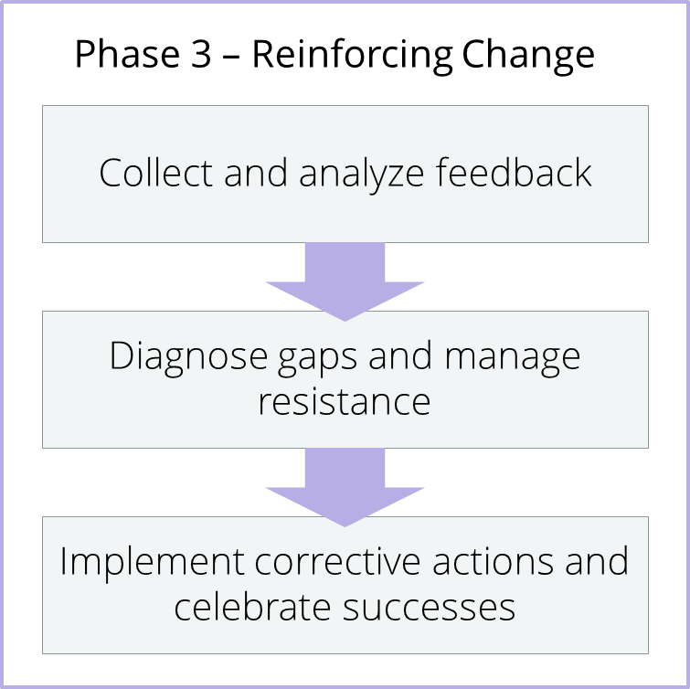
Graph 3
Graph 3 shows the phase 3 of PROSCI process. It is equally important as the first two phases, but it is likely to be ignored. This phase focuses on developing specific plans to ensure that the change is effectively handled. Furthermore, standards and mechanisms are developed to measure how well the change is managed, to the check whether employees are performing their works in a different way, to identify and minimize gaps as well as to recognize achievements. The outcome of this phase includes measuring changes in behavior, corrective action plans, reinforcement mechanisms, individual and group recognition approaches, success celebrations and after-action review (Hiatt & Creasey, 2003).
2.3 Kotter’s eight –step change process
John Kotter, a professor at Harvard Business School, introduced the eight-step change process for change management in 1995 (Gupta, 2011). There are eight steps in Kotter’s change process as shown in the Graph 4 below.
Graph 4
• Step 1: Create a sense of urgency (Kotter, 2012). Produce some events and utilize important chances to encourage people engaging in change activities.
• Step 2: Build a guiding coalition (Kotter, 2012). Gather a group of people who have skills and knowledge for guiding and assisting joint change management.
• Step 3: Form a strategic vision and initiatives (Kotter, 2012). Create a vision to enhance the performance for change, and work out effective methods to realize the objective.
• Step 4: Enlist a volunteer army (Kotter, 2012). Raise a group of volunteers who are well-prepared and desired to engage in change activities.
• Step 5: Enable action by removing barriers (Kotter, 2012). Eliminate the possible barriers to change, and adjust operational systems to avoid potential risks in the change management.
• Step 6: Generate short term wins (Kotter, 2012). Regularly create, trace, assess and celebrate important achievements, and relate them to outcomes.
• Step 7: Sustain acceleration (Kotter, 2012). Growing credibility should be applied to ensure systems, structures and policies are consisting with the vision. Staffs should be trained and stimulated to achieve the vision. The process should be revitalized with new projects.
• Step 8: Institute change (Kotter, 2012). The relationship between new conducts and success of organizations should be articulated. Also, effective measures should be taken to developing and achieving the leadership.

- Comparison
In order to provide appropriate recommendations to the project managers, a detailed comparison between PROSCI and Kotter’s change management approach is necessary.
  - Similarity
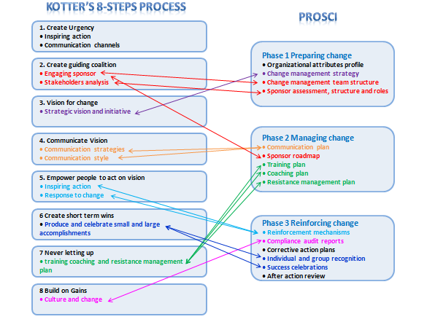
Graph 5
PROSCI and Kotter’s models are similar in several aspects. These two approaches utilize the identical change management processes. Both of them assemble a group of people to lead and assist the change management at the beginning, and then observing vision of the project. Also, these two approaches reinforce the change through developing prevention management plans.
Graph 5 illustrated a considerable overlap between these two approaches.
Step 2 of Kotter’s model creating a guiding coalition involves forming a personal from the organization to support the change and allocate roles and tasks for each personal, which aligns very well with phase 1 of PROSCI – Sponsor assessment, structure and roles.
Step 3 of Kotter’s approach focus on creating the strategic vision and initiatives, this can be mapped with PRSCOI’s change management strategy as it considers the same concepts for change rational, objectives and strategy.
Step 5 of Kotter -Empower people to act on vision, this step exam how we need to encourage employees to keep up with the change and not go back to old habits. Similarly, the phase 3 of PROSCI includes reinforcement mechanisms like compliance measures and corrective action plans.
Step 6 of Kotter’s model -Create short-term wins overlaps with Phase 3 of PROSCI, since it involves showing recognition to individuals and groups efforts as well as celebrating small and large achievements.
  - Differences
As shown in Graph 5, Kotter’s approach demands the support for the change from the employee in the organization before carrying out the planning in Step 1, while PROSCI model directly get into the planning stage without advocacy. Moreover, Phase 1 of PROSCI approach includes the organizational attribute profile, while Kotter failed to consider such characteristics. Also, the Phase 3 of PROSCI pays more attention to reinforcing change, such as after action review and corrective action plans, while Kotter’s model doesn’t have such guidance.

- Recommendation
According to the analysis above, Kotter’s 8-steps process demonstrates several advantages and disadvantages compared with PROSCI model.
The first two steps of Kotter’s model are extremely crucial, which are creating a sense of urgency and the guiding coalition. If project managers initiate a program in complicated organizations without convincing people that changes are necessary in advance, the vision is unlikely to be achieved. Also, if project leaders believe they could manage change without the supports of the team members who understand the urgency for change, the change management will turn out to be a deficiency. Since individuals are unlikely to be qualified with all the essential skills and knowledge to drive successful organizational change, Kotter’s guiding coalition is significant for the beginning stage of change management. As PROSCI model directly entered into the planning without advocacy, Kotter is stronger in the initiative.
Furthermore, Kotter’s model serves as a comprehensive checklist, including the important things project managers need to consider throughout the change management. For instance, if project manager forgot to ensure that the IT systems were updated to align with the new change, the small negligence will become a disaster to the whole project (Kazmi & Naarananoja, 2014). Kotter’s fifth step could remind managers to check whether the systems and structures are aligned with the changes. Also, celebrating short terms achievements is important for encouraging employees when they are starting to lose confidence in the change process. Since PROSCI process is not as specific as Kotter’s, it could not be a useful checklist.
Unfortunately, Kotter’s 8-steps model has significant disadvantages compared with PROSCI process. To begin with, Kotter’s approach is virtually a top-down model, which might not be suitable for all the organizations. Kotter is quite experienced on change management in large projects, and the majority of these projects is cooperating with considerably large enterprise (Pollack & Pollack, 2015). If the project managers are engaged in a situation where more participation is demanded for change management, PROSCI model will turn out to be more practical as it has more space for organizational customization (Prosci, 2012).
Moreover, Kotter’s process is too mechanistic, and PROSCI model is relatively more flexible. Since organizations are consisting of people, it is unlikely to operation as accurate as machines (Varkey & Antonio, 2010). Kotter’s 8-steps process could effectively serve as a checklist, because the step by step guidance for change is explicit. However, it is less useful than PROSCI approach on flexibility.
In addition, although Kotter’s model is effective in initiating change, it is likely to be weaker in the long term than PROSCI approach. For example, step 7 of Kotter’s model failed to provide specific tips for sustaining change. By the contract, PROSCI approach pays more attention to reinforcing changes.
Therefore, although Kotter’s model is more robust on the initiative of the change management and could serve as a checklist for the process, its limitations are inevitable. Project managers should choose the appropriate change management approach depend on the situation and requirements of the project (Meade, 2013). If the project manager is new to the change management, Kotter’s approach should be the best choice, since it could be a clear checklist to avoid negligence. If the project manager needs more flexibility and consideration of organizational attributes, PROSCI will become the appropriate choice. In addition, if the change manager is familiar with both approaches, it is practical to combine these two approaches and customize a new model for the organization (Todnem, 2005).

- Conclusion
PROSCI and Kotter’s change management approaches have a considerable overlap and significant differences. Kotter’s is stronger in the initiating change and could serve as a checklist for the change process, but it is too mechanistic and weak in reinforcing change. PROSCI is more flexible and stronger in reinforcing change compared with Kotter’s approach, and it also considers organizational attributes in Phase 1. When choosing the appropriate model for change management, project managers should evaluate the requirements of organizations as well as their understandings.
- Research Summary
References | Summary
Defining change management (Online) | This article provides a clear definition of change management.
Leading innovation change - the kotter way (Journal) | This journal analyzes the Kotter’s change management approach critically.
Change Management: the people side of change (Book) | This book provides a different perspective for PROSCI approach, which could help to discover its strengths.
The integration of project management and organizational change management is now a necessity (Journal) | This article raises an interesting point that integrating project management and change management is an inevitable trend, which could support the recommendations.
Collection of change management models – an opportunity to make the best choice from the various organizational transformational techniques (Journal) | This journal carries out comparisons between different change management models, which could provide relevant information for this report, and enhance the quality of arguments.
The 8-step process for leading change (website) | This website provides detailed information about Kotter’s 8-steps change management process.
Developing a change management plan for organizational transformation (Dissertation) | This article could improve the understanding of Kotter’s and PROSCI models, and the argument of combining two models to form a practical framework for organizational changes could support the recommendations.
Using kotter's eight stage process to manage an organizational change program: Presentation and practice (Journal) | This journal includes some examples of implementing the Kotter’s approach, which could help to discover the drawbacks of this model.
Prosci releases organizational change management maturity assessment (Journal) | This journal provides an introduction of PROSCI approach and illustrates its benefits for organizational change.
Organizational change management: A critical review (Journal) | This article offers a critical review of some popular approaches for organizational change management, which could help to understand the two approaches.
Change management for effective quality improvement: a primer (Journal) | This journal offers some improvements could be adopted for change management approaches.
- References
Creasey, T. (2007). Defining change management. Prosci and the Change Management Learning Center.

Gupta, P. (2011). Leading innovation change - the kotter way. International Journal of Innovation Science, 3(3), 141-150.

Hiatt, J., & Creasey, T. J. (2003). Change Management: the people side of change. Prosci.

Hornstein, H. A. (2015). The integration of project management and organizational change management is now a necessity. International Journal of Project Management, 33(2), 291-298.

Kazmi, S. A. Z., & Naarananoja, M. (2014). Collection of change management models – an opportunity to make the best choice from the various organizational transformational techniques. GSTF Journal on Business Review (GBR), 3(3), 1-14.

Kotter, J. (2012). The 8-step process for leading change. Kotter International.

Meade, K. J. (2013). Developing a change management plan for organizational transformation. ProQuest Dissertations Publishing.

Pollack, J., & Pollack, R. (2015). Using kotter's eight stage process to manage an organisational change program: Presentation and practice. Systemic Practice and Action Research, 28(1), 51.

Prosci releases organizational change management maturity assessment.(2012). Investment Weekly News, 623.

Todnem By, R. (2005). Organizational change management: A critical review. Journal Of Change Management, 5(4), 369-380.

Varkey, P., & Antonio, K. (2010). Change management for effective quality improvement: a primer. American Journal of Medical Quality, 25(4), 268-273.

