ELEC 152
MODULE 7: CAPACITORS AND INDUCTORS
M7A2
Problem 1. Consider an air-core inductor with an inductance of 5.6 mH.
a) Calculate the new inductance if we increase the number of turns by a factor of 3.
b) Calculate the new inductance if the length of the inductor is increased by a factor of 3.

Problem 2. Calculate the rate of change of flux linking in a coil when 20 V are inducted across a 200-turn coil.

Problem 3. Calculate the voltage inducted across a 22 mH coil if the rate of the change of the current is 1 mA/ms. Repeat the problem for a rate of change of 2 mA/10 µs.

Problem 4. Calculate the equivalent inductance as seen from the open terminals.
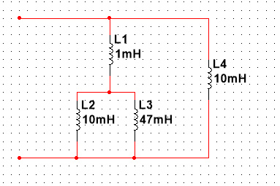

Problem 5. Reduce this network to the fewest elements:
