- (7 points) Complete the ray diagram needed to show the image for the object placed in front of this curved mirror. You must complete Ray 1. The 2nd ray has been drawn for you. Draw in the image. (You can just use an arrow.) Is the image real or virtual?
Answer:

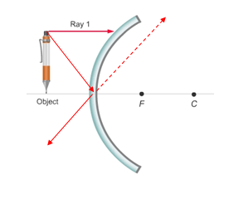
2. (10 points) On the diagram below, complete the ray diagram needed to find the image of the object placed in front of the curved lens. Use an arrow for your image. You will need at least 2 rays to locate the image. Is the image real or virtual? Find the image distance if the focal point is 10cm and the object is located 18cm from the lens. Show your work.
Answer:
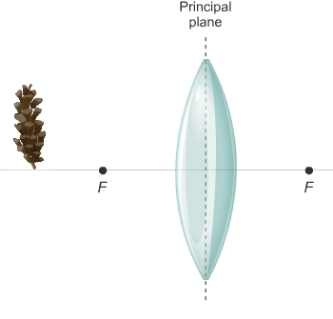

- (8 points) A laser light travels from air (n=1) through water (n=1.33), and then a piece of glass (n=1.55). The light first enters the water at an angle of 38 degrees (from air to water). Draw a diagram. Use Snell’s Law to find the angle of refraction in the water and the glass. Show all work.

Answer:

