Please note that each section aligns with one of the sections of the rubric for this course.

Introduction – Identify the problem, propose an IT solution, and discuss WHY it is necessary. Talk about where the problem is located, and how you propose solving it. Make the scope of the project clear, and be sure and add an additional sentence or two that clearly state that this document is a proposal to implement your specific project/solution.

Review of Other Work – This is where you talk about third party work done in the area by using sources (we recommend at least 4 for the proposal) to justify decisions you are making in the project. This can be white papers, best practices, tech blogs, etc. Try going to ProQuest database in the WGU library and using the search terms ‘white papers on [your topic]’ or ‘research studies on [your topic]’ and you will find more than you need. See https://owl.english.purdue.edu/owl/resource/560/02/ for help with correct formatting of in-text citations.

Rationale – this is the WHY… why is this project needed?

System Analysis -- Describe the current state of affairs in the company (or wherever the identified problem exists) and explain why that makes the project necessary.

Methodology – Explain what project management methodology will you use to implement your project (ADDIE, AGILE, SDLC, or other) and how you propose to use it.

Goals and Objectives – These must be specific goals for the project and must include their corresponding objectives. A good format is:

Goal #1:
- Objective 1: Step to reach the goal
- Objective 2:

Then you will provide some paragraph information (a logical explanation) about each goal and its corresponding objectives. You will repeat this for goal #2 and its objectives, and so on.

Remember, goals are the big picture (most project management methodologies include more than one phase/goal). Each goal will have objectives, which are the measurable steps that must be taken to achieve that goal. Deliverables are the predicted outcomes for Tech Writing, and proof of completion examples for Capstone (screen shots, snippets of code, network map, pictures of work done, etc.).
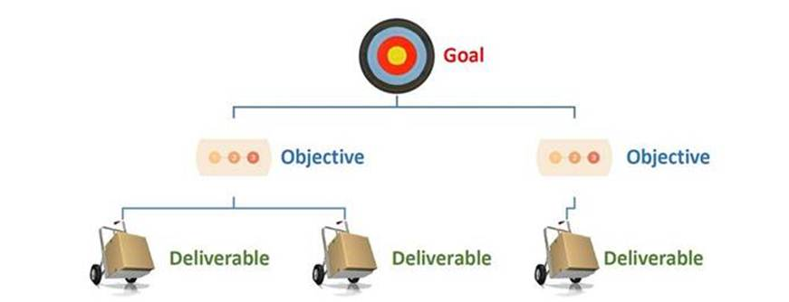

Deliverables – You will need a list of your deliverables from each of your goals and objectives. And you will need to give a verbal explanation for each deliverable.

Timeline – The timeline needs to include a table format of your milestones and must include duration, as well as start date and end dates. All dates must be in the future because this is a proposal.

Sources – You must include a reference list in APA format for every work cited in the body of your paper. See https://owl.english.purdue.edu/owl/resource/560/05/ for help with this.

