QUESTION 1
- 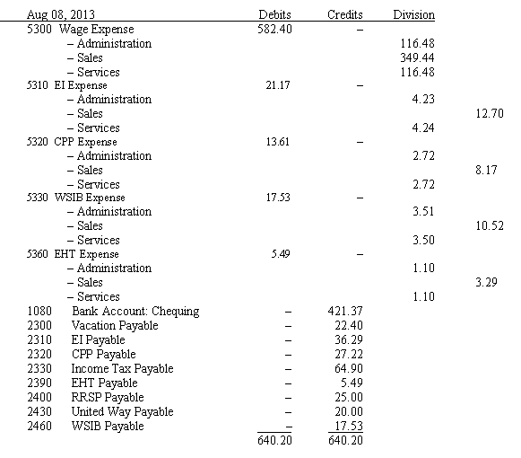 In the journal entry above –
- vacation payable shows no allocation because the entire amount is
- allocated to one division
- the vacation pay amount had not been calculated
- vacation payable is not allocated
- each amount allocated uses different percentages for the allocation

1 points
QUESTION 2
- Which one of the following allocated amounts is correct in the journal entry above –
- wage expense – Administration – $582.40
- wage expense – Sales – $349.44
- WSIB expense – Administration – $17.53
- EHT expense – Sales – $5.49

1 points
QUESTION 3
- Division report options include –
- choosing any or all of the revenue and expense accounts
- available drill-down report options
- summary or detail formats
- all of the above

1 points
QUESTION 4
- The Allocate function may be unavailable when –
- the cursor is on a blank journal line
- the account ledger does not allow allocations
- the item assembly journal is open
- all of the above

1 points
QUESTION 5
- To review the credit card details you entered after processing the sale, you would –
- post the sale and then look up the invoice
- click the Review Credit Card Details button before posting the sale
- click the Review Credit Card Details button after posting the sale
- you cannot review the details after the sale has been processed

1 points
QUESTION 6
- The journal entry above shows that –
- the vacation pay is not allocated
- the vacation pay is retained
- the vacation pay has been paid
- the vacation pay has not been calculated

1 points
QUESTION 7
- Journal reports can include or omit –
- division allocation details
- corrections
- details from the additional fields
- all of the above

1 points
QUESTION 8
- When you allow allocation for all expense and revenue accounts the following will not be allocated –
- sales and purchase discount amounts
- freight expense amounts
- freight revenue amounts
- all these expense accounts will be correctly allocated if you enter the allocation details

1 points
QUESTION 9
- Import duties –
- are charged at the same rate on all purchases
- are always charged on purchases but the rates may vary
- may or may not be charged on purchases
- are never charged on purchases of inventory items that will be resold

1 points
QUESTION 10
- When a division is set up and we enter a purchase, the allocate tool –
- will automatically be highlighted
- will automatically be dimmed
- will be highlighted when an account that allows allocation is selected
- will be highlighted only when an asset is purchased

1 points
QUESTION 11
- The option to apply an allocation to the entire transaction is available in –
- sales, purchases and payroll journals
- sales, purchases and general journals
- sales and purchases journals
- all journals

1 points
QUESTION 12
- The information provided from division allocations cannot be used for –
- preparing customer statements
- making decisions about expanding the business
- making decisions about eliminating parts of a business
- making decisions to control costs more effectively

1 points
QUESTION 13
- The Division module window has journal icons for –
- all journals that allow allocations
- division journals only
- sales, purchases and payments
- sales, purchases, general journal and paycheques

1 points
QUESTION 14
- What is the total amount allocated from the entry shown above –
- $582.40
- $640.20
- $421.37
- some other amount

1 points
QUESTION 15
- Which of the following general statements about divisions is not correct –
- special journals and linked accounts are required for divisions
- you may change allocation amounts at any time before posting
- you may print journal reports with or without division allocations
- if costs cannot be allocated accurately there is no reason to keep divisions

1 points
QUESTION 16
- Which one of the following general statements about divisions is true –
- all division income reports will show the profits for the selected divisions
- allocate revenues by double clicking the allocation column beside the amount
- you may print journal reports with or without division allocations
- all of the above

1 points
QUESTION 17
- Divisions may be set up by doing the following –
- choosing the method of allocation
- creating new divisions and allowing allocations in account ledgers
- creating new divisions
- none of the above

1 points
QUESTION 18
- Changing the name of the Division module will not change –
- the way you allocate costs and revenues
- the name of the reports in the reports menu
- the label of the division icon in the home window
- the labels in the division allocation windows

