Q1 | A simply supported beam has a concentrated downward force P at a distance of a from the left support, as shown in the figure below. The flexural rigidity EI is constant. Find the equation of the Elastic Curve by successive integration.  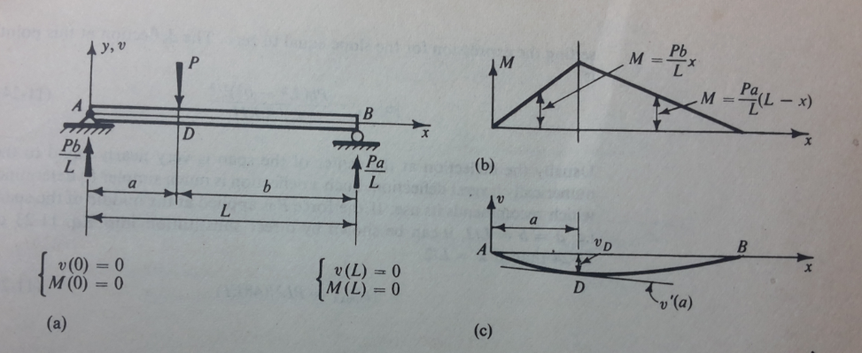 |  | [5 Marks]

Q2 | Determine the rotations at A and B due to an applied moment M_{B} on the beam, as shown in the figure below. Use the Method of Virtual Work.  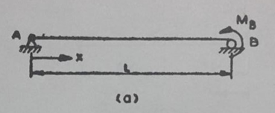 |  | [4 Marks]

Q3 | Find the strain energy stored per unit volume for the materials listed below when they are axially stressed to their respective proportional limits. |  | [3 Marks]
  Material | Proportional Limit (N/mm²) | Modulus of Elasticity Proportional Limit (N/mm²)
  Mild Steel | 247 | 2.06 x 10⁵
  Aluminium | 412 | 7.20 x 10⁴
  Rubber | 2.06 | 2.06

Q4 | As shown in the figure below, find the downward deflection of the end C caused by the applied force of 2 kN in the structure. Neglect deflection caused by shear. Let E = 7 x 107 kN/m².  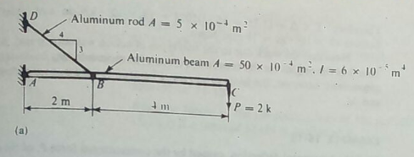 |  | [5 Marks]

Q5 | For the loaded beam, as shown in the figure below, determine the magnitude of the counter weight Q for which the maximum absolute value of the bending moment is as small as possible. If this beam section is 150 mm x 200mm, determine the maximum bending stress. Neglect the weight of the beam.  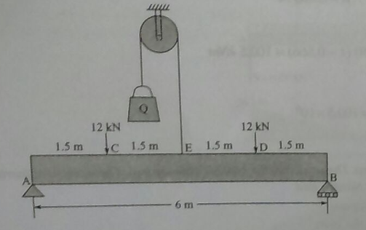 |  | [5 Marks]

Q6 | A wooden beam with sectional dimensions of 150 mm x 300 mm, carries the loading as shown in the figure below. Determine the maximum shearing and bending stress for the beam.  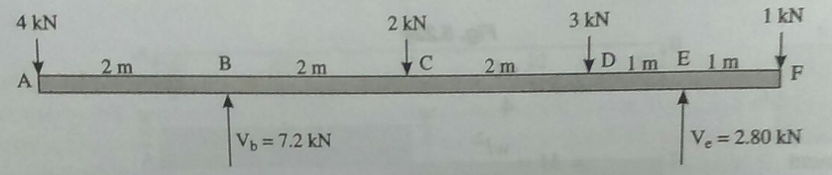 | [6 Marks]

Q7 | For the box beam shown in the figure below, determine the maximum intensity w of the distributed loading that can be safely supported if the permissible stresses in bending and shear are 10 N/mm² and 0.75 N/mm² respectively.  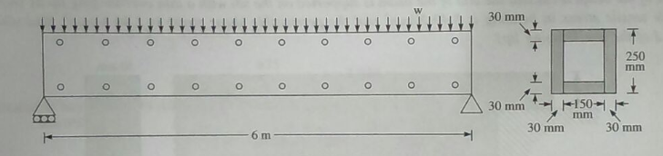 |  | [5 Marks]

Q8 | A beam of rectangular section 450 mm wide and 750 mm deep has a span of 6 metres. The beam is subjected to a uniformly distributed load of 20 kN per metre run (including the self-weight of the beam) over the whole span. The beam is also subjected to a longitudinal axial compressive load of 1500 kN. Find the extreme fibre stresses at the middle section span. | [5 Marks]

Q9 | A hollow alloy tube 5 metres long with external and internal diameters equal to 40 mm and 25 mm respectively, was found to extend by 6.4 mm under a tensile load of 60 kN. Find the buckling load for the tube when it is used as a column with both ends pinned. Also find the safe compressive load for the tube with a Factor of Safety of 4. |  | [4 Marks]

Q10 | A cantilever beam of length l carrying a distributed load varies uniformly from zero at the free end to w per unit run at the fixed end. Find the slope and downward deflection of the free end B.  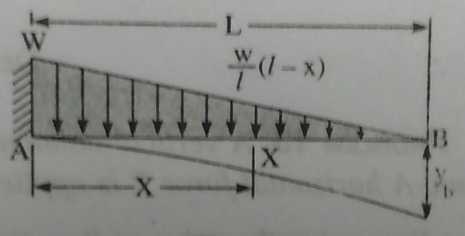 | [8 Marks]

