Comparative Analysis Case

The Coca-Cola Company and PepsiCo, Inc.
The financial statements of Coca-Cola and PepsiCo are presented in Appendices C and D, respectively. The companies' complete annual reports, including the notes to the financial statements, are available online.

Instructions
Use the companies' financial information to answer the following questions.
(a)What is the par or stated value of Coca-Cola's and PepsiCo's common or capital stock?
(b)What percentage of authorized shares was issued by Coca-Cola at December 31, 2014, and by PepsiCo at December 31, 2014?
(c)How many shares are held as treasury stock by Coca-Cola at December 31, 2014, and by PepsiCo at December 31, 2014?
(d)How many Coca-Cola common shares are outstanding at December 31, 2014? How many PepsiCo shares of capital stock are outstanding at December 31, 2014?
(e)What amounts of cash dividends per share were declared by Coca-Cola and PepsiCo in 2014? What were the dollar amount effects of the cash dividends on each company's stockholders' equity?
(f)What are Coca-Cola's and PepsiCo's return on common/capital stockholders' equity for 2014 and 2013? Which company gets the higher return on the equity of its shareholders?
(g)What are Coca-Cola's and PepsiCo's payout ratios for 2014?
(h)What was the market price range (high/low) for Coca-Cola's common stock and PepsiCo's capital stock during the fourth quarter of 2014? Which company's (Coca-Cola's or PepsiCo's) stock price increased more (%) during 2014?

C Specimen Financial Statements: The Coca-Cola Company
The Coca-Cola Company is the world's largest beverage company. It owns or licenses and markets more than 500 nonalcoholic beverage brands, primarily sparkling beverages, but also a variety of still beverages such as waters, enhanced waters, juices and juice drinks, ready-to-drink teas and coffees, and energy and sports drinks. Finished beverage products bearing Coca-Cola trademarks, sold in the United States since 1886, are now available in more than 200 countries. To access Coca-Cola's complete annual report, including notes to the financial statements, follow these steps:
- Go to http://www.coca-colacompany.com/investors/.
- Select Financial Reports and Information and then click on 2014 Annual Report on Form 10-K.
- The Notes to Consolidated Financial Statements begin on page 78.
THE COCA-COLA COMPANY AND SUBSIDIARIES CONSOLIDATED STATEMENTS OF INCOME
Year Ended December 31, | 2014 | 2013 | 2012
(In millions except per share data)
NET OPERATING REVENUES | $ 45,998 | $ 46,854 | $ 48,017
Cost of goods sold | 17,889 | 18,421 | 19,053
GROSS PROFIT | 28,109 | 28,433 | 28,964
Selling, general and administrative expenses | 17,218 | 17,310 | 17,738
Other operating charges | 1,183 | 895 | 447
OPERATING INCOME | 9,708 | 10,228 | 10,779
Interest income | 594 | 534 | 471
Interest expense | 483 | 463 | 397
Equity income (loss) — net | 769 | 602 | 819
Other income (loss) — net | (1,263) | 576 | 137
INCOME BEFORE INCOME TAXES | 9,325 | 11,477 | 11,809
Income taxes | 2,201 | 2,851 | 2,723
CONSOLIDATED NET INCOME | 7,124 | 8,626 | 9,086
Less: Net income attributable to noncontrolling interests | 26 | 42 | 67
NET INCOME ATTRIBUTABLE TO SHAREOWNERS OF THE COCA-COLA COMPANY | $ 7,098 | $ 8,584 | $ 9,019
BASIC NET INCOME PER SHARE1 | $ 1.62 | $ 1.94 | $ 2.00
DILUTED NET INCOME PER SHARE1 | $ 1.60 | $ 1.90 | $ 1.97
AVERAGE SHARES OUTSTANDING | 4,387 | 4,434 | 4,504
Effect of dilutive securities | 63 | 75 | 80
AVERAGE SHARES OUTSTANDING ASSUMING DILUTION | 4,450 | 4,509 | 4,584
¹Calculated based on net income attributable to shareowners of The Coca-Cola Company.
THE COCA-COLA COMPANY AND SUBSIDIARIES CONSOLIDATED STATEMENTS OF COMPREHENSIVE INCOME
Year Ended December 31, | 2014 | 2013 | 2012
(In millions)
CONSOLIDATED NET INCOME | $ 7,124 | $ 8,626 | $ 9,086
Other comprehensive income:
Net foreign currency translation adjustment | (2,382) | (1,187) | (182)
Net gain (loss) on derivatives | 357 | 151 | 99
Net unrealized gain (loss) on available-for-sale securities | 714 | (80) | 178
Net change in pension and other benefit liabilities | (1,039) | 1,066 | (668)
TOTAL COMPREHENSIVE INCOME | 4,774 | 8,576 | 8,513
Less: Comprehensive income (loss) attributable to noncontrolling interests | 21 | 39 | 105
TOTAL COMPREHENSIVE INCOME ATTRIBUTABLE TO SHAREOWNERS OF THE COCA-COLA COMPANY | $ 4,753 | $ 8,537 | $ 8,408

THE COCA-COLA COMPANY AND SUBSIDIARIES CONSOLIDATED BALANCE SHEETS
December 31, | 2014 | 2013
(In millions except par value)
ASSETS
CURRENT ASSETS
Cash and cash equivalents | $ 8,958 | $ 10,414
Short-term investments | 9,052 | 6,707
TOTAL CASH, CASH EQUIVALENTS AND SHORT-TERM INVESTMENTS | 18,010 | 17,121
Marketable securities | 3,665 | 3,147
Trade accounts receivable, less allowances of $331 and $61, respectively | 4,466 | 4,873
Inventories | 3,100 | 3,277
Prepaid expenses and other assets | 3,066 | 2,886
Assets held for sale | 679 | —
TOTAL CURRENT ASSETS | 32,986 | 31,304
EQUITY METHOD INVESTMENTS | 9,947 | 10,393
OTHER INVESTMENTS | 3,678 | 1,119
OTHER ASSETS | 4,407 | 4,661
PROPERTY, PLANT AND EQUIPMENT — net | 14,633 | 14,967
TRADEMARKS WITH INDEFINITE LIVES | 6,533 | 6,744
BOTTLERS' FRANCHISE RIGHTS WITH INDEFINITE LIVES | 6,689 | 7,415
GOODWILL | 12,100 | 12,312
OTHER INTANGIBLE ASSETS | 1,050 | 1,140
TOTAL ASSETS | $ 92,023 | $ 90,055
LIABILITIES AND EQUITY
CURRENT LIABILITIES
Accounts payable and accrued expenses | $ 9,234 | $ 9,577
Loans and notes payable | 19,130 | 16,901
Current maturities of long-term debt | 3,552 | 1,024
Accrued income taxes | 400 | 309
Liabilities held for sale | 58 | —
TOTAL CURRENT LIABILITIES | 32,374 | 27,811
LONG-TERM DEBT | 19,063 | 19,154
OTHER LIABILITIES | 4,389 | 3,498
DEFERRED INCOME TAXES | 5,636 | 6,152
THE COCA-COLA COMPANY SHAREOWNERS' EQUITY
Common stock, $0.25 par value; Authorized — 11,200 shares;
Issued — 7,040 and 7,040 shares, respectively | 1,760 | 1,760
Capital surplus | 13,154 | 12,276
Reinvested earnings | 63,408 | 61,660
Accumulated other comprehensive income (loss) | (5,777) | (3,432)
Treasury stock, at cost — 2,674 and 2,638 shares, respectively | (42,225) | (39,091)
EQUITY ATTRIBUTABLE TO SHAREOWNERS OF THE COCA-COLA COMPANY | 30,320 | 33,173
EQUITY ATTRIBUTABLE TO NONCONTROLLING INTERESTS | 241 | 267
TOTAL EQUITY | 30,561 | 33,440
TOTAL LIABILITIES AND EQUITY | $ 92,023 | $ 90,055

THE COCA-COLA COMPANY AND SUBSIDIARIES CONSOLIDATED STATEMENTS OF CASH FLOWS
Year Ended December 31, | 2014 | 2013 | 2012
(In millions)
OPERATING ACTIVITIES
Consolidated net income | $ 7,124 | $ 8,626 | $ 9,086
Depreciation and amortization | 1,976 | 1,977 | 1,982
Stock-based compensation expense | 209 | 227 | 259
Deferred income taxes | (40) | 648 | 632
Equity (income) loss — net of dividends | (371) | (201) | (426)
Foreign currency adjustments | 415 | 168 | (130)
Significant (gains) losses on sales of assets — net | 831 | (670) | (98)
Other operating charges | 761 | 465 | 166
Other items | 149 | 234 | 254
Net change in operating assets and liabilities | (439) | (932) | (1,080)
Net cash provided by operating activities | 10,615 | 10,542 | 10,645
INVESTING ACTIVITIES
Purchases of investments | (17,800) | (14,782) | (14,824)
Proceeds from disposals of investments | 12,986 | 12,791 | 7,791
Acquisitions of businesses, equity method investments and nonmarketable securities | (389) | (353) | (1,486)
Proceeds from disposals of businesses, equity method investments and nonmarketable securities | 148 | 872 | 20
Purchases of property, plant and equipment | (2,406) | (2,550) | (2,780)
Proceeds from disposals of property, plant and equipment | 223 | 111 | 143
Other investing activities | (268) | (303) | (268)
Net cash provided by (used in) investing activities | (7,506) | (4,214) | (11,404)
FINANCING ACTIVITIES
Issuances of debt | 41,674 | 43,425 | 42,791
Payments of debt | (36,962) | (38,714) | (38,573)
Issuances of stock | 1,532 | 1,328 | 1,489
Purchases of stock for treasury | (4,162) | (4,832) | (4,559)
Dividends | (5,350) | (4,969) | (4,595)
Other financing activities | (363) | 17 | 100
Net cash provided by (used in) financing activities | (3,631) | (3,745) | (3,347)
EFFECT OF EXCHANGE RATE CHANGES ON CASH AND CASH EQUIVALENTS | (934) | (611) | (255)
CASH AND CASH EQUIVALENTS
Net increase (decrease) during the year | (1,456) | 1,972 | (4,361)
Balance at beginning of year | 10,414 | 8,442 | 12,803
Balance at end of year | $ 8,958 | $ 10,414 | $ 8,442

THE COCA-COLA COMPANY AND SUBSIDIARIES CONSOLIDATED STATEMENTS OF SHAREOWNERS' EQUITY
Year Ended December 31, | 2014 | 2013 | 2012
(In millions except per share data)
EQUITY ATTRIBUTABLE TO SHAREOWNERS OF THE COCA-COLA COMPANY NUMBER OF COMMON SHARES OUTSTANDING
Balance at beginning of year | 4,402 | 4,469 | 4,526
Purchases of treasury stock | (98) | (121) | (121)
Treasury stock issued to employees related to stock compensation plans | 62 | 54 | 64
Balance at end of year | 4,366 | 4,402 | 4,469
COMMON STOCK | $ 1,760 | $ 1,760 | $ 1,760
CAPITAL SURPLUS
Balance at beginning of year | 12,276 | 11,379 | 10,332
Stock issued to employees related to stock compensation plans | 526 | 569 | 640
Tax benefit (charge) from stock compensation plans | 169 | 144 | 144
Stock-based compensation | 209 | 227 | 259
Other activities | (26) | (43) | 4
Balance at end of year | 13,154 | 12,276 | 11,379
REINVESTED EARNINGS
Balance at beginning of year | 61,660 | 58,045 | 53,621
Net income attributable to shareowners of The Coca-Cola Company | 7,098 | 8,584 | 9,019
Dividends (per share — $1.22, $1.12 and $1.02 in 2014, 2013 and 2012, respectively) | (5,350) | (4,969) | (4,595)
Balance at end of year | 63,408 | 61,660 | 58,045
ACCUMULATED OTHER COMPREHENSIVE INCOME (LOSS)
Balance at beginning of year | (3,432) | (3,385) | (2,774)
Net other comprehensive income (loss) | (2,345) | (47) | (611)
Balance at end of year | (5,777) | (3,432) | (3,385)
TREASURY STOCK
Balance at beginning of year | (39,091) | (35,009) | (31,304)
Sto  ck issued to employees related to stock compensation plans | 891 | 745 | 786
Purchases of treasury stock | (4,025) | (4,827) | (4,491)
Balance at end of year | (42,225) | (39,091) | (35,009)
TOTAL EQUITY ATTRIBUTABLE TO SHAREOWNERS OF THE COCA-COLA COMPANY | $ 30,320 | $ 33,173 | $ 32,790
EQUITY ATTRIBUTABLE TO NONCONTROLLING INTERESTS
Balance at beginning of year | $ 267 | $ 378 | $ 286
Net income attributable to noncontrolling interests | 26 | 42 | 67
Net foreign currency translation adjustment | (5) | (3) | 38
Dividends paid to noncontrolling interests | (25) | (58) | (48)
Acquisition of interests held by noncontrolling owners | — | (34) | (15)
Contributions by noncontrolling interests | — | 6 | —
Business combinations | (22) | 25 | 50
Deconsolidation of certain entities | — | (89) | —
TOTAL EQUITY ATTRIBUTABLE TO NONCONTROLLING INTERESTS | $ 241 | $ 267 | $ 378

D Specimen Financial Statements: PepsiCo, Inc.
Pepsico, Inc. is a leading global food and beverage company with a complementary portfolio of enjoyable brands, including Frito-Lay, Gatorade, Pepsi-Cola, Quaker, and Tropicana. Through its operations, authorized bottlers, contract manufacturers, and other third parties, PepsiCo makes, markets, distributes, and sells a wide variety of convenient and enjoyable beverages, foods, and snacks, serving customers and consumers in more than 200 countries and territories. To access PepsiCo's complete annual report, including notes to the financial statements, follow these steps:
- Go to http://www.pepsico.com/Investors.
- Select SEC Filings and then the 10K, dated 2/12/2015 (select the pdf version).
- Select Entire document.
- The Notes to Consolidated Financial Statements begin on page 73.
- Consolidated Statement of Income
- PepsiCo, Inc. and Subsidiaries
- Fiscal years ended December 27, 2014, December 28, 2013 and December 29, 2012
- (in millions except per share amounts

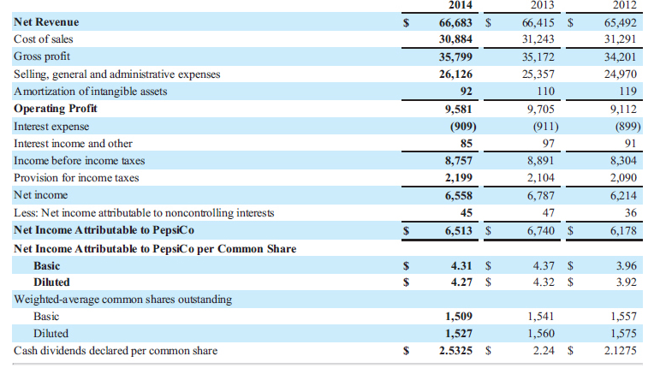

- Consolidated Statement of Comprehensive Income
- PepsiCo, Inc. and Subsidiaries
- Fiscal years ended December 27, 2014, December 28, 2013 and December 29, 2012
- (in millions)
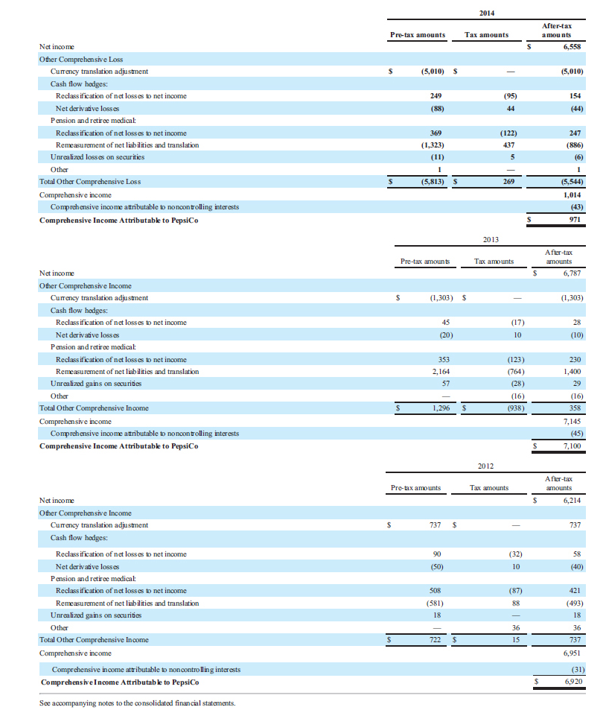
- Consolidated Statement of Cash Flows
- PepsiCo, Inc. and Subsidiaries
- Fiscal years ended December 27, 2014, December 28, 2013 and December 29, 2012
- (in millions)
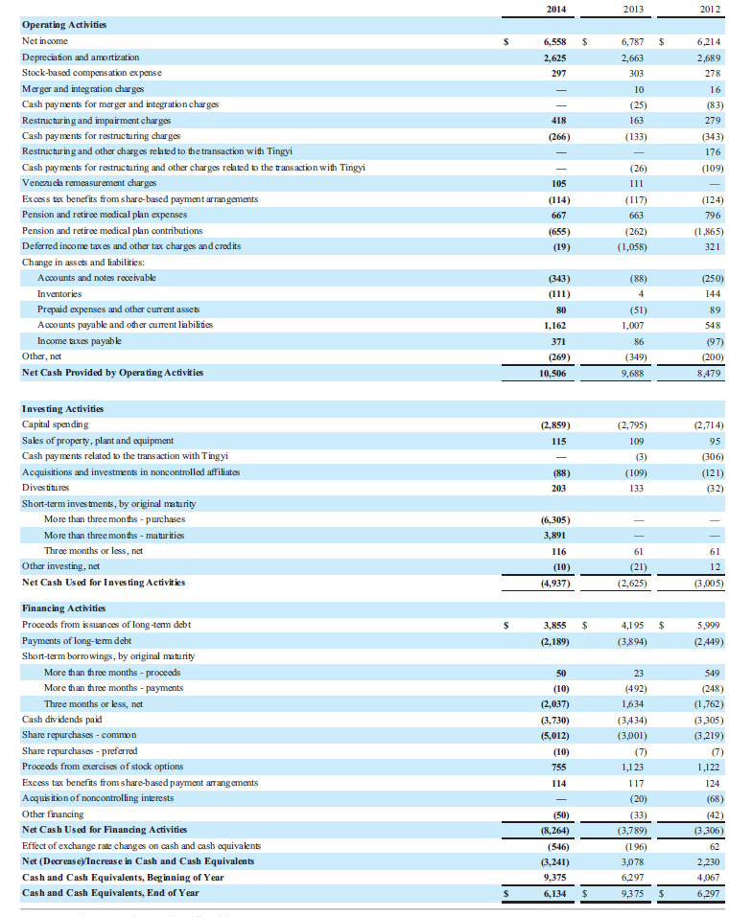
- Consolidated Balance Sheet
- PepsiCo, Inc. and Subsidiaries
- December 27, 2014 and December 28, 2013
- (in millions except per share amounts)

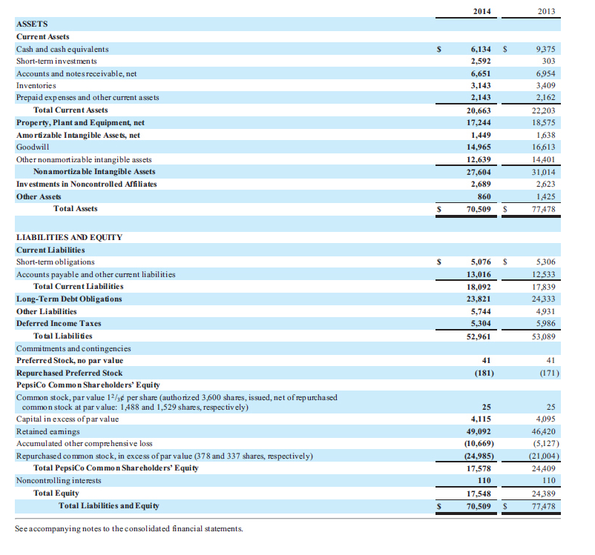

- Consolidated Statement of Equity
- PepsiCo, Inc. and Subsidiaries
- Fiscal years ended December 27, 2014, December 28, 2013 and December 29, 2012
- (in millions)

