Tianlun Ge
8/7/2016
RPW 300

Implementing Electronic Health Records. Steps, Costs, and Benefits

Introduction
The government is offering physicians up to $44, 0000 over five years if they can demonstrate effective use of electronic health records (EHR) (Blechman, 2014). The government is taking a position in ensuring the EHR are implemented because evidence support the belief that electronic health records can improve the quality of health care, benefiting both physicians and their patients (BEASLEY & Sinsky, 2014). The purpose of this paper is to propose a plan of effective implementation of EHR, as well to explain the cost and benefits of this implementation.

Implementing EHR is a Crucial Step in Modernizing the Health Care System
Implementing EHR requires a strong commitment of time and money, as well as expertise that some physician practices do not have. Despite the efforts, most physicians want to implement EHR because of the advantage they promise to bring. For example, the official website of the National Center for Health Statistics (www. cdc.gov) shows that most physicians are happy with EHR systems. The following images from the website showsome of the statistics obtained.
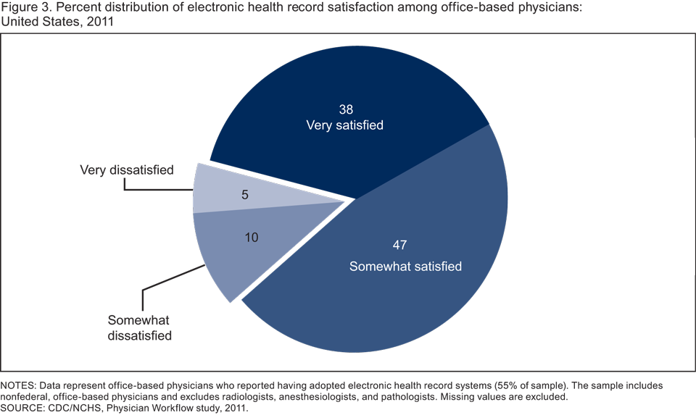
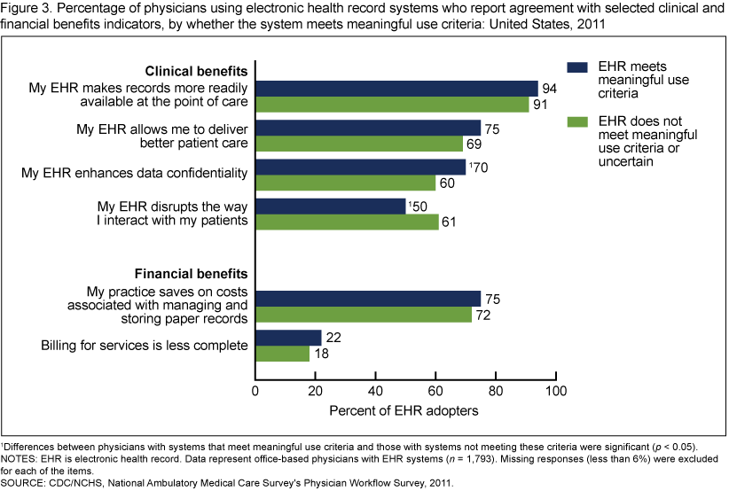
In order to fully benefit from electronic health records, it is important that physicians implement them following specific steps that address several crucial areas of implementation.

Step by Step Plan for Implementing EHR Effectively
Implementation of EHR can take between 2 months to several years. In order for a project to be successful, it is important to establish the groundwork, such as roles, accountability, consensus, and staff preparedness. Based on experts’ recommendation (BEASLEY & Sinsky, 2014), the following steps should lead to a successful EHR implementation.
- Establish the objectives
In order to reduce wasted time, health centers must initially clarify what they want to obtain from implementing EHR. For example, while some practices want to meet the minimum requirement to qualify for governmental funds, other practices want to automate their workflow, connect with laboratories and other providers, and improve patient communication through linked portals. Depending upon the approach taken on implementation, the time, training, and costs will differ significantly.
- Assess the current situation
In this step the practices must firmly establish their currently status, such as their existing users and systems. More so, if a clinic lacks experience with electronic records, it must consider the need of additional training. Discovering and fixing some of the problems during this step ensure that the organizations is are able to develop effective processes before and during implementation.
- Identify project protocol and leadership
It is important that leadership communicates the objectives and reasons for implementation, as well as their full commitment to it. Even in practices that have only a few people, it is important that there is a clear organization and everyone understands their role in the process. More so, establishing from an early time what the procedures are for dealing with staff or physicians who do not want to use the system can minimize disruptions and tensions later on.
- Establish the purpose of the system
This step involves establishing the specific requirements of the system. In other words, it means identifying the specifications and goals of the HER system and allows practices to prepare requests for proposal that allow objective comparisons of vendors. More so, establishing the required functions earlier minimizes the expenses associated with changing some of the requirements during implementation.
- Negotiate Carefully
Negotiating with vendors for a particular EHR system can be a difficult task, and requires establishing the support offered. There are some organizations, such as the state HIT centers, which make templates available for EHR vendor contracts. Reviewing these templates to check if the final contract contains elements such as responsiveness metrics, protection, and usability measures, among others, is important to save time and money in the long run.
- Train for proficiency
While most vendors offer training programs in order to support their products, practices must ensure that the training is fit for specific practices and not too general. Practice-specific training is focused on the processes used by the staff and provides, not only on the software that is most effective.
- Measure Results
The time, effort, and investment required for implementing an EHR only pays off when the practice remains focused on achieving full implementation throughout the organization. After the system is officially implemented, the health care practice must measure whether the providers and staff are using the new system and how they are using it. Surveying users about their experience with EHR is a good method of identifying processes or training issues that need to be addressed.
- Document the use of the EHR in order to qualify for governmental incentive programs
Because incentive payments are solely based on individual practitioners, those who are part of a given practice will have to individually demonstrate the use of certified EHR technology in accordance to standards imposed by the government. Health care providers can receive incentive one time a year, regardless of the number of locations or practices at which they offer services.

Qualifications, Costs, and Benefits

Qualifications
While vendors of EHR system may offer some limited training, many health care centers, especially smaller one, require investing from their own sources into training. In a health care practice characterized by physicians and/or nurses that do not know how to use EHR system, the benefits from implementation and the recovery of costs are unlikely to make themselves noticed. While training the staff of a health practice can be costly, recovering the costs of the initial investment and the additions costs is much more likely to become a reality with training (BEASLEY & Sinsky, 2014).
There is no standard procedure that defines what training should be and how it should occur. On the other hand, considering that the lack of training is usually related to the lack of skills for using some or all of the technologies that come within an EHR system, it is often recommended to receive training from a technical expert, such as an IT professional. Once at least some members of the health organization are skillful in managing the implemented EHR system, they can offer training to other members of the organization.
Finally, an important aspect of training can be the change of attitudes. While some members of a health organization know how to use the system, they may be unwilling to do so because they see no benefit in it. For this reason, it is important that all members of an organization that must work with EHR understand the full benefits of the system (Blechman, 2014).
Costs
The costs associated with implementing EHR vary from one health care center to another. According to evidence, $ 12, 000 is the optimal price point for any EHR system among small primary care practices. Some practices can receive implementation subsidy which can reduce the costs significantly (Blechman, 2014).
Benefits
EHR can improve the quality of the American health care system by increasing the quality with which health care records and taken and the accessibility by which both physicians and patients can access them. By making communication more readable and more accessible, physicians, nurses, relevant third-parties, as well as the patient can better understand a health situation and respond to it appropriately (Blechman, 2014).

Conclusion & Recommendation
Many practices will find implementing EHR are challenging. These challenges will be related to the costs, the training, and other requirement that can make the implementation of an electronic health record effective. Despite the efforts, most physicians want to implement EHR because of the advantages they promise to bring. For most practices, implementing EHR comes with making communication between the patients, physicians, nurses, and other third-parties more readable and accessible. Because costs are one of the most important challenges in implementing HER, many practices may consider going beyond government subsidies and look for additional certifications tied to financial incentives, such as the Patient-Centered Medical Home. There is little doubt that once an EHR system is fully adopted the costs will be recovered and benefits will soon become obvious.

Reference
Beasley, J. W., & Sinsky, C. A. (2014). Electronic health records. Annals of internal medicine, 161(9), 680.
Blechman, E. (2014). U.S. Patent Application No. 14/588,304.

