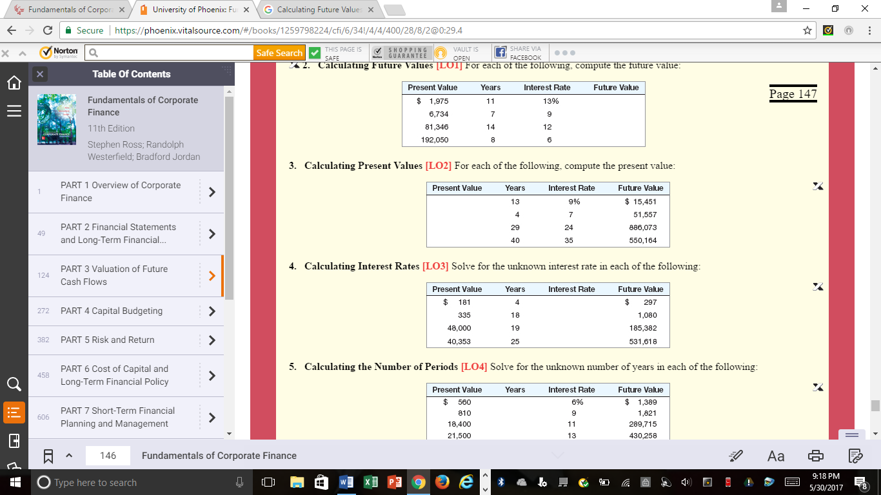

DO QUESTIONS #2 AND #5 (SEEN ABOVE) You can these answer on a Word Doc
***THEN USE THE WK 2, CHAPTER 5 EXCEL SHEET TO ANSWER QUESTIONS #3 AND #4 (SEEN ABOVE)***

