CHAPTER 7

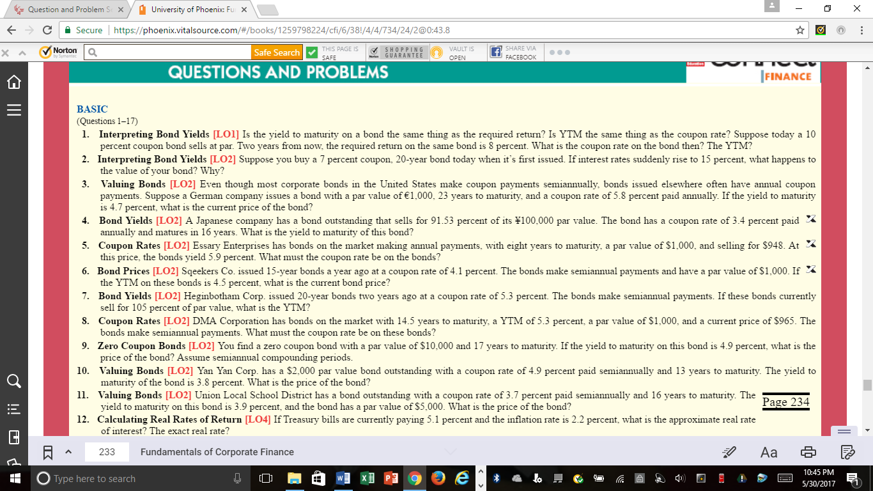
Do questions #1 and #8 (SEEN ABOVE) Can do on Word Doc

