CHAPTER 8
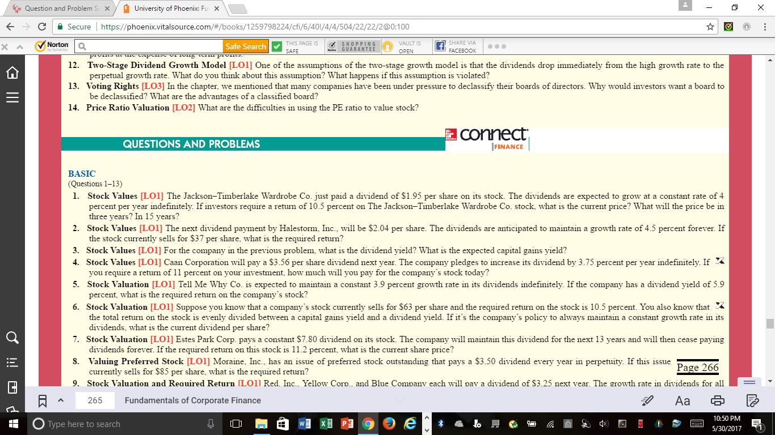

***Do questions #3 and #5 (SEEN ABOVE) Can do on a Word Doc ***
***Use the Week 2 Chapter 8 Excel Sheet for question #6 (SEE QUESTION #6 ABOVE)

