CHAPTER 6

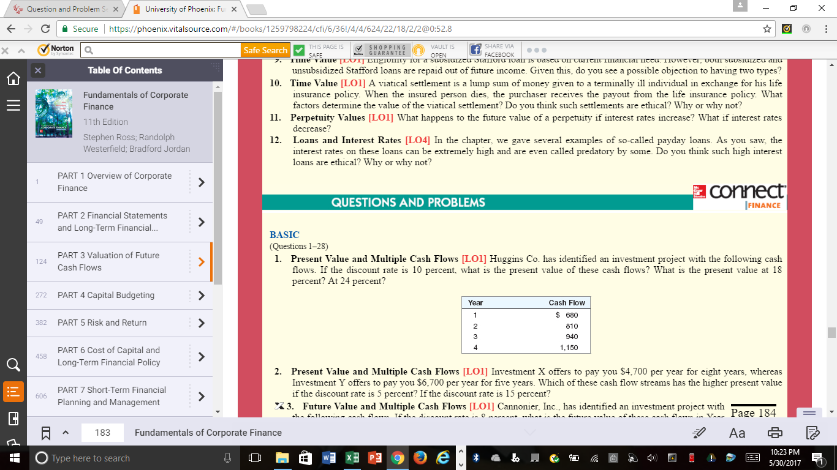

Two questions for Chapter #6 - #1 (SEEN ABOVE) and #22 (SEEN BELOW)
You can do on a Word Doc

