Assignment Information:
Part A is worth 20 marks and is a contracts law case scenario. Part B is worth 10 marks and is a property law case scenario. Total marks for the assignment is 30. Guideline for word length is 1500 words (1000 for part A and 500 for part B). There is no penalty for exceeding the 1500 word guideline.
Additional information to help you with your assignment is located under the Assessment section of Moodle titled “Useful Resources”:
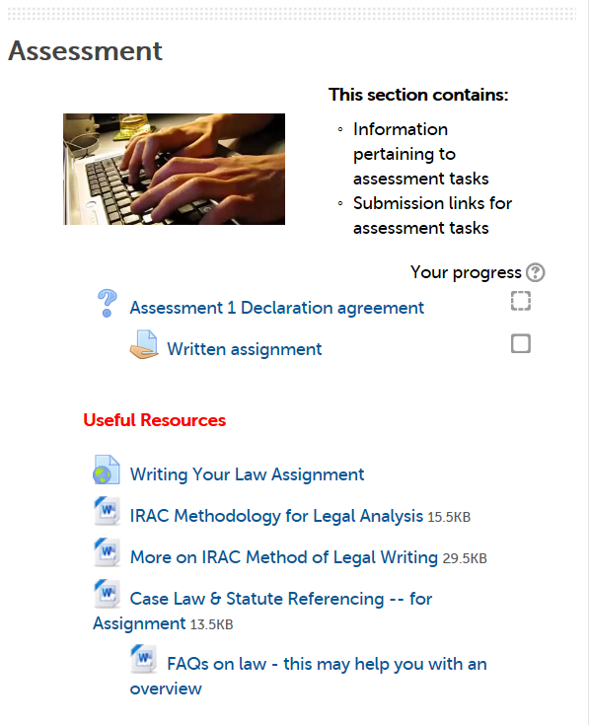
The video and documents are to aid you in how to format your assignment, and reference cases or statutes. Please note that for Part A, you should focus your case law research on the textbook only.

For additional help writing part A of the assignment, look to Topic B under Resources for “Additional websites, documents and readings”:
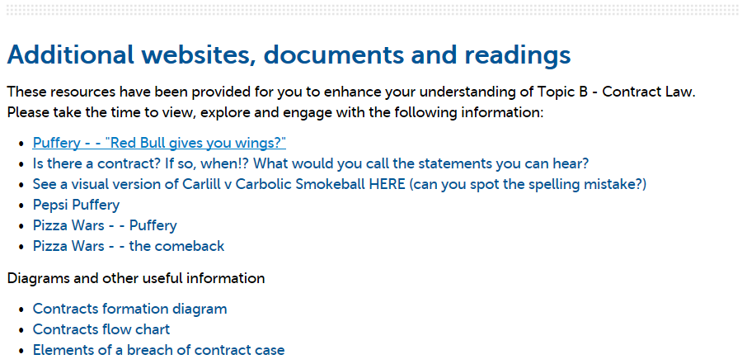
The three documents under Diagrams and other useful information are designed to help you with the assignment, especially with identifying issues.
For additional help writing part B of the assignment, look to Topic C under Resources, including the section for “Additional websites, documents and readings”:

Please note that you may not find cases that are exactly like the scenarios you have been given for the assignment. Focus your efforts on finding cases that support your arguments, instead of finding one that has identical facts. For example, if you wanted to argue that no valid contract existed because no consideration was given, then look for cases that involve no consideration to support your argument.

