A single-step income statement is one of two commonly used formats for the income statement or profit and loss statement. The single-step format uses only one subtraction to arrive at net income.



An extremely condensed income statement in the single-step format would look like this:
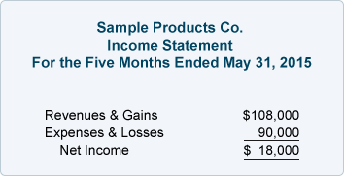

The heading of the income statement conveys critical information.
- The name of the company appears first,
- followed by the title "Income Statement."
- The third line tells the reader the time interval reported on the profit and loss statement. Since income statements can be prepared for any period of time, you must inform the reader of the precise period of time being covered.
- (For example, an income statement may cover any one of the following time periods: Year Ended May 31, Five Months Ended May 31, Quarter Ended May 31, Month Ended May 31, or Five Weeks Ended May 31.)

A sample income statement in the single-step format would look like this:
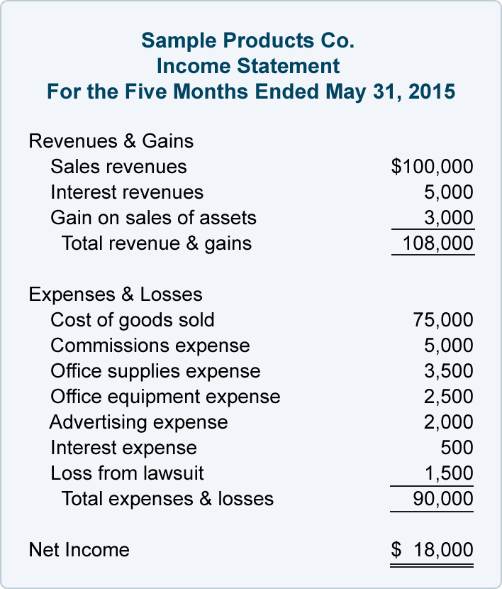

An alternative to the single-step income statement is the multiple-step income statement, because it uses multiple subtractions in computing the net income shown on the bottom line.

The multiple-step profit and loss statement segregates the operating revenues and operating expenses from the nonoperating revenues, nonoperating expenses, gains, and losses. The multiple-step income statement also shows the gross profit (net sales minus the cost of goods sold).
Here is a sample income statement in the multiple-step format:
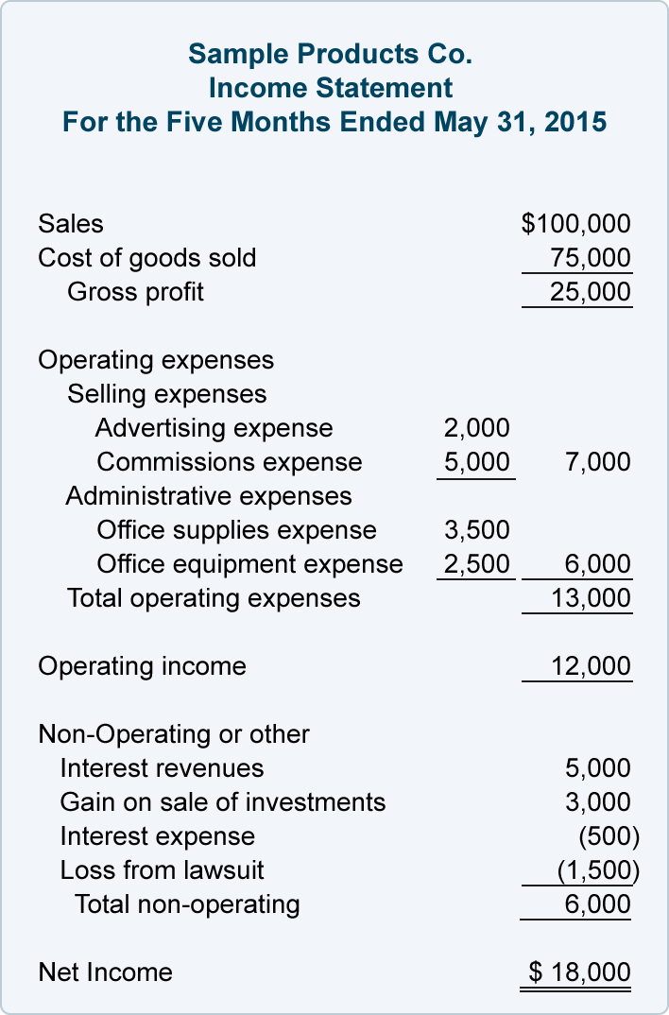
Using the above multiple-step income statement as an example, we see that there are three steps needed to arrive at the bottom line Net Income:
Step 1.
Cost of goods sold is subtracted from net sales to arrive at the gross profit.

Step 2.
Operating expenses are subtracted from gross profit to arrive at operating income.
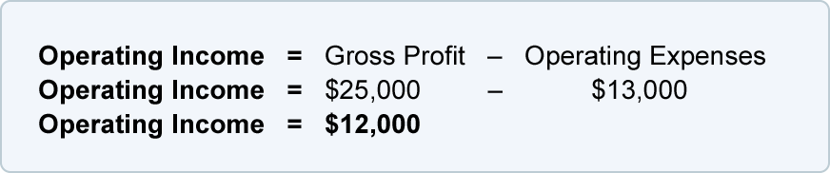
Step 3.
The net amount of nonoperating revenues, gains, nonoperating expenses and losses is combined with the operating income to arrive at the net income or net loss.


There are three benefits to using a multiple-step income statement instead of a single-step income statement:
- The multiple-step income statement clearly states the gross profit amount. Many readers of financial statements monitor a company's gross margin (gross profit as a percentage of net sales). Readers may compare a company's gross margin to its past gross margins and to the gross margins of the industry.
- The multiple-step income statement presents the subtotal operating income, which indicates the profit earned from the company's primary activities of buying and selling merchandise.
- The bottom line of a multiple-step income statement reports the net amount for all the items on the income statement. If the net amount is positive, it is labeled as net income. If the net amount is negative, it is labeled as net loss.

Earnings before interest and taxes (EBIT) is a calculation of the operational earnings of a businessbefore interest and tax(EBIT) divided by net revenue. It helps to identify the organization yearly growth.
EBIT can be calculated as the name implies, which is:
Net profit - interest expense - income tax expense = EBIT

Formula:
EBIT = R – E
EBIT Margin = EBIT / R
Taxable Income = EBIT - I
Tax Amount = Taxable Income x T
Net Income = Taxable Income - Tax Amount
Profit Margin = Net Income / R

Where,
R = Sales Revenue
E = Operating Expenses
I = Interest Paid
T = Tax Rate
Example :
A company has sales of $500000 with operating costs of $450000, interest paid of $6000 and a tax rate of 30%. Calculate the EBIT, Net Income, and Profit Margin.
Given :
Sales Revenue (R) = $500000
Operating Expenses (E) = $450000
Interest Paid (I) = $6000
Tax Rate (T) = 30% = 0.3
To Find :
Earnings Before Interest and Taxes, Net Income and Profit Margin
Solution :
EBIT = R - E = $500000 - $450000) = $50000
EBIT Margin = EBIT / R = ($50000 / $500000) x 100 = 10 %
Taxable Income = EBIT - I = $50000 - $6000 = $44000
Tax Amount = Taxable Income x T = $44000 x 0.3 = $13200
Net Income = Taxable Income - Tax Amount = $44000 - $13200 = $30800
Profit Margin = Net Income / R = ($30800 / $500000) x 100 = 6.16 %

