Financial Statement Analysis Cases

Case 1: Occidental Petroleum Corporation
Occidental Petroleum Corporation reported the following information in a recent annual report.

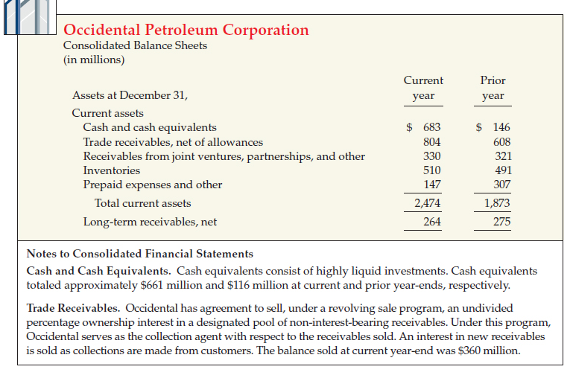

Instructions
(a)What items other than coin and currency may be included in “cash”?
(b)What items may be included in “cash equivalents”?
(c)What are compensating balance arrangements, and how should they be reported in financial statements?
(d)What are the possible differences between cash equivalents and short-term (temporary) investments?
(e)Assuming that the sale agreement meets the criteria for sale accounting, cash proceeds were $345 million, the carrying value of the receivables sold was $360 million, and the fair value of the recourse liability was $15 million, what was the effect on income from the sale of receivables?
(f)Briefly discuss the impact of the transaction in (e) on Occidental’s liquidity.

