- Thermohaline currents are caused by (select all that apply):
  - wind
  - coriolis effect
  - gravity
  - density
- What happens to density values as you descend to the bottom of the ocean?
  - increases
  - decreases
  - no change
- What happens to the salinity as you descend to the bottom of the ocean?
  - increases
  - decreases
  - no change
- What happens to the temperature as you descend to the bottom of the ocean?
  - increases
  - decreases
  - no change
- Where does all deep water in the world’s oceans originate?
  - poles
  - mid latitudes
  - equator
  - depends
- Use the following thermohaline currents to answer questions 7, 8, 9, and 10:
  - Antarctic Bottom Water (ABW)
  - Antarctic Intermediate Water (AIW)
  - Mediterranean Intermediate Water (MIW)
  - North Atlantic Deep Water (NADW)
  - Red Sea Intermediate Water (RIW)
- Which current is the densest?
  - AABW
  - AIW
  - MIW
  - NADW
  - RIW
- Which current is the least dense?
  - AABW
  - AIW
  - MIW
  - NADW
  - RIW
- Which current is the coldest?
  - AABW
  - AIW
  - MIW
  - NADW
  - RIW
- Which current is the warmest?
  - AABW
  - AIW
  - MIW
  - NADW
  - RIW
- What percentage of wind speed (10 m or 30 ft above the surface) is transferred to water to produce surface currents?
- What are the 5 circulation circles in the 3 main oceans called (generic term)?
- What causes the 'term', in Question 12, to form?
- Label the following surface currents on Figure 1 (time for some more research):
  - California Current
  - Equatorial countercurrent
  - Gulf Stream
  - Labrador
  - Canary
- Identify the following surface currents Figure 1
  - Current #5
  - Current #14
  - Current #17
  - Current #20
  - Current #22
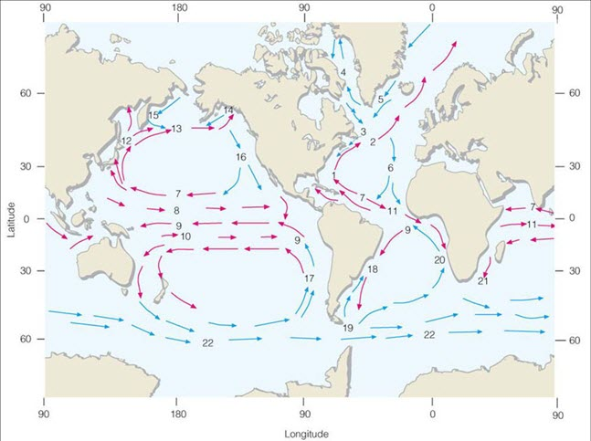
Figure 1. Ocean currents of the world.
- The mixing time of water in the world ocean is how many years?

