- Which of these graphs represent a one-to-one function? Answer(s): ____________
(no explanation required.) (There may be more than one graph that qualifies.)

(A)  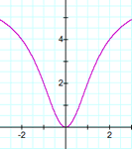 | (B)  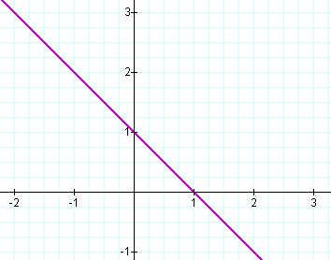 | (C)  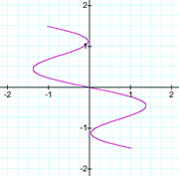 | (D)  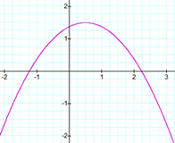

2. The Human Memory Model approximates the percentage of information the average person can recall after a certain period of months have passed by. One of the models is as follows:
$f\left(t\right)=75-6∙\ln\left(t+1\right),$where $0≤t≤12$: In this case, t is the number of months that have gone by after being presented the information (up to one year) and f(t) is the percent of the information retained. In other words, after “t” months, the average person remembers “f(t)” percent of the presented information. Round to the nearest tenth of a percent.

- What percentage was retained 2 months after being presented the information?

- What percentage was retained at the end of the first year (12 months)?

3. Convert to a logarithmic equation: 4^{x} = 4096. (no explanation required) 2. ______

A. $\log_{4}{4096}=x$

B. $\log_{x}{4096}=4$

C. $\log_{x}{4}=4096$

D. $\log_{4}{x}=4096$

4. Solve the equation. Check all proposed solutions. Show work in solving and in checking, and state your final conclusion.

$\sqrt{x+1}=x-5$

5.
(a) $\log_{3}{1=}$_______ (fill in the blank)

(b) Let ${x=log}_{3}{\frac{1}{81}}$ State the exponential form of the equation.

(c) Determine the numerical value of $\log_{3}{\frac{1}{81}}$, in simplest form. Work optional.

6. Let f (x) = x² –3x – 18 and g(x) = 3x + 2

(a) Find the composite function $\left(f o g\right)\left(x\right)$ and simplify the results. Show work.

(b) Find $\left(f o g\right)\left(-2\right)$. Show work.

7. Let $f\left(x\right)=\frac{x+4}{x-7}$

(a) Find f ⁻ ¹ , the inverse function of f. Show work.

(b) What is the domain of f ? What is the domain of the inverse function?

8. Let f (x) = e ^{x – 1} + 2.

Answers can be stated without additional work/explanation.

(a) Which describes how the graph of f can be obtained from the graph of y = e^{x} ? Choice: ________

A. Shift the graph of y = e^{x} to the left by 1 unit and up by 2 units.
B. Shift the graph of y = e^{x} to the right by 1 unit and up by 2 units.
C. Reflect the graph of y = e^{x} across the x-axis and shift up by 2 units.
D. Reflect the graph of y = e^{x} across the y-axis and shift up by 2 units.

(b) What is the domain of f ?

(c) What is the range of f ?

(d) What is the horizontal asymptote?

(e) What is the y-intercept? State the approximation to 2 decimal places (i.e., the nearest hundredth).

(f) Sketch the graph of f.

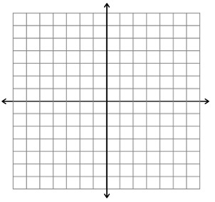

9. Solve for n.

- $\ln\left(n^{2}+18\right)=ln⁡(-11n-6)$ b) $\log_{3}\left(2x+1\right)=2$

10)
a) Use the properties of logarithms to write $5\log_{3}x-2\log_{3}z$ as a single log function.

- Express $\log_{b}x^{3}y^{2}z$ in terms of logarithms of each variable. (expand)

11)
Suppose $12,500 is invested in an account which offers 3.25% interest compounded quarterly ( 4 times a year).

- Express the amount A in the account as a function of the term of the investment t in years.

- How much would be in the account in 7 years (assuming non deposits or withdrawals are made)?

- How long will it take for the initial investment to double (round to the nearest tenth of a year)?

