- What is the equation of a circle with a center at (-3, 6) and a radius of 7?

- What is the equation of a circle with a center at (0, 9) and a radius of 9?

- What is the equation of a circle with a center at (4, 0) and a radius of 1?

- Write the equation of an ellipse with a major axis of length 8 and co-vertices (0,3) and (0,-3)

- Write the equation of an ellipse with vertices (0, 5) and (0, -5) and co-vertices (2, 0) and (-2, 0).

- Write the equation of an ellipse with vertices at (7, 0) and (-7, 0) and co-vertices at (0, 1) and (0, -1).

- Write the equation of a hyperbola with vertices (3, -1) and (3, -9) and co-vertices (-6. -5) and (12, -5).

- Write the equation of a hyperbola with vertices (0, -5) and (0, 5) and co-vertices (-2, 0) and (2, 0).

- Write the equation of a hyperbola with vertices at (-3, 0) and (3, 0) and co-vertices (0, 5) and (0, -5).

- 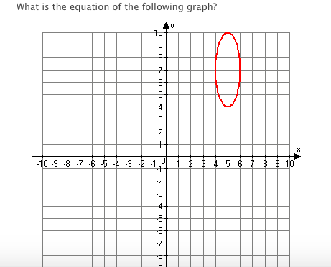

11.
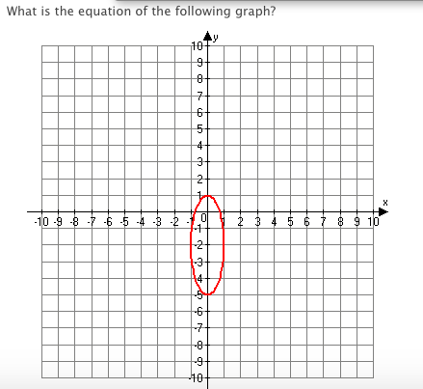

12.
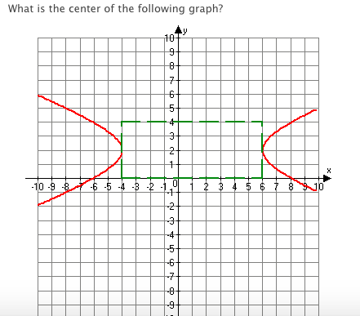

13.

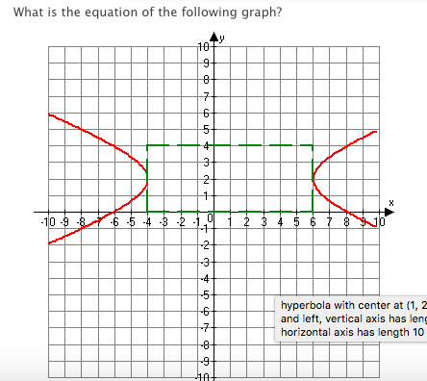

14. 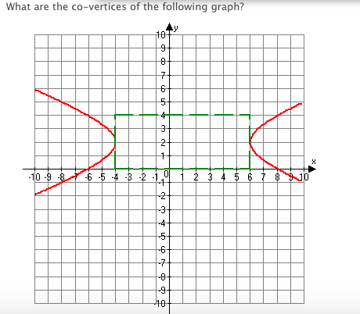

15. 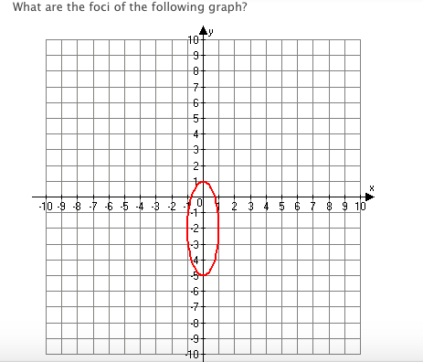

16. 