STEP 1: Understand the UML Diagram
Notice the change in UML diagram. It is common practice to leave out the accessors and mutators (getters and setters) from UML class diagrams, since there can be so many of them. Unless otherwise specified, it is assumed that there is an accessor (getter) and a mutator (setter) for every class attribute.
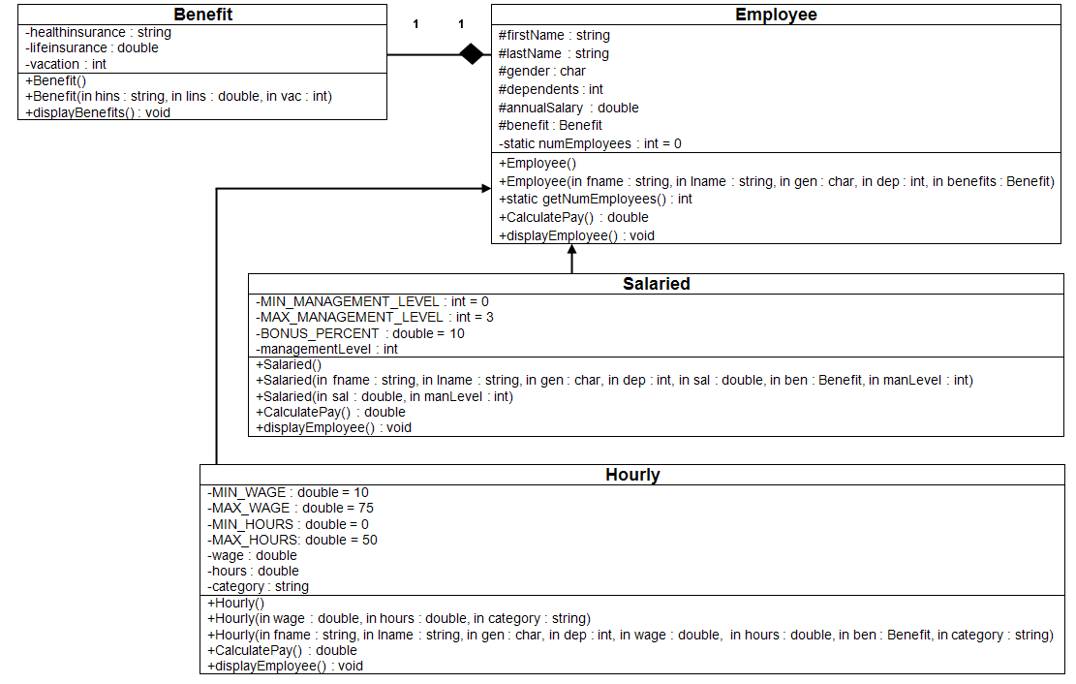

STEP 2: Create the Project
Create a new project and name it CIS247C_WK5_Lab.

STEP 3: Modify the Employee Class
- Using the updated Employee class diagram, modify the attributes to be protected.
- Delete the iEmployee interface class, and remove the reference from the Employee class.

STEP 4: Create the Salaried Class
- Using the UML Diagrams from Step 1, create the Salaried classes, ensuring to specify that the Salary class inherits from the Employee class.
- For each of the constructors listed in the Salaried class, ensure to invoke the appropriate base class constructor and pass the correct arguments to the base class constructor. This will initialize the protected attributes and update the numEmployees counter.
- The valid management levels are 0, 1, 2, and 3, and should be implemented as a constant.
- Override the calculatePay method to add a 10 percent bonus for each of the management levels (i.e., bonus percentage = managementLevel * .10). The bonus percentage should be implemented as a constant.
- Override the displayEmployee() method to add the management level to the employee information.

STEP 5: Create the Hourly Class
- Using the UML Diagrams from Step 1, create the Hourly classes, ensuring to specify that the Hourly class inherits from the Employee class.
- For each of the constructors listed in the Hourly class, ensure to invoke the appropriate base class constructor and pass the correct arguments to the base class constructor. This will initialize the protected attributes and update the numEmployees counter.
- The valid category types are "temporary", "part time", and "full time".
- The provided hours must be more than 0 hours and less than 50 hours, and the limits should be implemented as constants.
- The provided wage must be between 10 and 75, and the limits should be implemented as constants.
- Override the calculatePay method by multiplying the wages by the number of hours.
- Override the Employee setAnnualSalary method and set the annual salary by multiplying the weekly pay by 50.
- Override the displayEmployee() method to add the category to the hourly employee information.

STEP 6: Modify the Main Method
- Using previous weeks' assignments as an example, create at least one Employee, Hourly, and Salaried employee.
- For each object created, display the number of employees created.
- For each object created, write statements to exercise each of the public methods listed in the Class diagram.
- For each object created, invoke the object's displayEmployee() method to display the employee's information.
- For employee, the following information needs to be displayed:
Partial Sample output
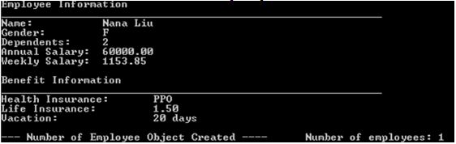
- For salaried employee, the following information needs to be displayed:
Partial Sample output
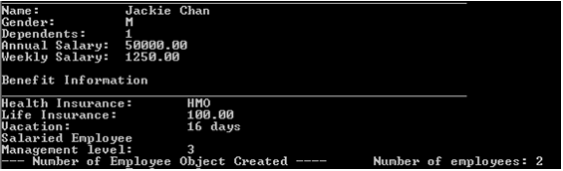
- For hourly employee, the following information needs to be displayed:
Partial Sample output
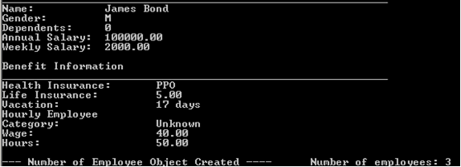

STEP 7: Compile and Test
When done, compile and run your code. Then, debug any errors until your code is error-free.
Check your output to ensure that you have the desired output, modify your code as necessary, and rebuild. Below is the complete sample program output for your reference.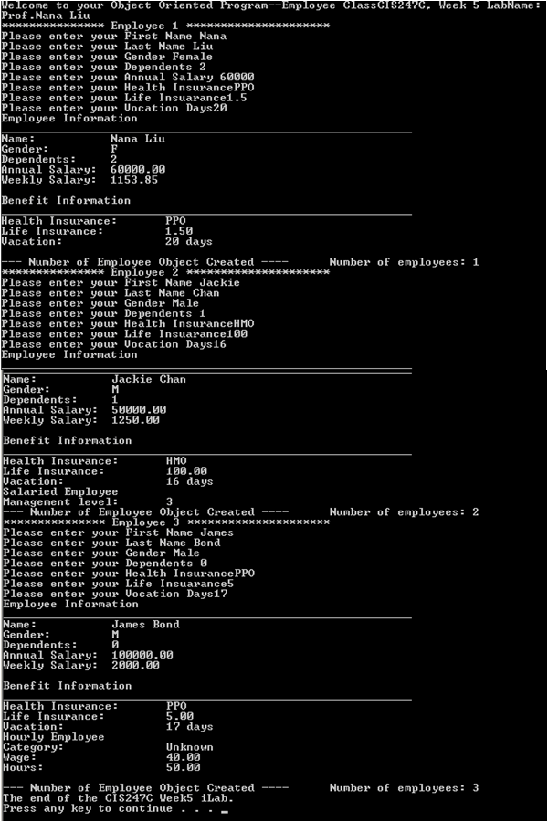

STEP 8: Submit Deliverables
- Capture the Console output window and paste it into a Word document
- Archive the files and screen shots (Project folder files Word document that contains programming code and screen shots of program output)

