Shanzhai! MediaTek and the “White Box” Handset Market

Ming-Kai Tsai looked back on 2009 with a great deal of satisfaction. His Hsinchu, Taiwan–based
fabless semiconductor company had grown to become one of the top-three global suppliers of

wireless chipsets,
the essential electronic
“brains” for
mobile telephone handsets. In the second

quarter of the ye r, the company had shipped 80 million chipsets, and the outlook for the third quarter was for 100 million, likely topping 350 million for the full year. In a global wireless handset market estimated to total 1.2 billion to 1.4 billion units,1 this was quite an accomplishment.

Over the last 30 years, mobile telephony progressed through several generations of technology. The first generation (1G) used analog signaling, and the second generation (2G) marked the switch to digital transmission. While much of the world’s attention in the first decade of the 21st century was focused on the deployment of the third generation (3G), MediaTek was confronting challenges selling its chipsets to tier-one companies like Nokia, Motorola, or Samsung, where it faced entrenched

competitors like
Infineon,
Freescale, STMicroelectronics, NXP
Semiconductors, and
Texas

Instruments. Those companies
were all chasing 3G in developed
markets. So
MediaTek offered

products for 2.5G or 2.75G, that is, 2G signaling technology that included general packet radio service (GPRS) for data handling and targeted the Chinese market where 3G was not yet deployed. The company enjoyed great success riding the explosive growth in China, as China and South Asia rapidly became the largest handset market in the world.

Yet, Tsai was also at the center of a larger controversy. A sizable number of China’s annual 600 million units of production were purported to be knock-off or shanzhai phones, what The Economist
magazine referred to as “counterfeit cool.”2 Shanzhai was literally translated as “mountain fortress”
and conjured up the image of bandits attacking travelers (the establishment). Although there was no

- Nokia’s press release of March 12, 2010, estimated the 2009 worldwide handset market at 1.26 billion.
- “Talk is Cheap—Counterfeit Handsets proliferate in China,” The Economist, November 19, 2009.

610-081 Shanzhai! MediaTek and the “White Box” Handset Market

strict definition of shanzhai, the narrowest definition applied to illegal counterfeits or knock-offs, while some broader definitions in many press accounts included local brands like K-Touch or ZTE. Quite a few white-box or no-brand phone makers had emerged, and these tended to get lumped in the shanzhai category as well. Interestingly, many Chinese consumers viewed shanzhai as a cultural attribute, suggesting an anti-establishment challenge to authority and a break with conventional ideas.3
MediaTek supplied the vast majority of the shanzhai makers with over 50% of its market share for all chipsets destined for handsets designed in China. The strategy was not deliberate, however. The company sold chips to what it thought were legitimate Chinese producers, with many of them purchasing large quantities to get better volume discount pricing. Some of those producers then resold a percentage of their chipsets on the secondary market, pocketing a profit along the way. This was a common practice in China; Intel faced the same issue with microprocessors. Also, there were often “shrinkage” problems in factories, where components, presumably misappropriated, ended up in the secondary market.

Though many established brand leaders like Nokia dismissed shanzhai products as cheap knock- offs, the rapidly growing export market from China to regions like India, Southeast Asia, the Middle East, Africa, Russia, and even Western Europe caused many who questioned MediaTek’s role to have second thoughts. Tsai was more sanguine. There was little doubt that the shanzhai market had benefited MediaTek. The question was how long the momentum would last. Should MediaTek try to grow by moving upmarket and winning the “sockets” of tier-one brands like Nokia or Samsung? These customers demanded the most of their suppliers, not only in the form of technical demands, but also on price and terms. Tsai reflected on the possibility: “It’s much harder work, and we would have to do business on their terms.”

The Mobile Handset Industry
Over the last two decades, mobile telephone handsets grew from a high-end niche market to become the most pervasive electronic devices on the planet. Industry estimates suggested that 1.2 billion to 1.4 billion units were shipped in 2009, with east and south Asia being by far the largest markets, followed by Europe and North America, and Africa coming in fourth and advancing quickly.

Mobile handsets utilized a radio network organized in cells to carry voice as well as data information. As a user moved from one cell to another, the phone would switch its transmission from one base station to another in a process known as “handover.” The first generation of handsets utilized analog transmission technology, and the phones were quite large and power hungry. The introduction of digital mobile communications in 1992, the so-called 2G technology, marked the beginning of widespread adoption. Several international standards emerged. By far the most popular was the GSM standard, which achieved widespread adoption across Europe and Asia, enabling international roaming. GSM was a pioneer in enabling short message service (SMS), also known as text messaging. This standard was updated several times to include a general packet radio service (GPRS) and enhanced data rates for GSM evolution (EDGE). Since the new standards were compatible with earlier versions, makers could enhance features and introduce new models every year.

- “Is Shanzhai Culture Piracy?” China Daily, May 4, 2009, p. 2, http://www.chinadaily.com.cn/bw/2009-05/04/con tent_7739416.htm, accessed February 2009.

2

The 3G technology incorporated wideband data communications, with much faster data rates for consumers who wanted to use the Internet. The 3G networks required massive capital investments from the carriers, who first had to bid at auction to acquire spectrum rights and then upgrade their network infrastructure to handle the much higher demands of 3G handset users. European countries led the way in 3G rollouts, while countries like China and India and many emerging markets lagged behind. The 3G systems used sophisticated technology including wideband CDMA4 (W-CDMA) for its air interface, which carried a heavy burden of “essential patents5 that had to be licensed from companies like Qualcomm in the United States, Nokia of Finland, and others.
According to the IDC Worldwide Quarterly Mobile Phone Tracker, the top-five mobile handset vendors in the first quarter of 2009 were Nokia, Samsung, LG Electronics, Motorola, and Sony Ericsson. Smartphones, handsets that incorporated Internet access and personal digital assistant functionality, were a rapidly growing subcategory, with Research In Motion (RIM), Apple, Nokia, HTC, and Samsung the leaders at the end of 2008.

Shenzhen and the China Handset Market
Shenzhen was the site of China’s first “special economic zone.” Located in the Pearl River Delta adjacent to Hong Kong, the city experienced spectacular growth beginning with the “reform and opening policy” in 1978. It soon became a hub for all kinds of production: garments, toys, electronics, and every imaginable kind of consumer product. Easy access by water and land to the growing container hub in Hong Kong made it China’s first export powerhouse region. Easy access also made the city a center for “parallel imports.” Branded goods from around the world entered China through the labyrinth of small docks, enabling small importers to avoid customs duties (9%) and value-added taxes (17%). This put Shenzhen on the map as a marketplace for all kinds of globally produced products, including electronics and mobile handsets. Parallel imports were an important mechanism even for some legitimate Western firms doing business in China, though they tended not to be understood, discussed, or even acknowledged at senior management levels.

As electronics manufacturing shifted into Shenzhen, the trade flow reversed. According to trade statistics, Shenzhen was the largest manufacturing center for mobile phones in the world, with estimated 2008 exports of 180 million units valued at US$12.23 billion, and an average export price of US$68.10. Of those, 34% were exported through Hong Kong, and others went directly to the United States, the European Union, Africa, Latin America, and South Korea. This number did not include the numbers that were believed to be smuggled out, which would include countless shanzhai phones.

An estimated 10,000 firms were engaged in the production, distribution, and sale of mobile handsets, components, or related services in Shenzhen and neighboring cities. There were several well-known retail and wholesale distribution centers, including SEG Plaza (赛格广场), Mingtong Digital (明通数码城), and Yuanwang Digital Mall (远望数码城) in Huaqiang North (华强北). Buyers from around the world came to these markets and purchased handsets for export. Retail customers also flocked to these markets to purchase.

- CDMA stands for code division multiple access, a spread-spectrum communications technology pioneered by Qualcomm, Inc. CDMA allowed a high number of concurrent calls per cell.
- “Essential patents” is a term used to denote patents that are incorporated into standards and requirement payment of a license fee to the patent owner.

3

Background on MediaTek Inc.
MediaTek started out as a spin-off from United Microelectronics Corporation (UMC). UMC was itself a spin-off from Taiwan’s Industrial Technology Research Institute (ITRI), a unique pilot agency whose role was to acquire technologies from abroad, commercialize them, and seed them into local industry. Established in 1980, UMC was Taiwan’s first indigenous semiconductor company and the first occupant of the now-famous Hsinchu Science-based Industrial Park. UMC originally set out to be an integrated device manufacturer, participating in the full value chain of designing, manufacturing, and selling integrated circuits (ICs). But the establishment and enormous success of the “dis-integrated” foundry and the design house model of across-the-street neighbor Taiwan Semiconductor Manufacturing Company (TSMC) caused UMC to spin off its IC design activities into several units. Novatek Microelectronics Corp. became a design house for panel driver ICs; ITE Technology, Inc., for chipsets; Davicom Semiconductor, Inc., for networking; AMIC Technology Corp., for memory chips; Faraday Technology Corp., an IP and design service; and MediaTek, for multimedia devices.

Tsai had been the design manager of the electronic research and service organization (ERSO) at ITRI and joined UMC in 1983 as director of R&D. From 1989 to 1994, he served as the executive vice president of a business unit that covered computer, communication, and consumer electronics. From 1994, he oversaw the development of the company’s memory, consumer, and multimedia business units. Thus, when the spin-off came, Tsai was the logical leader.

While still at UMC, Tsai recognized the rising importance of CD-ROMs to the personal computer industry as replacements for floppy disks. CD-ROMs had many electronic components inside, including controller chips that were the most expensive components of the drive. At the time, Japanese firms dominated the CD-ROM market, and Japanese suppliers produced all of the controller chips. As he moved to MediaTek, Tsai decided to make the company the top CD-ROM controller supplier.

In 1998, MediaTek produced an integrated single-chip CD-ROM controller. Taiwan-based CD- ROM manufacturers, including BTC and Lite-On, quickly adopted it. By 2000, MediaTek had garnered more than 50% of the worldwide market for CD-ROM controllers, including design wins at Toshiba, Sony, Hitachi, and LG. The company followed with new designs targeting DVD-ROMs, CD-R/CD- RW, DVD-RW, and DVD/Blu-ray DVD players. An important early design win in the DVD player market was Apex Digital, which made an inexpensive no-name DVD player that took the U.S. market by storm. Ultimately, the company was able to get design wins from global brands like Sony and Philips in DVD players as well, and it was thus well positioned to ride the rapidly growing demand in these market segments, as well as the growth in Greater China manufacturers’ global share of such devices. Company revenues grew from NT$508 million in 1997 to NT$12.86 billion in 2000.

MediaTek’s Handset Chipset Approach
For its mobile handset chipsets, MediaTek provided its customers with a reference design, a technical blueprint for the system that included both hardware and software. On the hardware side, it included a schematic and a printed circuit board layout for a typical implementation. MediaTek provided these in electronic form so that customers could easily modify them. Customers could also choose to use them directly without modification. In that case, all they had to do was add a plastic case and they would be halfway there. (Exhibit 1 shows the implementation of the MT6253 Reference Design in a typical feature phone.)

4

On the software side, the reference design included a proprietary operating system, a very specific man-machine interface (MMI) code base, and two key design tools: an emulator and a simulator. The emulator was a program that ran on a PC that duplicated the functioning of the handset. This meant that programs written for the phone would run on the emulator, and it would behave exactly as the phone would. The simulator would duplicate the software environment for the handset. MediaTek’s customers would use this to customize the software that ran on the handset. When they were done, they would have a new program that they could download into the handset. Ji-Chang Hsu, executive vice president of MediaTek’s handset business, explained: “While it’s not rocket science, not just anyone off the street can do it. You still need professional software developers. But it is true that very few people, perhaps 10 people, can do a good job by taking over what we give them and then doing a customization.”

MediaTek also provided training in using these tools. Rather than have customers come to MediaTek offices, it would send engineers out to customer sites to do a one-week training program. This was more effective because it was much more hands on. This intense support raised the capability levels within those firms, enhancing their competitiveness and time to market. The number of customers grew so quickly that MediaTek could not keep up with the training, so it focused its energies only on the top 20 to 30 customers. Knowledge spillovers took care of the rest of the customers. Small software engineering firms emerged that could take on customization projects, and a university in the Beijing area even began offering a course on how to develop handsets using the MediaTek development tools. “They can figure it out, given time,” observed Hsu.

MediaTek set high standards for its basic platform, integrating mainstream features into its base at what it called tier-one performance. Thus, its strategy was to offer audio quality better than that available on an Apple iPod, speech quality better than a typical Nokia handset, modem performance better than Nokia and so on, in its base platform as well as a host of features. (Exhibit 2 illustrates this platform approach.)

Handsets also incorporated other components that MediaTek did not supply. For these circumstances, MediaTek would do extensive testing and qualification of those components and publish the information for its customers. For example, the company did not make the camera modules for phones that could take still pictures or videos. But it did test modules that were available on the market and optimize drivers or software for them. Color rendition and image clarity were very dependent on the software used with them, so MediaTek invested extensively in R&D and testing to ensure that its designs could produce good results for its customers who were far less skilled. That meant a robustness that could survive the customers who chose to use cheap lenses instead of better- quality ones, or customers who wanted to take shortcuts. Hsu observed, “That took a much higher level of engineering on our part.”

How many of MediaTek’s customers just used the reference design and standard software implementation and shipped that model? A company spokesperson explained: “Well, they can sell just the standard design. How many of our customers are using that model? Very, very few. Because they add no value, no differentiation; because everyone is getting the same thing. This category of customer cannot survive. So they have to innovate to differentiate among themselves.”

The most capable customers tended to do a lot of engineering. The look and feel would be completely original, they might alter how the phone handled audio and video, and the menu tree in the user interface would be different. Lower-tier customers tended to keep more of the basic look and feel from the reference design.

5

A spokesperson from MediaTek gave another example of the power of the company’s building- block approach: MediaTek provided a touch-screen controller and a Chinese character recognition engine as a feature that its customers could build on. He explained:

In China, touch screens appeared much, much earlier than anywhere else. Because Chinese people are always sending short messages since they are very cheap. That is very common for the end-user. Entering short messages with a keypad is very awkward. In the early days, you saw people who were very fast, they had really fast fingers! Nowadays 60% of the phones that we sell, even at the very low end, use a touch screen. So users can write short messages.

Every year, the company would provide about 100 to 200 new features—those that it thought would be the most important. It would write the software, integrate it into the software base, and provide it to its customers free of charge. A technical marketing team collected the ideas, some from customers and some internally from R&D or marketing. Every week a new-feature development committee would meet to talk about the priorities, whether those features needed to be implemented or not. The committee would prioritize them and then decide which ones to go with. Then engineers would implement them and release them to the code base. (A sample feature list is shown in Exhibit 3.)

MediaTek’s customization model was particularly useful for those customers who wanted to tailor handsets for specific clients or carriers. It provided a feature menu that engineers could select from and then quickly implement. With MediaTek taking care of the handset engine, the entire development cycle for a feature phone was dramatically shortened from 9 to 12 months to as little as 3 months. Projects that formerly took a large development team with project management skills were transformed into simple assembly and programming projects that a few engineers could do.

The White-Box Model
Acer Inc., a pioneering Taiwan-based PC manufacturer, probably laid the foundation for the white-box model while trying to solve a problem. It manufactured PCs in Taiwan and exported them to the North American market via containership to the port of Oakland, California. This trip would take almost three weeks, and during that time, the rapid declines in PC market prices meant that a shipment would lose 1.5% of its value per week. This was a significant percentage of Acer’s profit margin. The company solved this problem by inventing a modular system that it dubbed “Acer UniLoad.” It would manufacture a desktop PC chassis that included the metal case, power supply, and floppy disk drive. These components were relatively stable in value, so it could ship them by container freight. It would manufacture the electronic motherboard, which contained most of the electronics of the PC except the microprocessor, and ship it by air to California. At its San Jose office, the company would receive the cases and motherboards, and then go to a local Intel distributor to purchase microprocessors and disk drives at the latest market price. Acer produced a video that explained how two workers with less than $12,000 in test equipment and a workshop the size of a two-car garage could assemble 80 PCs a day.

While Acer was not particularly successful in the U.S. market at the time (1991–1995), the UniLoad system enabled an army of mom-and-pop shops across Latin America and other less developed markets around the world to begin producing PCs with their own or no brand.

The term white box really came into prominence when Intel Corp. introduced its ATX platform. Intel was increasingly frustrated with the lagging pace of introduction of motherboards that would support its latest microprocessors. It reconciled this by introducing a new standard form factor dubbed “ATX,” which provided a complete mechanical form-factor specification for a desktop PC or server.

6

Perhaps it got the idea from Acer, or maybe it came up with it on its own. In any case, ATX specified where each of the components, such as the microprocessor or memory cards, should be physically placed, as well as the connectors for peripherals such as hard disk drives and the location of expansion card slots and mounting holes. The specifications, engineering drawings, and complete bills of materials were available directly from Intel.

Intel entered the motherboard business as well. It could coordinate motherboard introductions with the availability of its latest generation microprocessors. Thus, a company like Dell could use Intel-manufactured motherboards and announce new product availability on the same day that Intel announced availability of its newest microprocessors. Intel was not as interested in making money in the motherboard business as it was in commoditizing all the components of the PC that it did not manufacture. And by timing the introduction of motherboards with its microprocessors, it could pace the market to its liking.

The introduction of ATX had several effects in the marketplace. First, it standardized and commoditized motherboards, power supplies, PC chassis, and every piece of hardware besides the microprocessor. Second, it leveled the playing field in systems competition, giving an advantage to any company that would use the Intel reference design. The attendant commoditization had a third effect. It significantly lowered the entry barriers to getting into the desktop PC business. System integration skills were no longer required, as all the subsystems and their interfaces were completely codified. Firms small and large flooded into the PC business. Sony Corp. entered the market with its VAIO line using Intel-supplied ATX motherboards and an outsourced assembler. Many small shops also entered the business. In Silicon Valley, California, almost every small strip mall had a shop, often run by Asian immigrants, who would assemble PCs with no brand or a brand of their own making. Large retailers and value-added resellers in the United States created their own brands. Across Asia and around the world, countless small white-box PC assemblers emerged, fueled by inexpensive ATX motherboards sourced in Taiwan. At its peak, the white-box market in aggregate constituted the third-largest brand of PC. The economies of scale and market consolidation eventually reduced the numbers significantly, but the white-box model had become firmly established.

Shanzhai White-Box Handsets
Five years ago, there were no counterfeit phones. . . . You needed a design house. You needed software guys. You needed hardware design. But now, a company with five guys can do it. Within 100 miles of Shenzhen, you can find all your suppliers.
— Xiong Ting, sales manager, Triquint Semiconductor, mobile phone parts maker6
Mirroring what happened in the PC business, there was an explosion of small handset makers. Some, like Benephon or Anycoll, established their own product lines and brands and grew rapidly. Other no-name white-box handsets, which people started referring to as “shanzhai,” quickly grew to become a major segment of the Chinese market. Knock-off brands like Nckia, Nokir, Nokig, Sumsung, Samsing, and HiPhone showed up along with Blockberry (that ran Windows Mobile), Sunyericcsun, iPone, iPone Air, and Souy Ericssou.

Given market uncertainties, manufacturers could experiment by first producing about 1,000 handsets and sending them to the local wholesale markets. As sales numbers came back in about two weeks, they could refine their forecasts and produce more. The complete product life cycle of a handset was typically three to five months, and the entire supply chain was geared to support this rapid market evolution. (Exhibit 4 shows some of the complementary companies that enabled a

- David Barboza, “In China, Knock-off Cellphones Are a Hit,” New York Times, April 28, 2009.

7

robust supply chain for both small handset makers and shanzhai.) MediaTek’s total solution approach was described as empowering a giant army of ants, an army that would make the life of incumbents like Nokia miserable.

Did MediaTek target the shanzhai makers? As mentioned earlier, it had the resources to support only its top 20 to 30 customers. How then did it develop such an effective distribution network to all the small shanzhai makers, many of whom operated out of cubicles in the wholesale markets? Most of MediaTek’s sales were to larger, more formal mobile phone makers. A white-box cell phone CEO explained, “If your [company] size is not big enough, you may not get the chips [you need], but you can go to those mobile phone companies who can get them. They may only need 10 million chips themselves, but [they] can report that [they ordered an] amount of 20 million; the extra chips will flow to the white-box cell phone companies. They resell the chips and earn a lot of money!” This arbitrage increased and became an open secret in the industry. MediaTek could not control the ultimate destination of its chips, nor was it necessarily in its interests to control them.
Market followers like Linley Glennap suggested that the shanzhai segment was much larger than generally thought: “We believe that most handset-market estimates are missing the large number of unlicensed handsets produced in China. These ‘shanzhai’ phones are produced by many small suppliers, some even operating out of apartments. This market is largely supplied by MediaTek, which provides complete handset chip sets and reference designs to the shanzhai vendors.” 7
Tsai had a different view:
People really don’t understand the Shanzhai Ji issue. The whole license issue is really not central. For GSM phones, it is easy to get a license. You only have to apply, and it doesn’t cost much at all. The problem is that many small companies don’t know they need to get a license.

The other thing people don’t understand is where the Shanzhai Ji makers get their supply of components. MediaTek does not deliberately supply them, but in a market like China, it is also almost impossible to control the flow of grey market materials. Component supply tends to spill out of legitimate suppliers. The training and tools that we provide to our legitimate customers are really only intended to help them. But when engineers walk out the doors of those companies, it is really impossible for us to control what they do with their know-how. More than anything this is a cultural phenomenon, and it is not unique to China.

A Market for Innovation
The market is really bloody because everybody is getting the same starting point. They have to differentiate to sell their product for a little more money than others. That’s why they have to innovate!
— Ji-Chang Hsu
With the stream of new features that MediaTek and its open platform for software customization provided, white-box makers differentiated themselves on unusual features not typically found in tier- one brands. Many had two subscriber identity module (SIM) card slots so that the phone could operate simultaneously with two different phone numbers. This feature was particularly popular in India where consumers often shopped for different rate plans and used one plan (and SIM) for certain calls and the other SIM for another, perhaps a discounted prepaid card.

- http://blog.linleygroup.com/2009/08/handset-market-bigger-than-expected.html.

8

The “Farmers’ Thunder” shanzhai handset featured extra-large loudspeakers so that farmers could set them down on footpaths and hear them ring from a distance.8 Teenagers found these handsets convenient substitutes for boom-box portable music systems. Other handsets incorporated bright LEDs so that they could be used as flashlights or were tailored to the elderly, with large keys, large letters, and high-volume speakers.

Shoppers in the shanzhai markets could even select features they wanted in their phones. An engineer would simply go to the development system, load the feature, and download the new software into a waiting handset. Language customization was important, especially for grey-market exports to other countries. Products were also often tailored for export markets that might be too small for a tier-one brand to justify a separate development effort. The Economist reported: “Chinese grey-marketers have secured half the Ghanaian market with phones that can do nifty things like receiving television broadcasts, says BDA. In Kenya, Chinese models (including an imitation BlackBerry) feature images and quotes from the country’s favorite grandson, Barack Obama. A model in the shape of a dagger is popular in the Gulf States.” 9

Export from China was an easy way for MediaTek to extend a global reach. Speaking about the company’s first quarter 2009 earnings on a conference call, company CFO Ming-to Yu reported: “For the export, I think overall we export from China to other countries; our estimate, I think, is over 40% right now. . . . Last year the export number I think it’s probably around 35%. In first quarter our estimation I think is already over 40%. So, the overall sales in the emerging markets like Middle East, South East Asia, India are all very strong.”

Analysts following the company were watching for signs that MediaTek might break into selling its chipset solutions to Taiwanese ODM firms that designed handsets for tier-one brands. Responding to a question on what percentage of its shipments were to the global top-five brands versus the Chinese shanzhai makers, Yu responded, “That piece is very small; I believe nearly 95% goes to our China customers.”
Responding to an analyst inquiry about whether MediaTek planned to sell its newly introduced smartphone solution to tier-one brands, Yu replied, “I think for the smartphone we will target our current customers first. And, of course, I think we will choose those customers that have a much bigger operation and a good connection with the operators [to start with]. So that will be our first choice.”10
However, staying with its Chinese customers didn’t mean that MediaTek had no chance to get into leading brands’ supply chains. In the MediaTek’s 2009 third-quarter earnings conference call, Yu commented,

A few months ago, Vodafone announced that in two models [launching in Europe and emerging markets for this Christmas season], they’re using our chips and that actually is a trend. There are more and more operators who want to outsource using Chinese handset makers and are using our chips. For the Tier one, we also see the trend that there are more and more Tier one handset makers who want to outsource more to third parties. For example, Motorola, they have a strategy of . . . for the mid to low-end handset using ODM [makers]. So I think that actually will give us more opportunity to get into Tier one.

- Benjamin Chiang, “China’s ‘Bandit’ Cell Phones—The High-Tech Golden Egg with ‘Taiwan Inside,’” Commonwealth Magazine, December 3, 2008.
- “Talk is Cheap—Counterfeit Handsets proliferate in China.”
- MediaTek Q1 2009 Earnings Conference Call, April 29, 2009, CQ FD Wire, via Factiva, May 25, 2010.

9

MediaTek’s Competition
As major international handset chip suppliers are shifting their focus to the 3G market, MediaTek has been gifted with more opportunities of entering the global supply chain with its 2.5G/2.75G solutions.
— Cage Chao and Meiling Chen11

From a technology capability standpoint, MediaTek products were in some respects technology followers. They lagged behind the products of tier-one players like Infineon, ST-Ericsson, Freescale, or Qualcomm in the ability to provide 3G wireless capabilities. As a consequence, they did not sell much to top-tier branded handset makers like Nokia, Samsung, Sony Ericsson, Apple, or RIM (see Exhibit 5 for a list of suppliers).

From an integration standpoint, MediaTek appeared to be playing the same game it had in CD- ROM and DVD chipsets: consolidate as much function as possible into low-cost chipsets that were simple to design with. So while Nokia and Apple chased after 3G, MediaTek was content to feed the feature phone market with 2.5G or 2.75G solutions: solutions that were not the most advanced technologically, but packed with features that were leading edge only a year or two ago. As a consequence, its customers included many shanzhai makers.

Thus, while tier-one chipset suppliers worked with their best customers to incorporate more and more sophisticated capabilities and better performance, MediaTek’s customers grew rapidly by gobbling up the low end of the feature phone market. This probably added to a certain lack of respect in the eyes of a market leader like Nokia. Nonetheless, MediaTek chipset design wins continued to increase, both among tier-two brands and among carrier-branded handsets. (See Exhibit 6 for examples of design wins.)

Tsai’s Dilemma
“We are not happy to see shanzhai mobile phones thriving,” says Huang Xun, communications manager for Nokia China. His company, he says, works hard to attract low-end Chinese consumers and “stop the erosion of the market by shanzhai phones.” He wants better regulation, as the emergence of look-alikes “stains our brand and threatens our reputation.” 12

Arguably, MediaTek’s integrated solution approach to the mobile phone handset market had unleashed the shanzhai phenomena, as well as a new wave of innovation at the low end of the market. Millions of consumers who had never before owned a mobile handset had a plethora of affordable choices from hundreds of makers. And those makers had generated innovative products tailored to the needs of niche segments that were ignored by tier-one brands. MediaTek chipsets were now in handsets sold in 102 countries. (See Exhibit 7 for a map of MediaTek’s worldwide presence and Exhibit 8 for a comparison of shanzhai and normal handsets.)

Should MediaTek do something to cut supply to illegal knock-off phone manufacturers? Could it even do so if it tried? How many of its current Chinese customers could eventually establish a good brand image and continue to thrive, like Acer and ASUSTek in the PC world? How many of them would actually die out? Tsai had a different view:

- Cage Chao and Meiling Chen, Digitimes, December 2, 2000.
- Gady Epstein, “Counterfeit Cool: Who needs Nokia? The spirit of shanzhai rules the phone-pirate’s cove in Shenzhen,”
Forbes.com, February 12, 2009, http://money.canoe.ca/Forbes/2009/02/11/pf-8352971.html.

10

“Knock-off” phones are really a transient phenomena. In the beginning, those makers had very limited capabilities to make cell phones, so for them, 100% imitation and copying of a brand was the only way for them to survive. But over time, as they learned, both from the market, and by using the MediaTek turn-key solution, they could provide more and more innovative features on their own without resorting to copying. So they don’t need to make knock-offs anymore. The margin on pure knock-offs is very low, so it’s not worth it for makers to pursue this kind of business anymore, it’s better to innovate!
Maybe the answer for MediaTek was to help its Chinese customers be more successful against the tier-one companies worldwide.

A more interesting strategy would be to sell to the tier-one manufacturers themselves. MediaTek had achieved enormous economies of scale with its chipset offerings, and the shanzhai makers had certainly put pressure on tier-one chipset suppliers like Texas Instruments and Infineon. CFO Yu observed, “For tier one brands to choose a new supplier, it will require some time for them to feel comfortable with MediaTek.”13 Maybe Tsai should try to convince Nokia to use MediaTek solutions for its bottom-of-the-pyramid handsets. But if tier-one brands used MediaTek chipsets, would they lose any remaining differentiation that they might still have? What kind of terms would they impose on MediaTek, and how badly did Tsai really want that business?

- Robin Kwong, “MediaTek sets sights on challenging U.S. chip makers,” Financial Times, July 8, 2009, p. 16.

11

610-081
-12-
Exhibit 1
MediaTek Hardware Reference Platform
Source: Company presentation.

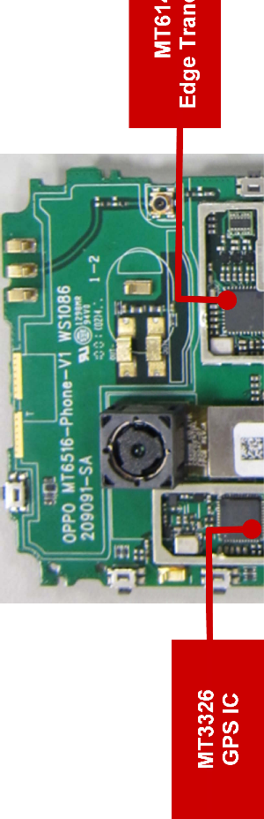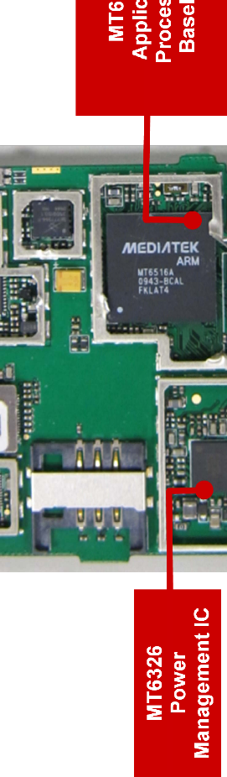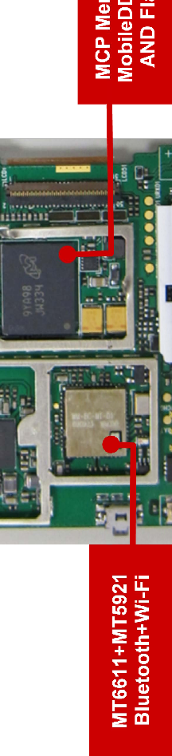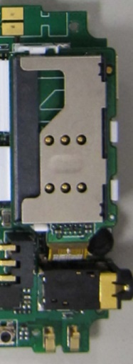
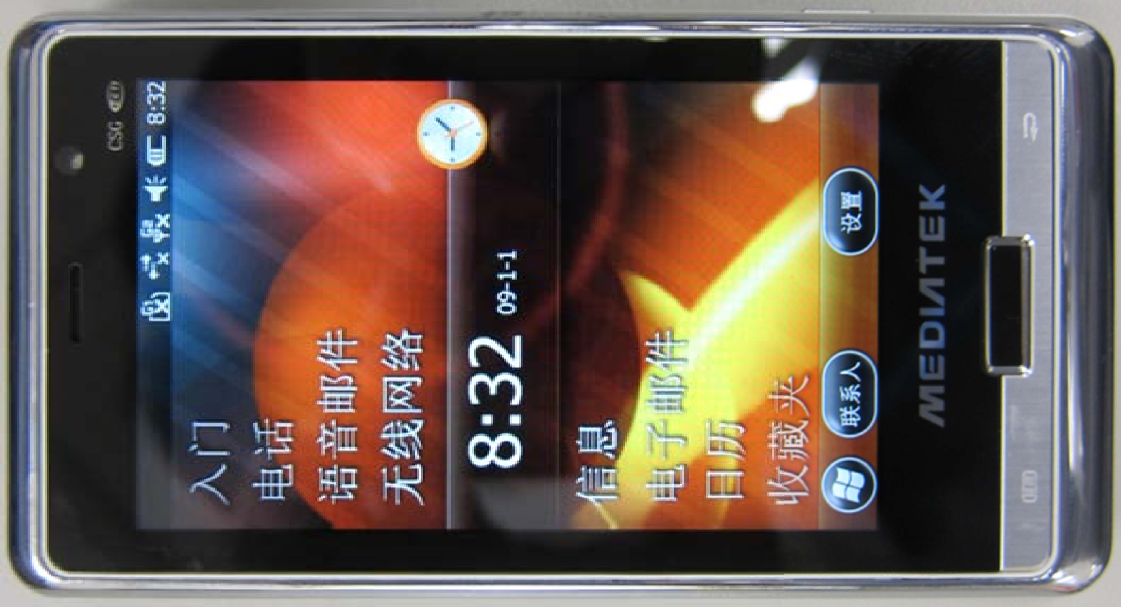

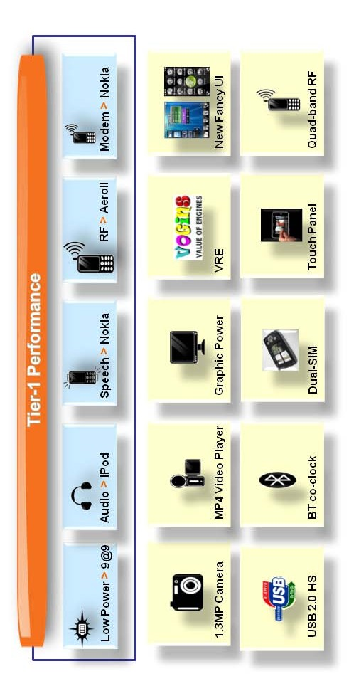
610-081
-13-
Exhibit 2
Integrating Mainstream Features at Tier-One Performance
Source: Company presentation.

610-081 -14-

Exhibit 3 Popular Feature List

Feature Name Description

Background MP3 play Support MP3 playback in the background in pioneer stage

Touch panel user interface (UI) and handwriting input PDA-like touch panel UI and handwriting recognition feature Dual subscriber identity module (SIM) standby Dual SIM, dual standby, single talk
Fancy UI: “Venus” UI Home screen: touch-oriented home screen with widgets

Video/camera feature Camcorder application + up to 5M pixel DSC, DVD player quality video with some advanced DSC features like face detect, best shot, high ISO sensitivity

Bluetooth application FTP, A2DP, name card (business card) sync

C dynamic runtime environment Dynamic runtime environment technology provided by Vogins

WAP and HTML browser Obigo Q03c/Q05A browser works with MII App application

Webcam support for Skype Use phone’s camera as a webcam for Skype and MSN

Media player Support SEPARATED or INTEGRATED audio and video playback, multiple playlist, streaming to comply with European operators’ requirement

Audio playback and FM via BT SCO link FM, music and ring tone through BT speech channel; can use low-end BT headset to listen to music Alarm and autopower on/off Provide multi set points for alarm, and on/off setting
eBook reader eBook reader, support to read Palm book (.pdb) & .txt in handset

e-mail e-mail client application in mobile

QQ-IM Mobile version of QQ, a popular instant messaging application in China

Source: Company presentation.

610-081 -15-

Exhibit 4 Complementary Components Supply Chain

Products Suppliers Major Advantages

Handset system chips
MediaTek Chipset platforms provide a turnkey solution that targets low-end handset models to middle-end multimedia models.
Other than the main chip (baseband plus multimedia application processor), MediaTek also provides assorted peripheral chips such as Bluetooth, WiFi, GPS, etc. Complete reference designs effectively reduce technology entry barriers. Low- price solutions allow shanzhai companies without an R&D capability to offer handsets with unique functions and shorten time to market.

Support chips Richtek, PixArt, Orise
Technology, EETI
Taiwan IC design houses’ offerings range from power management ICs, LCD panel driver ICs, sensor ICs, to touch panel ICs. These IC chipsets offer excellent price/performance and help shanzhai companies to provide low-cost yet innovative products.

IC channels WPG Holdings, WT Microelectronics, Arrow Electronics
Large electronic distributors support diverse product lines through a broad network of sales offices, and offer value-added bundling solutions for customers. Effectively meets the shanzhai makers’ demand of one-stop shopping and quick time to market.

Handset panel Wintek, Innolux, Giantplus Provide high-quality, small to midsize panels, from super twist nemantic (STN), thin-film transistor (TFT), to touch panel
displays. This diversity of offerings gives shanzhai makers, which tend to feature products with small quantities and high variety, the flexibility they need.

Handset components
Merry Electronics, TXC Corp., HarvaTek, Unity Opto
From multifunction receivers for mobile phones, quartz crystal units, oscillators, to LCD backlight components that help make possible the production of handsets with a wide selection of features.

Handset circuit board
Plotech, Tripod Technology Provide low-cost, high-density interconnect (HDI) printed circuit boards. Taking advantage of the vendors’ experiences in making diverse board designs, shanzhai makers can produce different models within very short time frames.

Source: Compiled by casewriter.

610-081 Shanzhai! MediaTek and the “White Box” Handset Market

Exhibit 5 Global Handset 2G/3G Chipset Suppliers

Handset Vendor Major Chipset Supplier Secondary Chipset Chipset Pricing Range
Supplier
Apple | Infineon |  | High
Palm | Marvell |  | High
RIM | Freescale |  | Mid–High
HTC | Qualcomm |  | Mid–High
Nokia | TI, ST-Ericsson | Qualcomm, Broadcom | Low–Mid
Samsung | Qualcomm | ST-Ericsson, Broadcom | Mid
LG | Qualcomm | ST-Ericsson, MediaTek | Mid
Sony Ericsson | ST-Ericsson |  | Mid–High
Motorola | Freescale | Qualcomm, MediaTek | Low–High
Japan-based vendors | Japan-based IDMs | Qualcomm | Mid–High
China white-box handset vendors | MediaTek | Infineon, MStar, Spreadtrum | Low–Mid
Source: Compiled by casewriter.

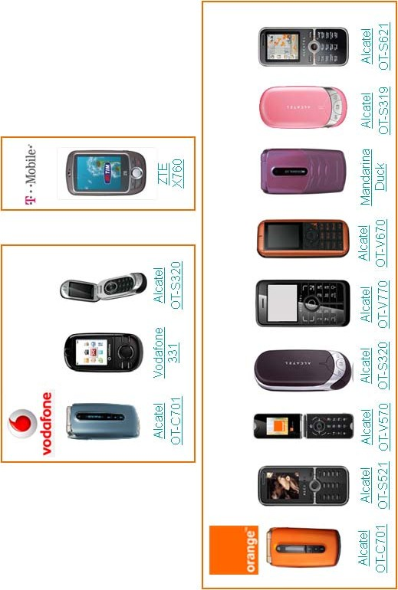
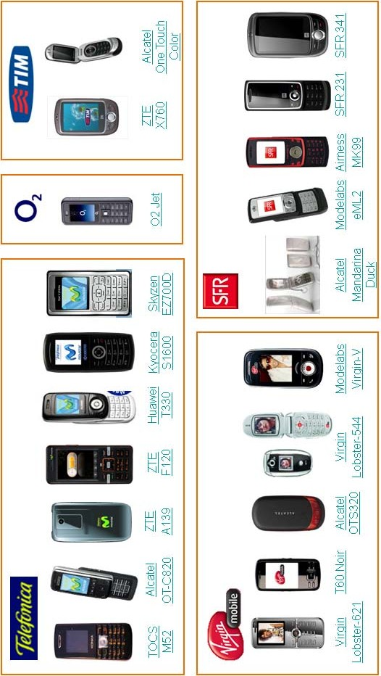
16
610-081
-17-

610-081
-18-
Exhibit 7
Worldwide Presence for Handsets Incorporating MediaTek Chipsets: 102 Countries
Source: Company presentation.



Shanzhai! MediaTek and the “White Box” Handset Market 610-081
Exhibit 8 Comparison of a Shanzhai Handset to a Normal Handset
Shanzhai Handsets Global Market Handsets

Products Some are copies of the originals, but most models are equipped with innovative functions and features. With their short time to market, shanzhai handsets may better suit the needs of consumers, even though quality and reliability may be less than global standards.
Products are designed for the mass markets with reliable quality. Market responsiveness may be slower because of relatively longer development cycles and desire to address larger segments.

Channels Handset retailers reap the largest percentage of the profit in the value network, often several times that of global branded handsets. Favored by channels such as TV shopping.
Provide stable profit margin shared by every layer of the supply networks. Rely on normal channels, but retailers are less powerful than those that sell shanzhai handsets.

Suppliers Suppliers have to be able to meet demands of low price, small quantities, and good enough technology. Order quantities are small and come with higher financial risks.
High entry barriers to become a qualified supplier due to the complicated certification process. Once certified, one can enjoy a longer term cooperative relationship with large order volumes and smaller financial risks.

Brands and after-sale service
Little to none. Consumers have little or no protection.
Products possess high brand awareness and much better after-sale services.

Government attitudes The Chinese government has been
trying to “guide” the market to a more normal route.
Manufacturers pay taxes, have legal access to the network, and comply with patent law.

Source: Compiled by casewriter from press accounts.

19

