1) find the domain of the function below.
y = 2(3)^{x}
All negative numbers.
All positive numbers.
All real numbers except 0.
All real numbers.

2) Find the range of the function below.
y = -2(5)^{x}
All negative numbers.
All positive numbers.
All real numbers except 0.
All real numbers.

3) Which of the following graphs shows the exponential function below?
y = -3(2)^{x}
A.  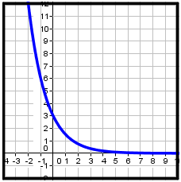 | B.  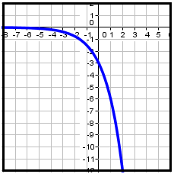
C.  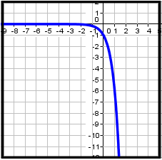 | D.  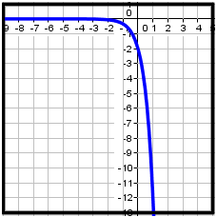

Which of the following graphs shows the exponential function below?
y = (1/4)^{x-1}
A.  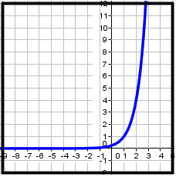 | B.  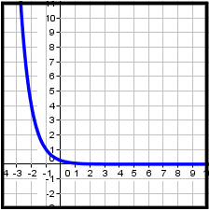
C.  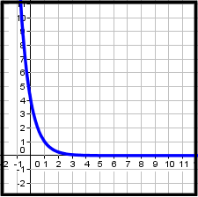 | D.  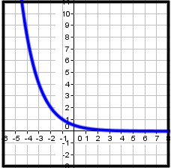

5) Which of the following is an exponential decay function?
A.
B.
C.
D.

6) Which of the following is an exponential growth function?
A.
B.
C.
D.

7) Solve the exponential equation shown below.
3^{2x - 2} = 81
x = 5/2
x = 1
x = 3
x = 4

8) Solve the exponential equation shown below.
(1/4)^{x}=16^{x - 3}
x = 2
x = -2
x = ½
x = -½

9) Solve the exponential inequality shown below.
3^{n - 3} > 27
n > 4
n > 6
n > 0
n > 7

10) solve the exponential inequality shown below.
(1/27)^{4x} <81^{x - 1}

x > ¼
x < ¼
x > 1/16
x < 1/16

