Memorandum

To: Dr. Brad Herzog From: Kelly Sievert Date: October 9th, 2015
Subject: Problem Analysis

The problem that I would like to shed light on encompasses the City of Saginaw, and their lack of police force to help keep people safe. Crime rates are increasing, and the police force is decreasing, which is not an ideal equation to have. Being that I live in the Saginaw Township area, I am still concerned over the cuts being made to police enforcers. The police keep the community safe, and fight to keep people away from the dangers of criminals. Without them, the community would be exposed to an increasing amount of crime and violence.

A lack of police force can cause numerous issues in the community. And with those causes, come the inevitable side effects. If there is not enough police enforcement on our streets, businesses may fear they have to close down in the Saginaw area. Less people are choosing to live in the city because of the crime, and lack of police presence. Each of these causes has effects on the community. One of these effects includes an increased crime and violence rate in Saginaw. The property value of houses in the city are decreasing because of the undesirable location due to crime, and with the police being laid off, crime is increasing and law enforcement is decreasing. Additionally, businesses do not want to occupy buildings in the City of Saginaw where there is a smaller customer base, and more crime.

This is a large issue to confront, and it will not get any better until something is done. The solution to this problem is generating money to hire new police officers to help keep the City of Saginaw safe.

Problem Analysis Report Kelly Sievert
Saginaw Valley State University Grant and Proposal Writing – RPW 320
Dr. Brad Herzog October 9th, 2015

Decreased Police Force Causes Negative Effects for Saginaw

Background Information and Problem Being Faced
The City of Saginaw was once a flourishing city with a focus on jobs and growth. The growth of Saginaw began during the 1850s; however, it was not until after the Civil War period that it officially began to develop. Between the 1860s-1880s, Saginaw’s position on the river gave it the title of the “lumber capital of the world,” with it providing lumber to areas around the world. The lumber business gave way to the initial start up of Morley Brothers, “the largest wholesale hardware company east of the Rocky Mountains.” The Saginaw River was an important feature in the area because it determined the settlement of the city and allowed access to the Great Lakes, pushing business (City of Saginaw, MI, 2015).
Fast forward to the 1990s. In 1995, 500 people were laid off from the Saginaw Steering complex, which was the beginning of the job losses for Saginaw. Then, in November of 1998, the General Motors Plant that was located in Saginaw closes its doors. This facility, better known as “Delphi Automotive Systems,” laid off a total of 2,700 employees, which was a major hit for community of Saginaw. The General Motors plant was what kept Saginaw thriving, people working, and crime down. For three quarters of a century, Saginaw was once a leader in providing “aluminum and iron castings for engine blocks, transmissions, and chassis systems” for cars, but now in the 2000s, the City of Saginaw is a shell of its former self when it comes to the employment of people, and positive activity in the city itself (White, 1998).
Today, residents of Saginaw are left with increasing crime rates and reports of violence on a regular basis. Police enforcers are now left with the task of keeping the community safe, even if there are not enough officers to go around. Figure 1 below illustrates the crimes per square mile, and contrasts Saginaw’s crime with Michigan’s overall crime. Figure 2 illustrates a

similar idea, except this graph shows the violent crime comparison between Saginaw and Michigan. As both graphs show, crime and violence is much higher in Saginaw when compared to the overall state of Michigan.

FIGURE 1
Crimes Per Square Mile*
160
140
120
100
80
60
40
20
0
Loca3on
Saginaw Michigan

 | 142
 | 142 |  | 34

*Crimes Per Square Mile [Chart]. (2015). Retrieved from http://www.neighborhoodscout.com/mi/saginaw/crime/

FIGURE 2
Violent Crime Comparison*
Per 1000 people
25.00
20.00
15.00
Loca3on
10.00
5.00
0.00
Saginaw
Michigan

 | 20.02
 | 20.02 | 4.50

*Violent Crime Comparison [Chart]. (2015). Retrieved from http://www.neighborhoodscout.com/mi/saginaw/crime/

Evidence of the Problem

Causes

- People are moving out of the City of Saginaw

With the crime rate increasing, people are beginning to migrate out of the City of Saginaw. Residents sit in fear, wondering when the next act of violence will start. Residents such as Garnet Lewless are noticing an evident change in the neighborhood compared to two decades ago. The increasing violence is causing residents to literally take cover. Lewless, who was living in her basement on North Bond in Saginaw at the time, says she had to move to her basement because “There was just too much going on around me. A young man with an AK-47 opened fire in my driveway.” At a time like that, it only makes sense to have an increased force of officers on duty who can be available at a moment's notice to take care of crime, but a lack of officers is preventing that.
With the movement of people out of Saginaw comes the eyesore and potential danger of abandoned houses. These abandoned houses can be places for gangs to hang out and cause even more trouble for the neighborhoods in the City of Saginaw (Tower, 2014b). If crime decreased, then there likely would not be a need to tear down as many houses, as more people would feel safer to live in their respective neighborhoods. The money used to tear down these houses could have been put towards a useful cause, such as education or repairing roads, but instead it’s being used on demolishing abandoned houses. If more police officers were out patrolling, there would be a decreased chance for violence to happen, which then in turn would incline more people to live in the city, leading to less abandoned houses for crime to happen in.

- Businesses are becoming targets for crime

While it is arguable that crime can happen anywhere, businesses located in the City of Saginaw are experiencing the lack of patrolling near their stores. For example, a triple shooting occurred in the City of Saginaw in June 2015. This shooting caused notices to be taped to two bars: Terry’s Place and Club Neutral. These notices put out by the City of Saginaw explained to the businesses that they were to be shut down immediately for the safety of their customers. As a result of the shootings, three people were injured. This likely could have been prevented, as the Saginaw Police Department’s headquarters is only located two blocks from Terry’s Place. There are not enough police officers to go around, and the injury of the three victims may have been prevented if there had been officers on call (Tower, 2015).
Meanwhile, another City of Saginaw business named “Pops Skateshop,” was faced with a burglary crime in September of 2015. Owner, Jerry Wilson’s store was robbed of skateboards, hats, and other merchandise totaling over $4,000. This act of crime also could have been preventable if a police officer had been patrolling the streets of Saginaw. If the officer saw the burglars, he or she may have been able to catch the culprit at the scene (Devereaux, 2015).
Shown below is Figure 3, which compares the property crime rates between Saginaw and Michigan overall.

FIGURE 3
Property Crime Rate
Comparison*
Per 1000 people
50
0
Loca3on
Saginaw Michigan
*Property Crime Rate Comparison [Chart]. (2015). Retrieved from http://www.neighborhoodscout.com/mi/saginaw/crime/

- Businesses move out of Saginaw, less activity in the City

When there is the risk of becoming a victim of a crime, people may be wary to shop at the stores in downtown Saginaw, as there are other viable options throughout Saginaw County. Some businesses are closing their doors because they do not have enough business to sustain themselves. As of 2013, Ewald’s Bar located in the City of Saginaw has since closed its doors after 61 years in business. It seems people are not going into the city as much as they used to, and businesses are clearly suffering (Tower, 2013).

Effects

- There is an increase in the crime/violence rate

Saginaw is not known for being a safe city, and that is nationally known. As a direct result of having less police enforcement on the roads, crime is increasing. In 2013, according to FBI statistics, Saginaw was named the “third most violent city in the country” (Devereaux, 2014). This should serve as a red flag for city officials. Saginaw is being nationally labeled as the third most dangerous city in America, so why not do something about it? A step in the right direction would be hiring additional police officers to help combat the crime. To make matters worse, around that same time in 2013, 4 officers of the Saginaw Police Department were laid off due to the city’s lack of budget (Shannon, 2013).
- House values and sales suffer in the city

When crime skyrockets in the city, people are forced to take cover, and even find new means of living. Whether that is through selling their house and moving to a new area, to renting, house values and sales are on the decline. With the initial increase in sales and sale prices after 2009 in both of the following figures, the housing market in Saginaw has always been slightly

inconsistent. This may be a result of the increase in violence in the City of Saginaw and less desirable areas, which dictate for lower sale prices on homes.

FIGURE 4
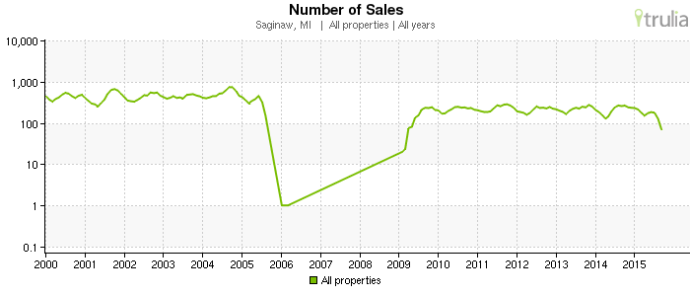
* Number of Sales [Chart]. (2015). Retrieved from http://www.trulia.com/real_estate/Saginaw-Michigan/market-trends/

FIGURE 5
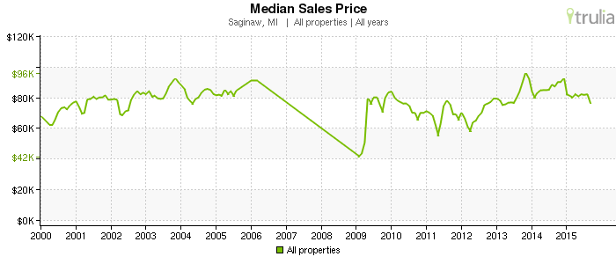
*Median Sales Price [Chart]. (2015). Retrieved from http://www.trulia.com/real_estate/Saginaw-Michigan/market-trends/

- Less people are moving to the City of Saginaw

The safety of a city is one of the main things to think about when moving to a new area. With Saginaw being labeled as one of the most violent in the country, it just serves as a warning for those potentially thinking of moving to Saginaw. This city strives to show off a good impression, but falls short when there is so much violence and crime. “In just five decades, the city [of Saginaw’s] population dropped from nearly 100,000 in the 1960s to fewer than 52,000 by the 2010 census” (Tower, 2014a). Figure 6 below depicts the population shift, where the number of people living in the City of Saginaw was much higher (61%) in 1950, compared to that of 2010 (29%). The population is now shifting away from the city, and is moving elsewhere. And this shift appears to be the direct result of the increasing crime rates in the city, as houses are becoming more and more abandoned.

FIGURE 6
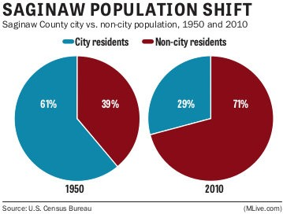
*Tower, M. (2014, January 26). Saginaw Population Shift [Chart]. Retrieved from http://www.mlive.com/news/saginaw/index.ssf/2014/01/i_used_to_live_there_series_wi.html

Conclusion

After taking a look at whether or not new police officers should be hired to offset crime in the City of Saginaw, there is a clear need. Between the shifting population changes from city to non- city residents, to the sale prices of homes declining; these are just a few of the reasons why people are choosing to not move to Saginaw. Violence and crime have been especially high in Saginaw compared to Michigan as a whole, and we need to hire extra police force to keep the crime in check.

References

City of Saginaw, MI. (2015, March 23). Saginaw, Michigan - A Brief History [Video file].

Retrieved from https://www.youtube.com/watch?v=7mdGCWANl8Y Crimes Per Square Mile [Chart]. (2015). Retrieved from
http://www.neighborhoodscout.com/mi/saginaw/crime/

Devereaux, B. (2014, November 10). Saginaw remains 3rd most violent city in the country in 2013, FBI statistics show. Retrieved from Mlive website: http://www.mlive.com/news/saginaw/index.ssf/2014/11/saginaw_3rd_most_violent_city. html
Devereaux, B. (2015, September 10). Saginaw skate shop robbed, owner finds boards with teens at skate park. Retrieved from Mlive website: http://www.mlive.com/news/saginaw/index.ssf/2015/09/saginaw_skate_shop_robbed_ow ne.html
Median Sales Price [Chart]. (2015). Retrieved from http://www.trulia.com/real_estate/Saginaw- Michigan/market-trends/
Number of Sales [Chart]. (2015). Retrieved from http://www.trulia.com/real_estate/Saginaw- Michigan/market-trends/
Property Crime Rate Comparison [Chart]. (2015). Retrieved from http://www.neighborhoodscout.com/mi/saginaw/crime/
Shannon, B. (2013, June 30). Layoffs to take effect Monday for Saginaw PD. Retrieved from 25 News website: http://nbc25news.com/news/local/layoffs-to-take-effect-monday-for- saginaw-pd?id=916059

Tower, M. (2013, May 22). Goodbye to Ewald's Bar: Saginaw family business to close after 61 years. Retrieved from Mlive website: http://www.mlive.com/news/saginaw/index.ssf/2013/05/four_generations_of_ewalds_sag
.html

Tower, M. (2014, January 26). Saginaw Population Shift [Chart]. Retrieved from http://www.mlive.com/news/saginaw/index.ssf/2014/01/i_used_to_live_there_series_wi. html
Tower, M. (2014a, January 26). 'I used to live here': Saginaw's steep population drop hits neighborhoods. Retrieved from Mlive website: http://www.mlive.com/news/saginaw/index.ssf/2014/01/i_used_to_live_there_series_wi. html
Tower, M. (2014b, August 6). Saginaw demolition update: 273 homes knocked down, 377 more expected before 2015. Retrieved from Mlive website: http://www.mlive.com/news/saginaw/index.ssf/2014/08/saginaw_demolition_update_274
.html

Tower, M. (2015, June 25). Saginaw shuts down bars located near recent triple shooting.

Retrieved from Mlive website: http://www.mlive.com/news/saginaw/index.ssf/2015/06/saginaw_shuts_down_bars_locat e.html
Violent Crime Comparison [Chart]. (2015). Retrieved from http://www.neighborhoodscout.com/mi/saginaw/crime/
White, J. (1998, December 23). GM plant closing in Saginaw, Michigan. Retrieved from https://www.wsws.org/en/articles/1998/12/sag-d23.html

