Name:
Date:

Graded Assignment

Unit Test, Part 2: Counting and Probability
Answer the questions below. When you are finished, submit this assignment to your teacher by the due date for full credit.
Total score: ____ of 23 points
(Score for Question 1: ___ of 10 points)
- A container holds 15 pennies, 8 nickels, and 10 dimes. You will randomly select two coins without replacement.
- Fill in the probabilities on each branch of the tree diagram.
- Use the tree diagram to answer the following:
How many ways can you select the coins?
How many way can you select exactly 1 nickel?
What is the probability that you select 2 pennies?
What is the probability that you select a dime and then a penny?
Answer:
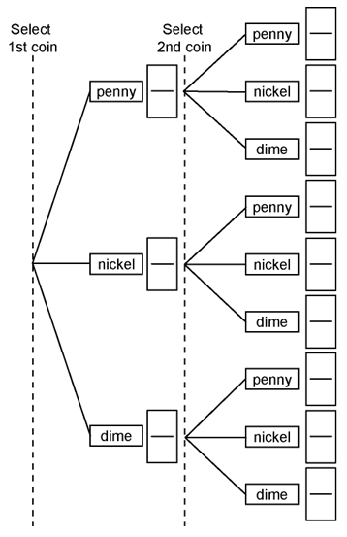
(Score for Question 2: ___ of 8 points)
- The numbers 1 through 50 are written with red marker on slips of paper while the numbers 51 through 100 are written with blue marker on slips of paper. All the papers are put into a bag and shuffled. One card is randomly selected.
- Find the probability of selecting a number less than 10 or a number written in blue. Show your work.
- Find the probability of selecting a number written in red or a multiple of 20. Show your work.
Answer:

(Score for Question 3: ___ of 5 points)
- There are 12 red checkers and 3 black checkers in a bag. Checkers are selected one at a time, with replacement. Each time, the color of the checker is recorded. Find the probability of selecting a red checker exactly 7 times in 10 selections. Show your work.
Answer:

