1) Which graph shows the asymptotes of the function below?
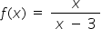
A.
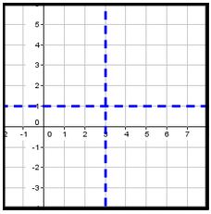
B.
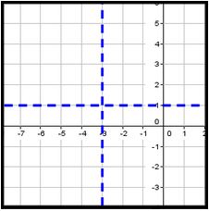
C.
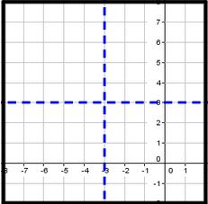
D.
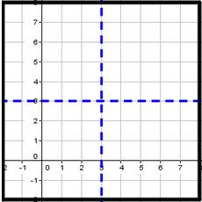

2) Identify the equations of the vertical asymptotes of the following function.

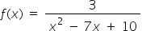

x = -5, x = -2

x = 5, x = 2

x = -5, x = 2

x = 5, x = -2

3) Identify all holes in the function below.
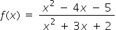

x = -2

x = -1

x = 5

x = 1

4) Identify vertical asymptotes in the function below.
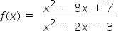

x = 1, x = -3

x = 1

x = -3

x = 7

5) Which of the following graphs shows the function below?
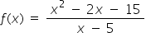
A.
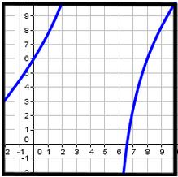
B.
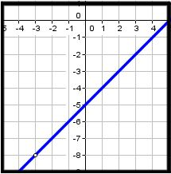
C.
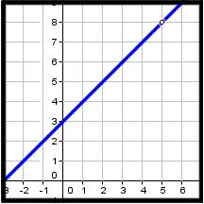
D.
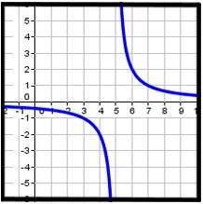

6) Which of the following graphs shows the function below?
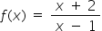
A.
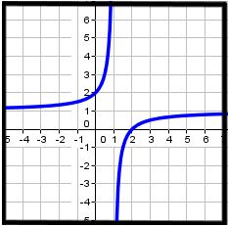
B.
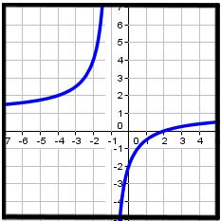
C.
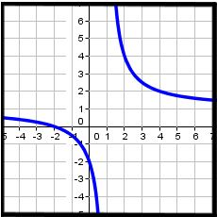
D.
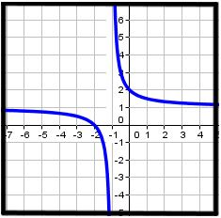

7) Which of the following graphs shows the function below?
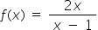
A.
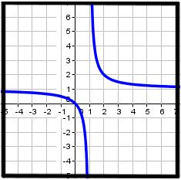
B.
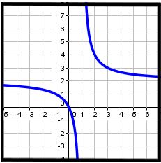
C.
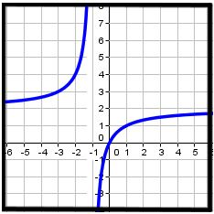
D.
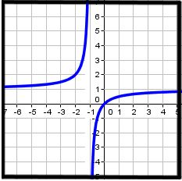

8) Which of the following functions is shown in the graph below?
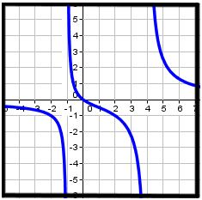

A.
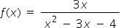

B.
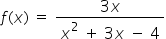

C.
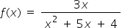

D.
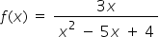

9) Which of the following functions is shown in the graph below?
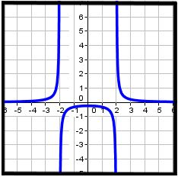

A.
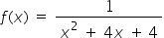

B.
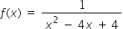

C.
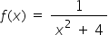

D.
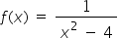

10) Which of the following functions is shown in the graph below?
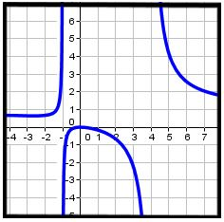

A.
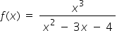

B.
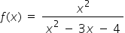

C.
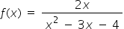

D.
