Name: Darien Younger Date: 4 – 18 – 17

Graded Assignment

Honors Project: Samples and Histograms
The company owner wants to determine whether the cost of a certain computer training program is worthwhile. Often, employees are not able to effectively judge their own computer skills. So the owner wants to test the employees. It would be too costly and time-consuming to test all 177 employees, therefore, only a sample of the employees will be tested.
Total score: ____ of 50 points
(Score for Question 1: ___ of 15 points)
- The Company Data Excel sheet lists the employee numbers of all 177 employees in the company (Employee 001 through Employee 177). You must select a sample of 25 to 30 employees. Describe the type of sampling method that you will use and explain why you chose that method. Then use your method to select the group. List the employee numbers of the employees in your test group.
Answer:
To get an overall view of the changes throughout the entire company, a truly random sample should be taken. We don't want to look at only one department or one age range or one salary range. People should be selected from the company at random to get a representative sample.
Since grouping by age or salary is not desired, those values cannot be used to sort the data. It would also not be random, if you would just pick every 5th person from the list. Sorting by age or salary would give you only a subset of the employees. It is likely that both factors may have their own effect on the computer skills of an employee. Even just picking every 5th or 3rd person, or any other pattern, could cause some unknown biases depending on how the employee numbers are assigned.
There are a few ways to get a random sample, you could use a random number generator to pick out an employee at random out of the list. The random number generator is the closest way to get a truly random number. This will essentially randomly without considering any other values select the desired number of employees from the list. A random number generator from excel, or an online calculator, or even a list of random numbers, will give a good representative sample from the company.
The random number generator from excel will be used. A new column will be added to the data set at the beginning, in front of the employee number. The command RAND() will be used. That will create a random number between 0 and 1 in the cell. The list can then be sorted by the random number list. Use the first 30 employees for the random sample. 30 employees were chosen over 25 or another number to test the maximum number. The more people tested the better representation of the whole company the sample set will have. Those ID numbers are shown below.

(Score for Question 2: ___ of 35 points)
- You will now simulate testing the employees that you chose in Problem 1. Open the Company Data Excel sheet. Highlight columns C and E and select Format > Column > Unhide. Obtain the scores of each employee who took the test by selecting the corresponding cell in column D and removing the shading from that cell. List the scores below as you obtain them. Possible scores range from 1 to 20. Create a frequency table of the scores. Use the scores to make a histogram. Explain how you would interpret the histogram to the owner.
[Your Student Guide gives instructions and tips for working in the Excel file.]
Answer:
Since the range of the skills would be from 1 to 20, the bin size used for the frequency table was decided to be 2.
The raw data with the computer scores and employee ID numbers are shown in the next column.
Count each value in each bin to determine the frequency of the sampled employees.

Class -  Computer Skills Score | Frequency
1-2 | 0
3-4 | 0
5-6 | 6
7-8 | 3
9-10 | 3
11-12 | 4
13-14 | 0
15-16 | 7
17-18 | 4
19-20 | 3

Then use the above table to create a histogram. This will be a graphical representation of the same data.
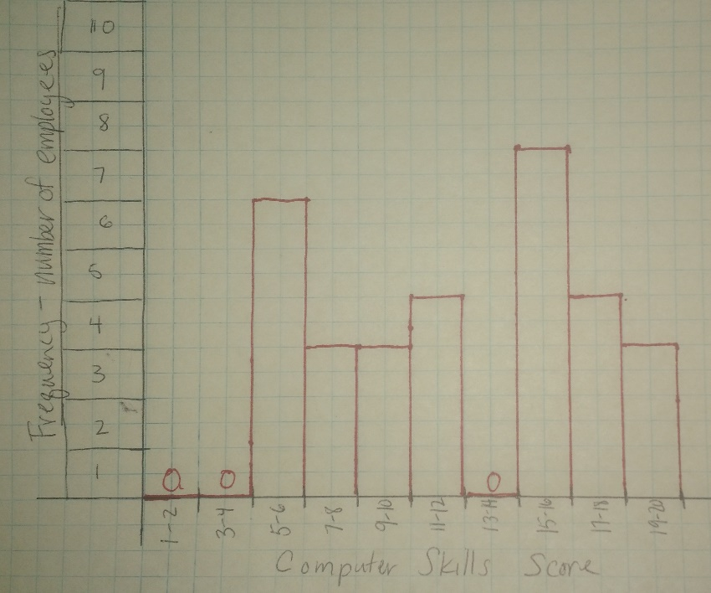

This histogram above shows the frequency of which those computer skills scores were achieved by a random sample of 30 of the employees at the company. The mode of the data (the most common score) was between 15 and 16 points on the test. This would indicate that most employees are proficient in their computer skills, as the most probable score was in the upper 25% of possible scores. The other good news is that no one sampled scored in the lowest two classes. However, the second most common scores were in the 5 to 6 range. 6 out of 30 people or 20% of those employees tested. Assuming that this would hold for all 177 employees at the company, there are 35 employees with computer skills in this range. A skill set in this range is most likely not considered to be proficient to complete any job that requires regular computer usage. Having this number of employees not meeting the basic proficiency could be a large drain on company resources. If employees are struggling to complete computer tasks, then they are taking longer to complete tasks than if they had the proper skills.
Since there is no indication of a what computer skills score is needed or desired for employees at the company, let's assume it is desired that a score of at least 70% was obtained on the skills test. 70% would correspond to a score of 14 on the test. 14 employees scored above a 14 and 16 scored below. That means less than half of the employees tested would 'pass' the computer skills test. This is a surprising number if you consider that these skills are necessary for people to do their jobs. If these individuals are representative of the entire company, then a computer training course would certainly be effective and informative for more than half of the employees in the company.
Since this survey also had data about age and salary, it may be possible to look for correlations between that data and the computer skills score to determine if only certain groups of employees should attend the additional computer training.

Even without using the extra data, with more than half the company (53%) preforming below a 14 on the skills test, would indicate that the additional training classes would be beneficial. The cost of the classes would be offset by the majority of employees being able to learn new skills that they can apply to their jobs to increase performance.

