Objective: At the conclusion of this lab the student will be able to compile a program using Visual Studio 2015 and debug coding errors.
Resources required:
Hardware: XenDesktop
Software: Visual Studio 2015
Instructions
Step 1
Open your Visual Studio 2015 XenDesktop image, create a new project, and type the coding segments down below into the source file. Run the program(s) (Debug > Start without debugging). If you are asked to re-build, select yes to ensure that you are compiling the latest typed code. If you are asked to run your last successful build, check the box not to ask you again, and select No. Make sure that your output details box is open so that you can see where any errors may have occurred. See screen shot below:
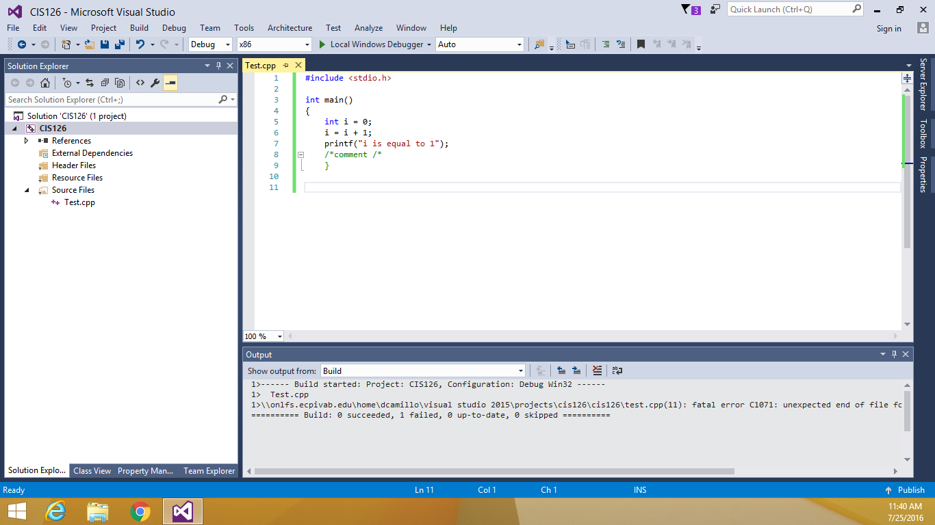
Step 2
Execute the following coding segment and identify the errors in the program. Debug the program and provide the correct version of the code. Note: The errors can be syntactical or logical.

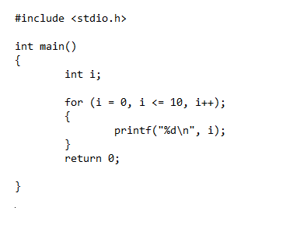

Compile the coding segment down below and explain the output and exactly how the looping structure works.
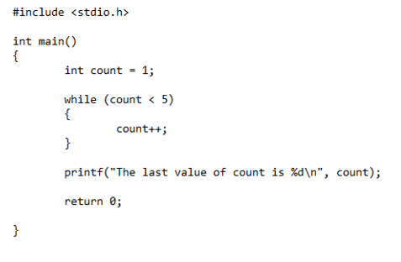
Submission Instructions
Upload a Microsoft Word Document with your written explanation of the error(s) and revised code

