1) Which of the following graph shows the inequality y ≤ + 1
A.
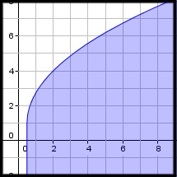
B.
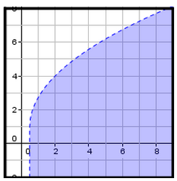
C.
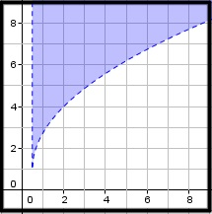
D.
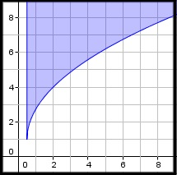

2) Which of the following inequalities is shown in the graph below?
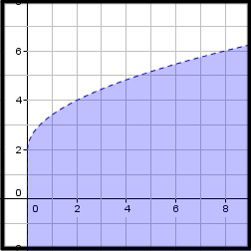
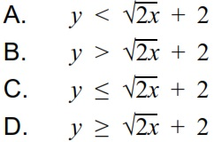

3) Which of the following inequalities is shown in the graph below?
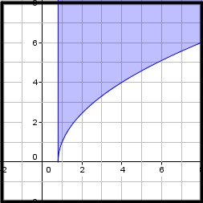
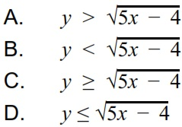

4) Which of the following graphs shows the function below.
f(x) = 5 -
A.
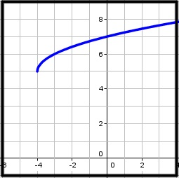
B.
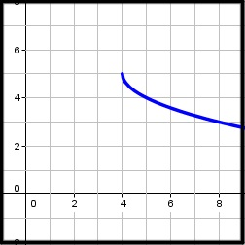
C.
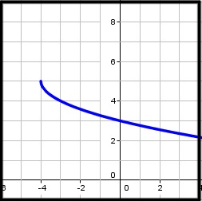
D.
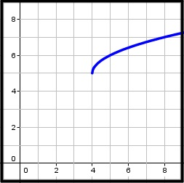

5) Which of the following functions is shown in the graph below?
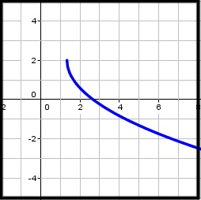
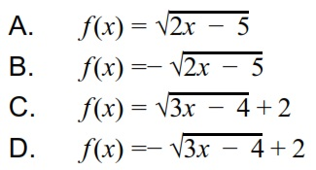

6)Which of the following functions is shown in the graph below?
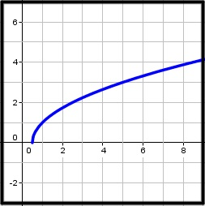
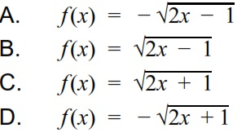

7) Find the range of the function below.
y = + 3

y ≤ 3

y ≥ 3

y ≥ ¾

y ≤ ¾

8) Find the domain of the function below.
y =

x > -2

x ≥ -2

x ≤ -2

x < -2

9) Find the x-intercept of the function.
y =

(6, 0)

(0, 6)

(4 ⅔, 0)

(0, ­4 ⅔)

10) Find the x­intercept of the function.
y =

(-­⅗, 0)

(⅗, 0)

(0, - ­⅗)

(0, ⅗)

