A store found that the number of customers that will attend a limited ime sale can be modeled by N = , where N is the number of customers expected, P is the percent of the sale discount, and t is the number of hours the sale will last. Find the number of customers the store should expect for a sale that is 50% off and will last four hours.
731 customers
1160 customers
3535 customers
5386 customers

A store found that the number of customers that will attend a limited ime sale can be modeled by N = , where N is the number of customers expected, P is the percent of the sale discount, and t is the number of hours the sale will last. Find the number of customers the store should expect for a sale that is 50% off and will last four hours.
731 customers
1160 customers
3535 customers
5386 customers

Use a calculator to approximate the value rounded to three decimal places.

3.679
1.003
0.216
134.8

Use a calculator to approximate the value rounded to three decimal places.

3.871
-3.871
7.616
-7.616

Use a calculator to approximate the value rounded to three decimal places.

24.125

24.124

8.350

8.349

Simplify the radical expresion.
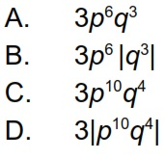

Simplify the radical expression.
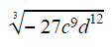
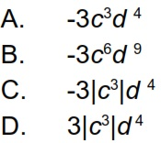

Simplify the radical expression.

x

-|x|

|x|

Not a real number

Simplify the radical expression.

-9

3

-3

Not a real number

Simplify the radical expression.

