Climate Change and the Spread of Vector and Waterborne Diseases

Public Health Literature
Professor Davis
December 8, 2015

Table of Contents
Topic Page
- Abstract…………………………………………………………………………….…2
- Introduction…………………………………………………………………….……..3
- Methodology…………………………………………………………….……………4
- Findings……………………………………………………………………………….5
  - Impacts of climate change on the spread of vector borne diseases……………….5
  - Impacts of climate change on the spread of water borne diseases.……………….8
- Discussion…………………………………………………………………................12
- Conclusion…………………………………………………………………...............13
Table of Figures
Topic Page
- Figure 1……………………………………………………………………………...11
  - Association of extreme precipitation and waterborne outbreaks in the U.S..........11
- Figure 2…………………………………………………………………....................12
  - Trend of global sea level rise……………………………………………………12

- Figure 3……………………………………………………………………………...12
  - Association of Dengue transmission with temperature rise……………………..12

Abstract
Global climate change is one of the greatest challenges currently facing the human population. Over the past century, increased release of carbon dioxide and other greenhouse gases into the atmosphere by anthropogenic sources has resulted in global warming. Evidence of climate change can be demonstrated by elevations in global temperatures and rises in sea level due to the melting of arctic sea ice. The aforementioned changes in climate have contributed to the increased intensity and frequency of extreme weather events such as floods, heavy precipitation, and droughts which impact public health specifically byaffecting the spread of infectious diseases. Higher temperatures create ideal biological and ecological conditions for disease, flooding due to sea level rise damages protective public health infrastructure, heavy precipitation events result in contamination of various water sources, and droughts create conditions of poor hygiene and affect reliability of clean water supplies. The projected increase of extreme weather events can exert indirect effects on health by affecting the range and activity of disease vectors and the ecology of waterborne agents. This research seeks to examine how climate change is associated with an increased spread of vector and waterborne disease. Public health is the science of protecting and improving the health of communities and it plays an important role in building human resilience and reducing vulnerability to climate change impacts. Preparedness will be essential in successfully adapting to climate change to reduce thespread of vector and waterborne diseases.

Introduction
Global climate change, very likely a human-induced phenomenon, exerts significant influences on public health. Current warming trends seem to be the result of human expansion of the greenhouse effect in whichthe atmosphere prevents heat from escaping Earth’s surface. Consequences of the greenhouse effect are shown by the elevation of global temperature by 0.8 degrees Celsius since 1880 which in turnhas led to increased evaporation and precipitation. Warming of the oceans by 0.302 degrees Fahrenheit since 1969 has resulted in melting of arctic ice and thermal expansion of sea water whichhas raised sea levels by 6.7 inches in the last century (“Climate Change…”, fig. 2 p.12).Global climate change has and will continue to increase the probability and intensity of extreme weather events such as heavy precipitation, floods, and drought (Keim).
Global climate change creates conditions which affect the spread of disease due to impacts on different parts of the chain of infection such as the pathogen, host/vector, and the environment (Patz et al. 105). For instance, an increase in mean temperature can change the population and range of vectors, changing the endemicity of certain diseases (Parkinson and Butler 478). Extreme weather events can damage infrastructure and result in displacement and crowding,creating ideal conditions for the rapid spread of disease. Increases in precipitation and flooding events can lead to outbreaks of waterborne infections due to the contamination of drinking and recreational water with microbial pathogens through polluted runoff (Hunter 38). Through several mechanisms, climate change is associated with an increased spread of vector and waterborne diseases.
This research paper has been subdivided into several sections. Methodology addresses the motivation for choosing the research topic, the significance of the issue, and steps taken to complete the research. Findings discuss how in general climate change creates optimal conditions for spread of vector and waterborne diseases and provides examples of past and projected outbreaks. The Discussion examinesthe hesitance to directly link climate change and spread of infectious disease without considering other variables. Lastly, the Conclusion addresses risk factors of the susceptibility to climate change and providesrecommendations to public health of how to adapt to and reduce climate change induced outbreaks.
Methodology
The current issue of climate change has enraptured the attention of the global community due to itsimmense effects on all life on Earth. Although climate change affects health through countless pathways, I was motivated to focus on the spread of infectious disease due to its more noticeable, direct effects on human health. The increased spread of infectious disease is important due to its numerous costs, global effects on all nationalities and socioeconomic levels, and exacerbation of morbidity, mortality and disability in humanpopulations. I am interestedin the essentiality that humans, specifically public health, areprepared for warming effects by ensuring that proper policies and plans are in place to mitigate and adapt to the corresponding changes.
To begin my research on the increased spread of vector and waterborne diseases due to climate change, I began by examiningthe degree to which climate was changing and of the climate events which were increasing, which of theseyielded the most harmful effects on human health (such as heavy precipitation, flooding, and high temperatures). I proceeded by researching outbreaks associated with the aforementioned climate events to see if there was an association between climate change and the spread of infectious disease. After confirming that associations had been made, I decided to focus on the increased spread of vector and waterborne diseasesbecause I noticed that the types of climate events that were increasing had greater impacts on the transmission cycles of these specific types of infectious disease. Transmission cycles that require a vector or physical vehicle, such as water, are more susceptible to external environmental influences than those diseases that only require a pathogen and human (Patz et al. 105). To support my claim, I read research explaining in what ways climate change creates ideal environments for vector and waterborne diseases and then sought out studies which documented specific outbreaks of these diseases after climate change associated events. I focused on academic journals and studies providing links of climate events and the spread of vector and waterborne diseases in the past and possible future projections. Lastly, I analyzed what actions could be taken to adapt to and reduce climate change effects on the spread of vector and waterborne diseases.
Findings
Changing climate conditions facilitate the spread of vector and waterbornediseases. Insect vectors are a crucial link in the spread of infection among humans or from animals to humans (Hunter 42). Extreme weather events,predicted to increase with climate change, lead to weakened public health infrastructure, crowding of infected and susceptible hosts, and disruptions of control programs, all of which contribute to vector borne disease transmission
(Ivers and Ryan).Evidence shows that climate and temperature changes affect the distribution of vectors and their effectiveness of pathogen transmission (Hunter 43).Seasonal fluctuations of disease outbreaks imply disease association with climate- for instance, vector borne diseases such as malaria and dengue fever show seasonal patterns in which they have high transmission rates in heavy precipitation and humidity months (Patz et al. 107).
Precipitation events favor the growth of mosquito-vector populations which increasesdisease incidence. For example, increased precipitation was associated with vector-borne malaria outbreaks in Pakistan and Argentina (Greenough 47).Heavy precipitation events create stagnant pools of water which areideal breeding sites for mosquitos (Greenough 47). Increased rainfall also expands the size of vector larval habitats andvegetation which supports a greater population of vertebrate reservoirs (Patz et al. 108; Hunter 43). Flooding due to heavy precipitation may force vectors indoors,increasing the probability of vector-human contact (Patz et al. 108).Since the intensity and frequency of precipitation events are projected to increase due to climate change, outbreaks due to vector borne diseases can be predicted to increase.Global warming willincrease frequency of droughts. This low precipititation will increase breeding sites due to slowed river flow which serve as stagnant pools (Hunter 43).
Global temperature riseaffects pathogen transmission of vectors. Warmer temperatures increasevector survival, change the rate of vector population growth, and the seasonality of vector activity and pathogen transmission (Hunter 43). Insect vectors adapt quickly to climate change and thus have extended their range farther north than seen in several centuries (Greenough 47). High temperatures speed up pathogen development and replication in the vector, increasing microbe density, which then leads to higher infection and transmission rates between humans and vectors (NJCAA 9). In other words, warmer temperatures shorten the disease’s incubation periods (Greenough 47). Mosquitos increase biting and replicationrates with increasing temperatures which enhanceand lengthen seasons of transmission and increase disease incidence (Parkinson and Butler 482).
There have been several outbreaks of vector borne diseases associated with climate events, or conditions, which will be exacerbated due to climate change. For example, in the United States, mosquito-borne St. Louis encephalitis outbreaks occurred after “periods of hot weather when temperatures [had] been greater than 30 degrees Celsius for more than seven consecutive days” – global increases in temperatures will increase the frequency of vector borne outbreaks (Ivers and Ryan).
A clear instance of climate change impacts on the spread of vector borne diseasesis supported by a study conducted in the United States on outbreaks of West Nile virus (WNV). WNV is a mosquito-borne flaviviruswhichbreeds in stagnant waterand can also thrive in drought conditions due to concentration of organic material and lack of mosquito predators (Patz et al. 112). The virus came to the U.S. in 1999 and spread rapidly due to drought and warm temperature years. In 2002, high temperatures were associated with increased cases of disease in the northeastern metropolitan area.Warm temperatures increase viral load and decrease the incubation period which accelerates blood-feeding and reproductive activity of the mosquitos (Soverow et al. 1049). The study investigated climate conditions, particularly temperature and precipitation, associated with human WNV cases in the U.S by assessing 16,298 cases reported from 2001-2005 (Soverow et al. 1049). Results showed that increasing weekly maximum and cumulative temperatures“were significantly associated with a 35-83% higher incidence of reported WNV infection over the next month…” (Soverow et al. 1049). Also, at least one day of heavy precipitation a week “was associated with a 29-66% higher incidence during the same week and over the subsequent 2 weeks” (Soverow et al. 1049). The study concluded that warmer temperatures and heavy precipitation increased the rate of WNV infection (Soverow et al. 1049).
Climate change may induce outbreaks of vector borne diseases in non-endemic regions. Global warming may cause northward movement and faster metamorphosis of the Aedesaegypti and Aedesalbopictus mosquitos which carry dengue and yellow fever viruses. North America could experience epidemics due to wider distribution of these mosquitos and shorter incubation periods; thus allowing the viruses to cycle more rapidly and increase epidemic spread (Shope 172). Currently, the northernmost range of the Aedesaegypti mosquito is around the latitude of Memphis, Tennessee but due to global warming this distribution is projected to move and encompass large northern population centers (Shope172). Warmer climates result in rapid development of mosquito larvae allowing for the earlier maturation of disease-carrying adults,which then lengthens the disease transmission season (fig. 3 pg. 12). Aedes mosquitos can also thrive in dry conditions since theybreed easily in water storage jars and cisterns commonly used during drought(Shope172).In other regions of the world such as Brazil, Indonesia, and Venezuela, rain and temperature associations have been made with patterns of dengue infection (Ivers and Ryan). Currently Delhi, India is facing the worst outbreak of dengue fever it has faced in over five years with a total of 1,800 cases reported within a few weeks compared to 1,695 cases reported in 2010. Dengue cases increase during and after the rainy season since monsoon rains provide more stagnant water breeding grounds for mosquitos through puddles and open sewage drains (“Delhi Battles Dengue…”). The intensity of this season’s rains may be due to warmer temperatures due to global warming. From this contemporary example, it can be extrapolated that dengue fever outbreaks may increase in the U.S. due to anticipated increased heavy precipitation and drought accompanying climate change.
Changing climate conditions increase the spread of waterborne diseases. A water borne disease outbreak is defined to occur when “two or more persons experience similar illness after consumption or use of a common water source” (Rose et al. 211). Climate affects the spread of infectious pathogens due to heavy rainfall runoff and the effects of temperature on pathogen survival and replication (Parkinson and Butler 479).Increasing weather events such as heavy precipitation and flooding will result in widespread contamination of water sourcesand damage to sanitation infrastructure (Parkinson and Butler 481). For instance, cross contamination of water and sewage lines can occur due to overflow caused by heavy rains or flooding, if the two systems run in parallel since a break in the system would allow pathogens to be drawn into the water line (Greenough 48).
Waterborne diseases can be spread through drinking or recreational water contaminated with human waste, run off and storm waters (Parkinson and Butler 479).Indirect weather effects on waterborne disease agents include facilitation of transport from fecal and waste water sources due to intense rainfall and direct weather effects include increased survival and maturation of agents at higher temperatures (Patz et al. 110). Weather conditions affect water quality and quantity through many routes such asthe contamination of surface and groundwater. Watersheds are contaminated when heavy rains transport wastes in groundwater; for instance 60% of annual contamination of urban watersheds occurs during storm events (Rose et al. 211; Curriero et al. 1199). Storm drains, which may be combined with the public sewage system, can overflow due to precipitation and as a result fecally polluted water will contaminate surface water sources such as rivers. Surface water turbidity also increases during intense rainfall which strains water treatment systems (Hunter 40).
Climate change is projected to produce increases in heavy precipitation in the U.S. A study analyzed the relationship between precipitation and waterborne diseases by examining 548 waterborne outbreaks from 1948 to 1994. Results showed that 51% of the outbreaks were preceded by extreme precipitation events- outbreaks produced by surface water contamination had the strongest association with extreme precipitation during the month of the outbreak and there was a two month lag applied to outbreaks due to groundwater contamination (Curriero et al. 1194). Figure 1 displays the 548 outbreaks, more than half of which were preceded within a 2 month lag by heavy precipitation (fig. 1 pg. 11).
Specific instances of waterborne outbreaks due to climate eventsprovide evidence that as climate change increases there will be an increased spread of waterborne disease. Cholera, caused by bacterium V. cholerae, is transmitted by contamination of drinking, cooking, or irrigation water and through the consumption of shellfish (Lipp, Huq, and Colwell 766).Climate change is predicted to yield higher temperatures and increased frequency of heavy precipitation events which will help the spread of cholera.V. cholerae resides in marine ecosystems and attaches to zooplankton reservoirs whose survival is dependent on the food supply of phytoplankton. As sea levels rise, inland areas will face saltwater intrusion thus increased levels of V. cholerae (Lipp, Huq, and Colwell 766). Heavy rainfall results in additional nutrient input into bodies of water which leads to the rapid growth of plankton species (Hunter 40). Moreover, when sea surface temperatures increase, phytoplankton populations increaseand V. cholerae is better able to attach and multiple within zooplankton thus increasing outbreaks (Patz et al. 107). This relationship of elevated temperature and reported cholera cases has been observed in Bangladesh over an 18 year period and in Peru as well (Rose et al. 215).
Giardiasis and cryptosporidiosis are waterborne diseases caused by protozoan organisms, G.lamblia and C. parvum, and are transmitted by fecal oral spread through drinking or recreational water (Hunter 38). Giardiasis and cryptosporidiosis are significant waterborne diseases in the Mid-Atlantic region (MAR) of the United States. C. parvum are released in feces of infected people, wildlife, and livestock. Cattle is an important source of C. parvum in the MAR since dairy and livestock farms make up large portions of the region (Benson, Kocagil, and Shortle250). U.S. climate research indicates that the MAR will become warmer and experience increased precipitation due to global warming (Benson, Kocagil, and Shortle250). Greater rainfall will lead to transportation of C. parvum into water supplies due to greater surface water run-off. This scenario has been demonstrated by increased amounts of C. parvum in the Delaware River basin after heavy rainfall (Benson, Kocagil, and Shortle250). Milwaukee, Wisconsin suffered a large cryptosporidiosis outbreak in 1993 following heavy precipitation and runoff events which increased water turbidity, undermining theintegrity of their water treatment plant which then failed to properly remove C. parvum pathogens (Curriero et al. 1194). In 1980, two outbreaks of giardiasis were associated with heavy rainfall and runoff in Red Lodge, Montana (Rose et al. 216). Disease outbreaks have been associated with periods of heavy precipitation thus cryptosporidiosis and giardiasis outbreaks may increase with the projected wetter climate in the MAR (Benson, Kocagil, and Shortle250).
Figure 1: Waterborne Disease Outbreaks and Associated Extreme Levels of Precipitation in the United States from 1948-1994 (Curriero et al. 1195)
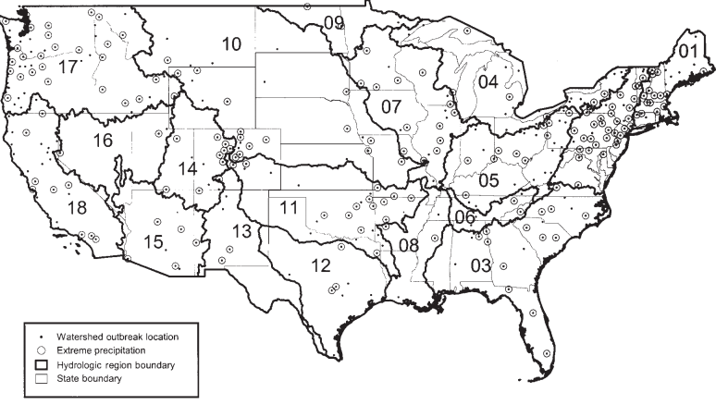

Figure 2: Trend of Global Sea Level Rise from 1993-Present (“Climate Change…”)
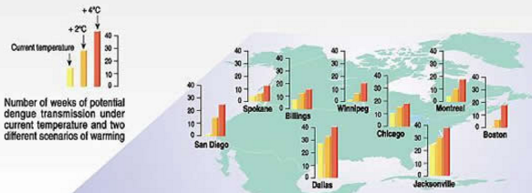
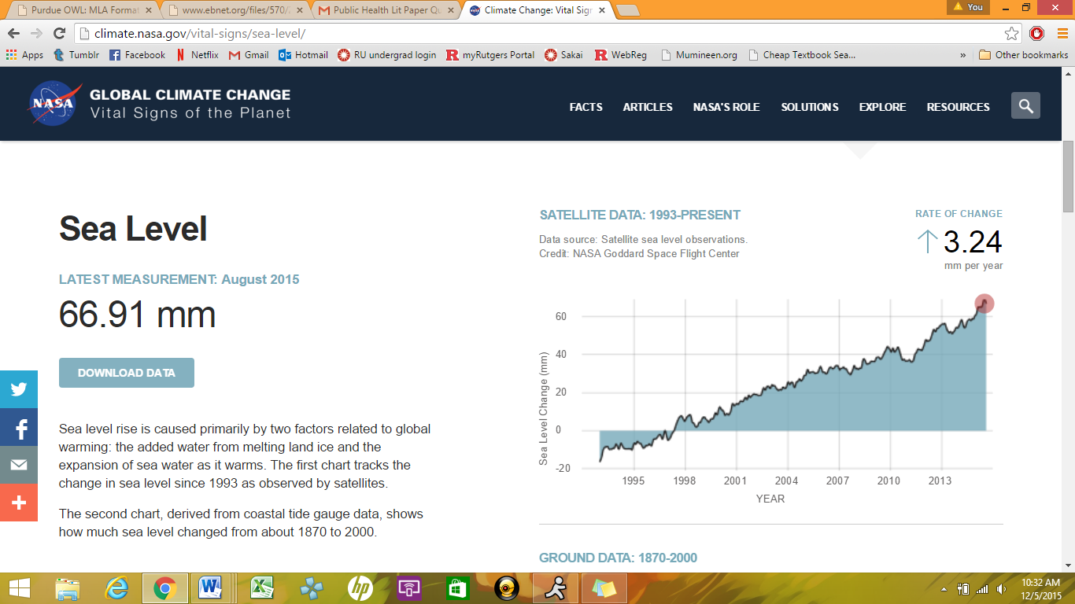
Figure 3: Potential Dengue Transmission in Case of Temperature Rise in the United States (“Climate Change and Vector…”)
Discussion
Past outbreaks reflect the association between climate events and the spread of infectious disease thus predictions have been made that future outbreaks of vector and waterborne diseases may increase due to climate change. These findings further support the conclusion that climate changes such as increases in temperature and extreme weather events promote the spread of vector and waterborne diseases through effects on the disease pathogen, vector or physical vehicles, and environmental conditions. Yet, the spread of infectious disease is dependent on a variety of factors and cannot solely be attributed to climate events. Some research is hesitant to directly link climate change and disease incidence ratesdue to its dependence on long term trends and confounding variables. For instance,climate impacts on vector borne disease ratesdiffer depending on the specific vector and the environmental conditions which foster its growth. Incidence rates are also affected by the population size of the primary and intermediate hosts and local wildlife (NJCAA 9). Outbreaks are governed by the endemicity of diseases in a region and the nature and intensity of the climate event (Ivers and Ryan). Most importantly, the strength of public health infrastructure in a community affects disease incidence due to climate and other contributing variables.
Conclusion
Global climate change presents an immense challenge to the international community. In order to combat the increased spread of vector and waterborne diseases and countless other impacts of climate change, public health should play a role in building human resilience and reducing vulnerability to global warming effects. Preparedness must be carried out at all levels of society to reduce the spread of disease with increasing temperatures and extreme weather events.
Risk factors for susceptibility to climate change induced outbreaks are inadequate public health infrastructure, population displacement, overcrowding, lack of access to healthcare services, and vaccination status of the community.
If proper infrastructure is in place then other risk factors’ effects are minimized. For instance, flooding in a Chinese province in 1998 left one million people homeless but unexpectedly no epidemic occurred due togovernment monitoring of drinking water and the restriction of a maximum of 400 displaced persons living together in any one location (Greenough 52). Deficiencies in watershed protection should be addressed and updated. For instance, some communities still utilize combined sewer systems which are especially susceptible to contamination of water lines during heavy precipitation. Additionally, during intense rainfall the volume of water can exceed the capacity of the sewer or water treatment plant which then results in overflow and discharge of water into surface water which increases risk of waterborne disease (Rose et al. 213). Although developed nations, including the United States, consider themselves well-fortified against the spread of infectious disease, they should recognize that existing systems are aging and strained under increasing populations. In order to treat water under heavy precipitation or flooding events facilities have to improve their processes and capacities (Rose et al. 218). In regards to vector borne diseases, public health infrastructure such as vector control programs which minimize human-vector contact and availability of protective provisions such as vaccines and window screens should be functional before and after climate events (Ivers and Ryan).
Further processes that would strengthen public health preparedness systems are adequate disease and climate surveillance and research to identify which vector and water borne diseases are endemicand susceptible to climate change induced outbreaks for each region. Also, risk assessments should be conducted to identify vulnerable populations, such as communities of low socioeconomic status or of older infrastructure, so that resources can be allocated properly. Early warning systems are vital, along with sufficient public education/awareness of appropriateactions to take in the event of an outbreak (such as covering water storage containers to protect against vectors and boiling drinking water). Preventive efforts can be taken as well such as the use of permeable pavement and rain gardens to reduce precipitation runoff into water sources (“Testing the Waters”). Through a coordinated global effort, public health can prepare human populations for increased spread of vector and waterborne diseases due to climate change.

Works Cited
Benson, Keith, Patricia Kocagil, and James Shortle.“Climate Change and Health in the Mid-
Atlantic Region.”Climate Research 14 (2000): 245-253. Web. 13 Nov. 2015.
“Climate Change and Vector-Borne Disease.”UCAR Center for Science Education.National
Science Foundation, n.d. Web. 5 Dec. 2015.
“Climate Change: How do we know?” Global Climate Change.NASA, n.d. Web.28 Nov. 2015.
Curriero, Frank C., et al. “The Association between Extreme Precipitation and Waterborne
Disease Outbreaks in the United States, 1948-1994.” American Journal of Public Health
91.8 (2001): 1194-1199. Web. 14 Nov. 2015.
“Delhi Battles Dengue Fever Surge.”BBC News. BBC, 16 September 2015. Web. 29 Nov. 2015.
Greenough, P. Gregg. “Infectious Diseases and Disasters.”Disaster Medicine.2nd ed. Eds. David
E. Hogan and Jonathan L. Burstein. Philadelphia: Lippincott Williams & Wilkins, 2007.
44-54. Print.
Hunter, Paul R. “Climate Change and Waterborne and Vector Borne Disease.”Journal of
Applied Microbiology 94 (2003): 37-46. Web. 10 Nov. 2015.
Ivers, Louise C., and Edward T. Ryan.“Infectious Diseases of Severe Weather-Related and
Flood-Related Natural Disasters.”Current Opinion in Infectious Diseases 19.5 (2006).
Web. 14 Nov. 2015.
Keim, Mark E. “Building Human Resilience.” American Journal of Preventive Medicine.35.5
(2008).Web. 17 Nov. 2015.
Lipp, Erin K., Anwar Huq, and Rita R. Colwell. “Effects of Global Climate on Infectious
Disease: the Cholera Model.” Clinical Microbiology Reviews 15.4 (2002):
757-770. Web. 17 Nov. 2015.
New Jersey Climate Adaptation Alliance (NJCAA).Stakeholder Engagement Report:
Public Health. Eds. George T. DiFerdinando Jr., Sarah Watson, and Marjorie B. Kaplan.
New Brunswick: Rutgers University, 2014. 3-18. Web.
Parkinson, Alan J., and Jay C. Butler. “Potential Impacts of Climate Change on Infectious
Diseases in the Arctic.” International Journal of Circumpolar Health64.5 (2005): 478
486. Web. 15 Nov. 2015.
Patz, J.A., et al. “Climate Change and Infectious Diseases.” Climate Change and Human Health
Eds. A.J. McMichael, et al. Geneva: World Health Organization, 2003. 103- 127. Web.
Rose, Joan B., et al. “Climate Variability and Change in the United States: Potential Impacts on
Water and Foodborne Diseases Caused by Microbiologic Agents.” Environmental Health
Perspectives 109.2 (2001): 211-219. Web. 15 Nov. 2015.
Shope, Robert. “Global Climate Change and Infectious Diseases.”Environmental Health
Perspectives 96 (1991): 171-174. Web. 16 Nov. 2015.
Soverow, Jonathan E., et al. “Infectious Disease in a Warming World: How Weather Influenced
West Nile Virus in the United States (2001-2005).” Environmental Health Perspectives
117.7 (2009): 1049-1052. Web. 14 Nov. 2015.
“Testing the Waters.”Natural Resources Defense Council.NRDC, n.d. Web. 15 Nov. 2015.

