Assessing the Efforts to Combat Microbial Resistance

Public Health Literature
Professor Davis
December 8th, 2015

Table of Contents:
Topic Page
- Abstract………………………………………………………………………………2
- Introduction…………………………………………………………………………..2
  - Threats posed by antibiotic resistant infections……………………….…………2
  - Factors promoting the spread of resistance ……………………………..………3
- Methodology…………………………………………………………………...……4
  - Understanding the process of tackling resistance……………..…………….…..4
- Findings…………………………………………………………………..................5
  - Impact of the agricultural industry on resistance………………….….…….…..5
  - The misuse of antibiotics in healthcare…………………………………….…...5
  - Efforts of antibiotic stewardship to combat resistance……………………........6
- Discussion………………………………………………………………….............10
- Conclusion…………………………………………………………………............10
Table of Figures
Topic Page
- Figure 1………………………………………………………………….................9
  - Antibiotic usage in Food Producing Animals ….…………...…………….…...9
- Figure 2………………………………………………………………….................10
  - Number of antibiotic prescriptions per 1000 persons by state.…………......…10

- Figure 3…………………………………………………………………................10
  - Trend comparing CDI incidence vs. usage of varying high risk antibiotics … 10

Abstract:
Over the past few decades’antibiotic resistant infections (ARIs) have become a growing problem. Many of the pathogens that medicine previously triumphed over during the 20th century are making a return.Bacteria such as clostridium difficilie (CDIFF), carbapenem-resistant enterobacteria (CRE), extensively drug resistant tuberculosis (XDR TB), and methicillin-resistant staphylococcus aureus (MRSA) are claiming thousands of lives and millions of dollars a year. Not only are these bacteria becoming resistant to more classes of antibiotics, but the drug pipeline has run dry with fewer new tools being produced. The CDC has branded these bacterium as urgent threats that need to be dealt aggressively and soon before resistance becomes the norm. This has resulted inthe healthcare industryexploring novel practices to improve the efficacy and efficiency of antibiotics.

Introduction
Antibiotic resistance is one of the primary healthcare challenges for the 21st century. The ever increasing number of resistant strains compounded with a dwindling arsenal of drugs has set the crisis into full throttle, threatening to send medicine back to the dark ages of a pre-antibiotic era.According to the CDC, each year in the United States at least 2 million people acquire an antibiotic resistant infection with up to 23,000 patients dying as a result of these infections. (CDC 12) Along with the loss of human lives, there is also a significant financial cost, with annual estimates in the U.S to be around $20 billion dollars and resulting in 8 million additional days in the hospital. (Fair& Tor1)The concept of antibiotic resistance is not new, having existed almost as long as antibiotics themselves. Penicillin, discovered by Alexander Fleming in 1928, began to see regular clinical use to treat infections in 1942. By 1945, scientists had discovered resistance to penicillin in some strains of staphylococcus aureus. Methicillin, a subclass of penicillin, hit the shelves in 1959 but by 1961 physicians had already started encountering methicillin resistant staphylococcus aureus (MRSA). By 1999,methicillin resistance was observed in 53% of s. aureus isolates obtained from patients in ICUs across the U.S. (SHEA, IDSA, & PIDS1)In 2012, MRSA was associated with almost 90,000 infections and a staggering 19,000 deaths. (Carletet al. 2)The intrinsic ability for bacteria to rapidly mutate and develop resistance is a huge challenge when it comes to developing microbial agents. It is impossible to entirely prevent pathogens from developing resistance, however healthcare professionals are exploring methods to control the rate and spread of resistance. This research identifies the macroscopic factors that have augmented antibiotic resistance and attempts to evaluate some of the methods currently used in the healthcare industry to curb the threat of resistance.
Although microbial resistance itself is a consequence of evolutionresulting from the process of natural selection, much of its spread can be attributed to failures in planning, infrastructure, and human behavior. The leading culprit for antibiotic resistance is the misuse and abuse of antibiotics in both the agricultural and healthcare industries. The agriculture industry uses about 80% of antibiotics in the USA(Spellberg, Bartlett, & Gilbert 301) and only 17% of that usage was deemed forpurely therapeutic purposes (FDA 20, fig 1). In healthcare about 200 million to 300 million antibiotic prescriptions are written every year across the U.S. and numerous studies considerthese prescriptions inappropriate in as many as 50% of cases. (Fishman 54) Even when antibiotic usage is justified, patience noncompliance is another problem that has further increased the spread of resistance. The other major issue is the increasing lack of drug development. Over the past few decades the drug pipeline has run dry, dropping from developing 20 new antibacterial agents every 5 years in the 1980s to 2 novel drugs between 2010 and 2012. (CDC 44) The pharmaceutical industry has hit a wall and as a result has cut funding on developing new antibiotics. Between 2004-2005, only 1.6% of the drugs in development by the world’s 15 largest pharmaceutical companies were antibiotics. (Fair& Tor 1) In 2004, the Infectious Disease Society of America released a report aptly named “Bad Bugs, No Drugs” outlining the danger resistance poses to humanity, spurring government and healthcare agencies to action in developing strategies to combat and hinder the spread of resistance before it passes its tipping point.
Methodology:
To properly understand how to tackle the problem of antibiotic resistance, this research began by exploring the major culprits responsible for the intensified prevalence of antibiotic resistance. It was essential to first explore the root of issue and develop the context behind the problem before analyzing the attempted solutions. This research focused less on bacteria’s ability to develop resistance and spent more time accessing the factors that were a direct result of human behavior. Theresult was examining several sources that explored lack of production of new antibiotics, the misuse and abuse of the agricultural industry, and the failures of physicians and healthcare institutions.Gathering this informationprovided information on which areas are causing the most problems and which factors can be plausibly addressed in a reasonable timespan.
After developing a proper understanding of the factors behind resistance, the next step was to analyze some of the strategies aiming to reducing resistance. In 2013, the CDC’s report “Antibiotic Resistant Threats”released a four pronged plan on fighting antibiotic resistant infections. It included preventing infections and the spread of resistance, tracking resistance, promoting antibiotic stewardship, and encouraging development of new drugs and diagnostic tools. The focus of this paper is mainly on promoting antibiotic stewardship as most of the advancements in the past few years have been in that area.By analyzing the various strategies being implemented by healthcare facilities, critiquing their viability, and determining their efficacy, itprovides insight into whether the healthcare industries’ efforts have bared any fruit. This investigation also delivers a better understanding of where resources need to be allocated and what future work needs to be done in order to improve outcomes in reducing the incidence of resistance.
Findings:
The mistakes of various industries over the past few decades’ have allowed resistance to spread as far as it has. The agriculture industry shares a large part of the blame when it comes to the misuse and abuse of antibiotics. In 2009, it was reported that 12.5 million kilograms of antimicrobial drugs were used in food-producing animals (FDA 20, fig 1), while in comparison only 3 million kilograms were used in human patients. ((Spellberg, Bartlett, & Gilbert 301). Upon further examination of the FDA’s report, 61% of the 12.5 million kilograms were medically important antibiotics used to treat humans and only 17% of these important antibiotics were used for purely therapeutic purposes. The remaining 44% of medically important antibiotics were used for ulterior motives such as assisting production via increased weight gain and improved feed efficiency. (FDA 20, fig 1) The problems the agriculture industry poses to resistance are not recent either. In fact, the first instance to suggest completely banning antibiotic usage on livestock because of resistance was in the United Kingdom with the Swann Committee Report of 1969 (Davies & Davies 428) Although the FDA currently does not support the use of medically important antibiotics for purely production purposes, (FDA 20, fig 1) this has been hard to enforce largely due to the deception of the agriculture industry by using medically relevant antibiotics under different names to give to animals. (Davies& Davies 428) As it currently stands measures to limitantibiotic usagein livestockhavelargely failed but the hope is that the FDA and other agencies will continue to apply pressure and usher in change.
The healthcare industry has also been found guilty of overusing antibiotics these past few years. It is estimated that every year over 200 million – 300 million prescriptions are written for antibiotics in the U.S. (Fishman 54). A 2010 study published in the New England Journal of Medicine showed the number of antibiotic prescriptions per 1000 persons of all ages across all 50 states. The results wereappalling, with over 9 states reporting between 996-1237 prescriptions per 1000 individuals, the equivalent of more than 1 prescription per person in the state. (CDC 42, fig 2). Numerous studies over the past several years have suggested that over 50% of these prescriptions are unnecessary and result from errors in dosage, selecting the wrong antibiotic, or precautionary prophylactic prescriptions. (Fishman 54) Antibiotic usage is especially heavy in hospitals, with somewhere between 30% to 50% of patients admitted to an acute care facility receiving some form of prophylactic or therapeutic systemic antimicrobials. (Knobleret al. 141) This has made hospitals a breeding ground for antibiotic resistant infections which is a concerning problem as those who are most vulnerable to these infections are also regularly in and out of the hospital. One bacterium in particular, clostridium difficile, frequently occurs in patients who are or have recently been hospitalized. It has been deemed an immediate public health threat by the CDC, currently infecting 250,000 patients every year, resulting in 14,000 annual deaths and 1 billion dollars in excess medical costs. (CDC 51)Fortunately many healthcare facilities have begun implementing antibiotic stewardship programs to help limit microbial resistance.
One strategy to fighting microbial resistance in hospitals and health centers has been to implement policies that regulate the use of antibiotics. In order to do this many hospitals have opted for restricted formularies, considering costs, benefits, toxicities,local infection rates, duplicate agents, and the risk of developing resistance before selecting certain antibiotics to keep in their formulary. Restricting the usage of high risk antibiotics such as second and third generation cephalosporin’s which have a CDI occurrence of 1 out of 14 and 8 respectively, has shown some promise. (Aldeyabet al. 2989) A study conducted by the Northern Health and Social Care Trust (NHSCT) in Northern Ireland involving the restriction of high risk antibiotics such as second and third generation cephalosporin’s, fluoroquinolones and clindamycin concluded that restricting these antibiotics resulted in a significant decrease of clostridium difficile infections. (Aldeyab et al.2991, fig 3) Adaption of prior approval programs are also another method many hospitals are using to cut down on antibiotics.These often involve something along the lines of having the prescriber phone in approvals with an appointed supervisor or fill out antibiotic order forms to provide justification for their choice. Although they’ve been described as arduous for physicians, adding an extra step to providing treatment, many studies have shown that these programs have had repeated success with reducing the incidence of resistance. For example, a retrospective review of a prior approval program at the Indiana University School of Medicine shows that prior approval is associated with significantly lower rates of enterococcal bacteremia (0.34 vs. 0.16 events per 1000 patient days), selected gram-negativebacteremia (0.26 vs 0.11 events per 1000 patient days), stenotrophomonas colonization or infection (0.35 vs 0.17), and MRSA colonization or infection (0.66 vs 0.20). (Fishman 56)These methods are clearly working, and many hospitals continue to work and fine tune them today.
Along with limiting the usage of antibiotics, many efforts have also been made to improve the efficiency of antibiotics.The development of computer assisted programs has been a huge advantage in optimizing antibiotic utilization, being used as a means to improve drug selection, dosing and scheduling, monitoring adverse events, and predicting patient outcomes. These programs are able to take information such as patient history, lab results, and drug information to provide guidelines for physicians to follow. The ability to provide instantaneous feedback and suggestions has saved a lot of time for physicians, and helps them catch mistakes they might have otherwise made. One study indicated that computer assisted programs resulted in fewer antibiotic susceptibility mismatches (12 vs. 206) and fewer drug related allergic reactions (35 vs 146). (Fishman 58) By decreasing the number of mistakes it also decreases the amount of antibiotics used, directly reducing the rates of resistance. Physicians have also explored other methods such as antibiotic cycling and antibiotic mixing, which involve using multiple different antibiotics simultaneously. The ideology behind this method is that if the underlying infection is resistant to one class of antibiotics, the other class will kill it before the infection reemerges in full force and gets to infect other patients. Although there has been some success with such methods, the studies have been criticized for their methodology and there is no concrete evidence of their effectiveness as of yet.

Figure 1: FDA report on antimicrobial drugs approved for use in animals during 2009

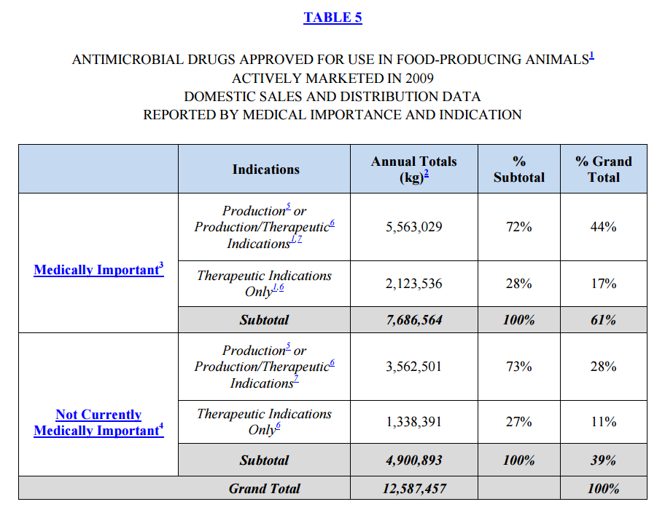

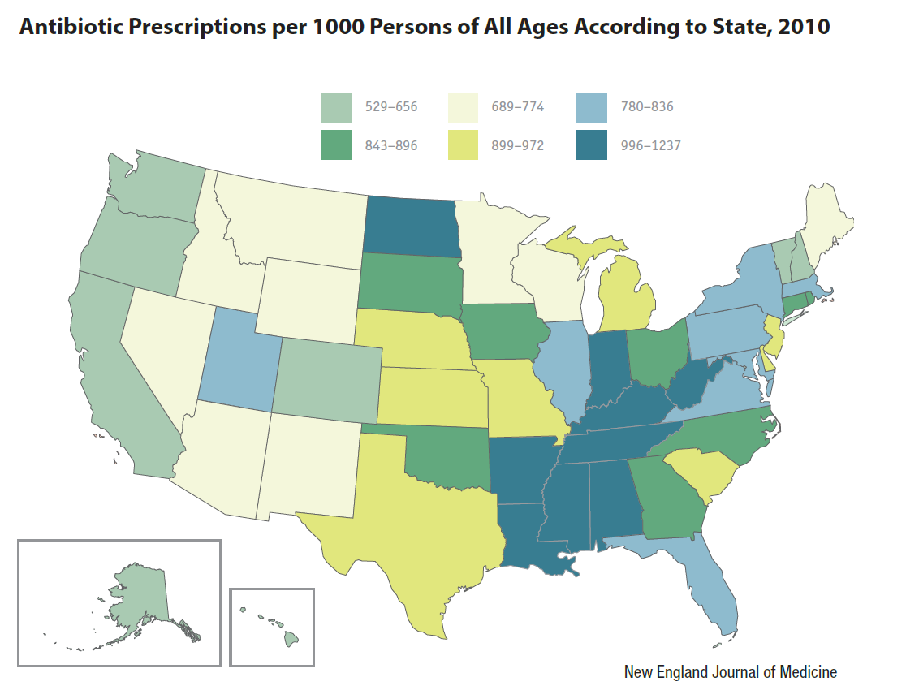

Figure 2: Number of antibiotic prescriptions per 1000 persons by state

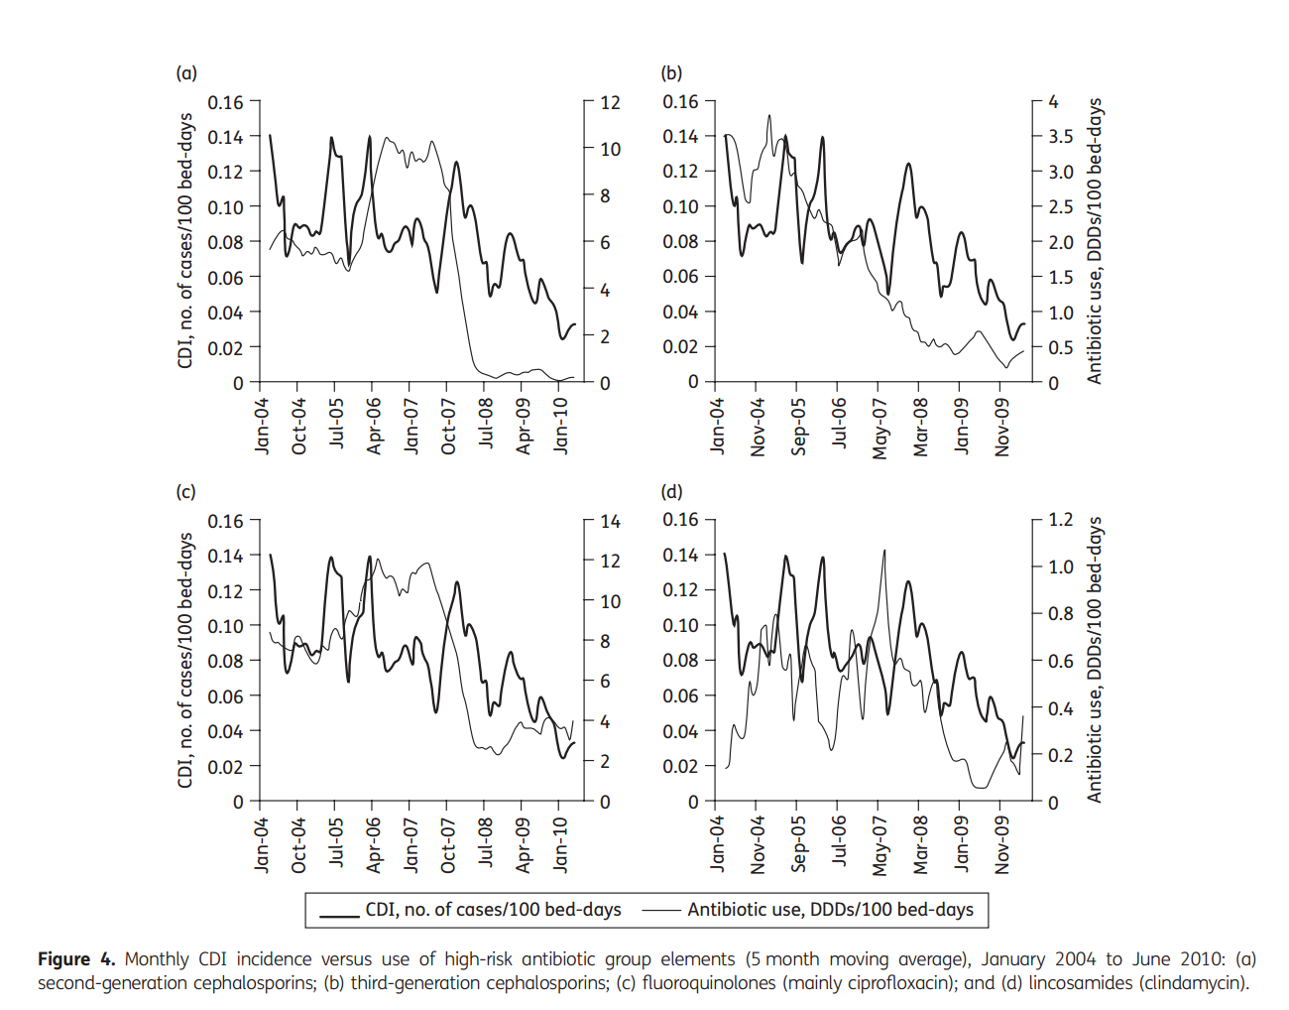

Figure 3: Northern Health and Social Care Trust (NHSCT) results comparing monthly CDI incidence vs. usage of varying high risk antibiotics.

Discussion:
The threat of antibiotic resistance continues to grow every year.The findings above identify the primary cause of the spread of resistance to not be the unstoppable process of natural selection, but rather the excessive use and abuse of antibiotics by both the agricultural and healthcare industries. In an odd twist of fate this news does provide some hope, as it means that it can potentially be solved. This has encouraged the exploration of new practices and policy to limit the usage of antibiotics,spawning the movement of antibiotic stewardship within the healthcare industry. By adopting frugal policies and embracing technology many hospitals have been able to cut down on the number of antibiotics they use and are using them more efficiently. These findings show that doing so has reduced the incidence of resistance. However much work remains to be done as the healthcare industry continues to explore new ways to improve the utilization of antibiotics.
Conclusion:
The emergence of superbugs resistant to most available antibiotics has aroused concern over whether or not society will once again descend into an era without antibiotics. Despite the efforts of the healthcare industry, antibiotic resistant infections continue to claim thousands of lives each year and cost millions of dollars in excess medical treatment and loss of productivity. New antibiotic stewardship strategies are being developed, but there is only so much health professionals can do on their own. The agricultural industry consumes a large percentage of total antibiotic usage each year and that number is not dwindling. Although the FDA has tightened regulations on antibiotic usage in agriculture over the past few years, many cases of abuse still slip through the cracks. In order to promote real change, the general public needs to be more informed about antibiotic resistance and the threat it poses to society. Unfortunately, when it comes to infectious diseaseshowever, the public has shown an extensive lack of knowledge. This was showcased in a recent survey done by the World Health Organization over 12 differentcountries, receiving around 10,000 responses. Around 64% of respondents believed antibiotics could be used to treat viral infections like the flu, while 32% believed they should stop taking antibiotics when they feel better. On the topic of antibiotic resistance, 76% of respondents think that antibiotic resistance is when the body becomes resistant to medication, not the actual bacteria. (WHO 1) These misconceptions are not only bad for the individual but also further increase the incidence of resistance. By educating the public on how antibiotics function and how resistance actually develops, it would go a long way in reducing the spread of resistance and would also put pressure on policy makers to take action.
Unfortunately controlling the usage of antibiotics and promoting education will not be enough to sustain society over a longer period of time. The reality of the situation is that even if the spread of resistance were slowed down, without the production of new antibiotics eventually resistance would catch up. In order to ensure long term viability new antibiotics must be developed. Although the development of new antibiotics over the past few years has been sparse, hope has not been lost. In 2010 the Infectious Disease Society of America (IDSA) launched the “10 x 20” initiative, encouraging the production of 10 unique antibiotics by the year 2020. In 2014, IDSA’s president Barbara Murray released a statement that some progress has been made and “two novel antibiotics, dalbavancin and tedizolid phosphate were recently approved by the FDA”. Although progress has been slow the hope is that theseefforts continues to push for innovation. Only by promoting and enforcing proper usage of antibiotics and refreshing the arsenal of drugs can society hope to control the threat of resistance, ensuring a healthy world for future generations.
Works Cited:
Aldeyab, Mamoon A., Mary P. Kearney, Michael G. Scott, Motasem A. Aldiab, Yaser M. Alahmadi, Feras W. DariwshElhajji, Fidelma A. Magee, James C. McElnay. “An evaluatioin of the impact of antibiotic stewardship on reducing the use of high-risk antibiotics and its effects on the incidence of Clostridum difficile infection in hospital settings”.Journal of Antimicrobial Chemotherapy 67(2012): 2988-2996. Web. 5 Dec 2015
Carlet, Jean, Vincent Jarlier, Stephan Harbarth, Andreas Voss, Herman Goossens, DiddierPittet. “Ready for a world with without antibiotics? The Pensieres Antibiotic Resistance Call to Action”.Antimicrobial Resistance and Infection Control 1.11(2012). Web. Nov 2015
Center for Disease Control and Prevention “Antibiotic Resistance Threats in the United States, 2013” (2013). Web. 2 Dec 2015
Davies, Julian, and Dorothy Davies “Origins and Evolution of Antibiotic Resistance”. Microbiology and Molecular Biology Reviews (2010): 417-433. Web. 2 Dec 2015
Fair, Richard J., Yitzhak Tor.“Antibiotics and Bacterial Resistance in the 21st Century”. Perspectives in Medicinal Chemistry6.0(2014): 25-64. Web. 29 Nov 2015
Fishman, Neil. "Antimicrobial Stewardship". The American Journal of Medicine 119.6A(2006): 53-61. Web. 29 Nov 2015
Food and Drug Administration “2009 Summary Report on Antimicrobials Sold or Distributed for Use in Food-Producing Animals” (2010). Web. 5 Dec 2015
Knobler, Stacey L., Stanley M. Lemon, Maria Najafi, Tom Burroughs. (2003) Factors Contributing to the Emergence of Resistance “The Resistance Phenomenon in Microbes and Infectious Disease Vectors: Implications for Human
Health and Strategies for Containment” (pp.130-158). The National Academics.Web. 4 Dec 2015
Spellberg, Brad, John G. Bartlett, David N. Gilbert, “The Future of Antibiotics and Resistance”. The New England Journal of Medicine368.4(2013): 299-302. Web. 3 Dec 2015
Society for Healthcare Epidemiology of America, Infectious Disease Society of America, Pediatric Infectious Disease Society “Policy Statement on Antimicrobial Stewardship”.Infection Control and Hospital Epidemiology 33.4(2012). Web. 5 Dec 2015
World Health Organization “WHO multi-country survey reveals widespread public misunderstanding about antibiotic resistance”. 16 Nov. 2015. Web. 6 Dec 2015

