Hardness test procedure
- Prepare the test specimens for hardness test
- Measure the specimen dimension
- Put the test specimen on the hardness test device
- Attached the weights to hardness test
- Adjust the level of the hardness test
- Attach the diamond indenter
- Attach the anvil on top of the raising/lowering screw
- Remove the transport protector
- Secure the anti-topping fitting to the installation platform
- Start to operate the machine as instructor demonstrated

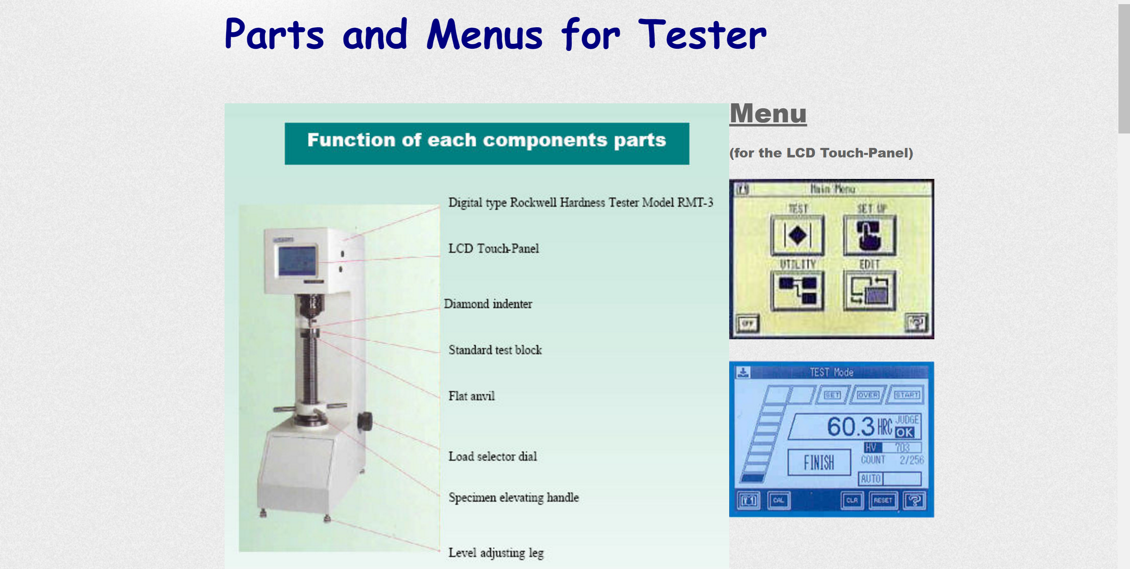
The machine we used for hardness test

Data was taken during the lab
samples | Trailer 1 | Trailer 2 | Trailer 3 | Average
A | 62.1 | 61.7 | 60.8 | 61.53
B | 117.7 | 118.7 | 120.2 | 118.86
C | 86.3 | 84.9 | 82.4 | 84.53
D | 73.2 | 74.3 | 76.3 | 74.6
E | 77.9 | 76 | 73 | 75.63

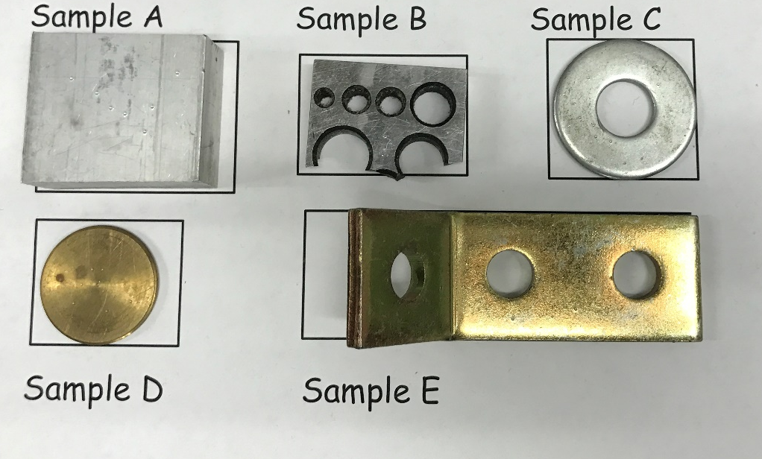
The sample we used

