Microsoft Word Equation Editor

Taking a math course online is challenging, so congratulations on having the courage to do it! One of the things that makes taking a math course online more difficult than taking the same course in a physical classroom is that showing your work in a word processing document can be difficult and time consuming. Yet despite it being difficult to show work without a traditional pencil and paper, it is still essential that you do so because seeing your process allows your instructors to gauge your understanding of the concepts and know not only that you got a problem right or wrong, but also why you got it right or wrong.
This short tutorial will introduce you to the equation editor, a tool within Microsoft Word that makes showing your work online quick and easy. Let’s see how it works! While you’re going through this tutorial, it’s probably a good idea to open up a Word document so you can try the tool for yourself!
So let’s say that you’re trying to solve the problem $5x+10=25$
First, let’s number the problem. Let’s say it’s number 1 in your assignment.
- $5x+10=25$
To start the problem in Microsoft Word’s Equation Editor, click on the “Insert” tab on the top ribbon of Microsoft Word and then click the “Equation” button on the right side of the ribbon:
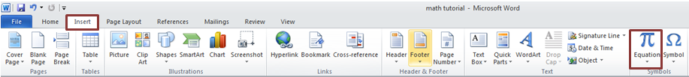

When you click on the Equation button, a small box will appear where you can enter an equation:
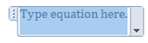

TIP
For a list of built in equations and formulas you can click the down arrow below the equation. A drop down menu will appear that has a several options for built-in equations and formulas.
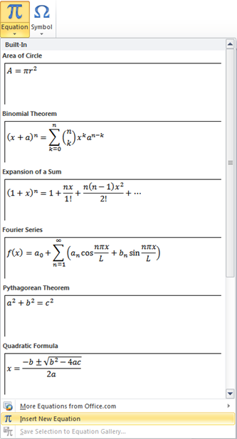

And a ribbon full of equation tools opens up at the top of your screen:

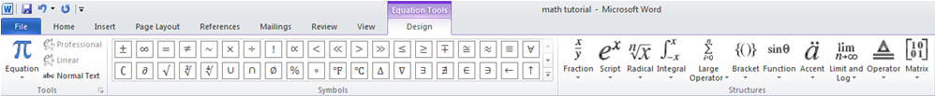
This ribbon contains a lot of helpful tools such as an option to create fractions, exponents, radicals, and a whole bunch of other functions. I recommend that you spend a few minutes familiarizing yourself with the features of the equation editor.
Okay, so let’s get back to our problem.
In order to begin, click inside the equation box and type in your equation:
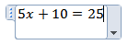
Then press enter and the equation will appear in your document. To show each line of work, simply click on the equation button again and a new equation box will appear below the original equation:

TIP
You can change the alignment of the equation box by clicking on the down arrow on the right and selecting “justification”

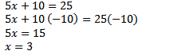

Though at first this process takes a little bit more time than writing the equations with a pencil and paper, the tool allows you to clearly demonstrate to your instructor that you’ve taken the steps to get your answer. Further, once you get used to it, the process will be much quicker.

Let’s try another one!
Let’s say you’re trying to solve the problem $\frac{5}{6}+\frac{2}{3}$
First, let’s click on the insert tab and then on the Equation button to start a new equation:
Okay, now one of the coolest things about the equation editor is that it has a button you can use to create fractions. When you click on the fraction button, a dropdown menu appears that gives you several different options for creating fractions:

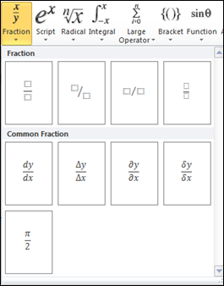

We’re just going to use the regular fraction with the numerator on top and denominator on the bottom. When we choose that option a blank fraction bar appears where we can enter any fraction we want:
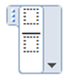
Let’s enter our problem:

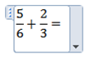

Note that to enter the addition sign (+) we can type it on the keyboard, and to insert the second fraction we can simply select the fraction option again from the equation editor.
$$\frac{5}{6}+\frac{2}{3}=$$
Find the common denominator: 6
$$\frac{5}{6}+\frac{4}{6}=\frac{9}{6}$$
Reduce:
$$\frac{9}{6}=1\frac{3}{6}=1\frac{1}{2}$$

Easy enough, right?

The last example I want to show you has to do with exponents.
Let’s say we’re trying to solve the problem: $6^{3}$
But how do you write the exponent?
With the equation editor it’s easy!
Start a new equation, and click the “Script” button from the tool ribbon at the top of your screen:
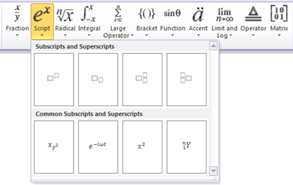
Then select the exponent option as indicated above:
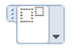
Now all you have to do is type in the exponent and solve!
$$6^{3}=6∙6∙6=216$$

Using the equation editor really is easy and fast when you get the hang of it, and, with a little practice, you’ll be knocking out math problems faster than you would be able to with a pencil and paper!
Take some time to explore the different features of the equation editor and be sure to show your work when you submit your assignments.

