1.Estimate the zeros of the function shown in the graph below.
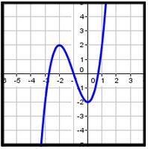

A) {­-2.9, ­-1, 0.8}

B) {-­2, 0}

C) {-­2, ­-1, 0}

D) {­-2.9, -­1, ­-2, 0.8}

2.In the function shown in the chart below, at which values of x are there relative minima or maxima?
x f(x)
-3 -2
-2 2
-1 0
0 -2
1 2
2 18
3 52

A) 2 and ­-2

B) -3 and 3

C) -2 and 0

D) -3, 0, and 3

3.In the function shown in the chart below, between what values of x would you find the zeros of the function?
x f(x)
-3 73
-2 8
-1 -7
0 -8
1 -7
2 8
3 73

A) -1 and 0, 0 and 1

B) -2 and ­-1, 1 and 2

C) -7 and 8, ­-8 and ­-7

D) 1 and ­-1

4.Which of the following could be the graph of f(x) = x³ + x² - 3x?

A.
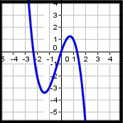
B.
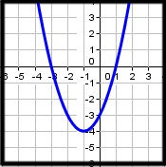
C.
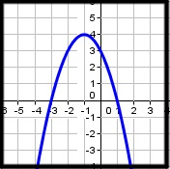
D.
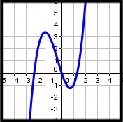

5.Estimate the relative maximums in the graph below.
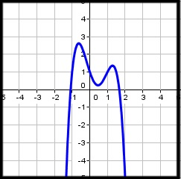

A) (1.3, 1.4) and (-­0.6, 2.6)

B) (­-0.6, 2.6,), (0.5, 0.3), and (1.3, 1.4)

C) (­-1, 0) and (1.8, 0)

D) (-­1, 0), (0, 1), and (1.8, 0)

6.Which of the following shows a graph that meets the following conditions.
I. As x → ∞, f(x) → ∞ II. The degree of f(x) is odd III. the leading coefficient is positive
A.
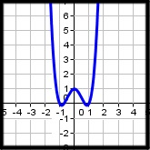
B.
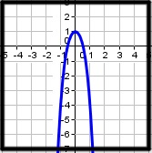
C.
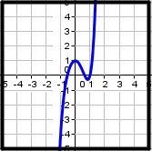
D.
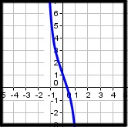

7.For the graph below, which of the following is true?
I. As x → ∞, f(x) → ∞ II. As x → ∞, f(x) → ­-∞ III. As x → -­∞, f(x) → ∞ IV. As x → ­-∞, f(x) → -­∞ V. f(x) is odd VI. the leading coefficient is negative
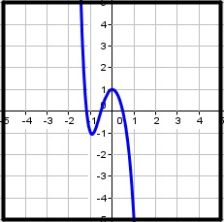

A) I, III, and V are true

B) II, III, V, and VI are true

C) II, III, and V are true

D) II, IV, V, and VI are true

8.Find r(x + 1) if r(x) = x³ + x + 1

A) x³ + 3x² + 4x + 3

B) x³ + 4x² + 5x + 3

C) x³ + 2x + 3

D) x⁴ + x³ + x² + 2x + 1

9.Find p(-4) if p(x) = x⁵ - x²

A) 1040

B) -1040

C) 1008

D) -1008

10.What is the degree and leading coefficient of the polynomial below?
6x³ + 3x⁴ = 2x² - 2

A) degree = 4, leading coefficient = 3

B) degree = 3, leading coefficient = 6

C) degree = 2, leading coefficient = 2

D) degree = 0, leading coefficient = -2

