Find the real square roots for the number below:
16
------------
4
4, -4
-4
8

Simplify the expression below. Assume all variables are nonnegative real numbers.:

5y
-5y

Approximate the value for the expression below. Round to three decimal places, if necessary.

4.243
9
324
3.240

Simplify the expression below:

1
3
0
no real answer

Simplify the expression below. Assume all variables are nonnegative real numbers.:

-4x²
-4x², 4x²
no real answer

Simplify the expression below. Assume all variables are nonnegative real numbers.
(Hint: Factor the polynomial).
x+2
Simplify the expression below. Assume all variables are nonnegative real numbers.

12x-4
3x-1
no real number

Find f(-1) for the function

2.4
2.2
2
No real answer

Which function is shown in the graph below?
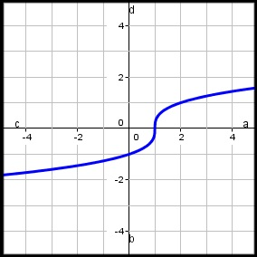

Simplify the expression below. Assume all variables are nonnegative real numbers.:

No Real Answer

