Python
From this point on in the semester we will be working with Python. A great resource for learning Python is, “Learning Python the hardway”: h ttps://learnpythonthehardway.org/book You will have to save your files as .py instead of .cpp when working with python.
You can use Geany as your IDE for writing python programs or just use a text editor and a terminal window to compile your program.
Note: During the recitation your TA will be demonstrating the example code shown below in Geany and a Text Editor.
Indentation :
In Python the delimiter is a indentation of the code itself. No curly braces will be used to mark where the code starts and stops and for any loops, if-else statements, or functions there is not an explicit begin or end without the indentation. T here are no explicit braces, brackets, or keywords. This means that whitespace is significant, and must be consistent.
“Code blocks” or sections of code are defined by their indentation. Code blocks means sections of code for functions, if statements, for loops, while loops, and so forth. I ndenting starts a block and is ended when the indentation moves back a tab.
For example:
Block 1 #statements in Block 1 is Executed Block 2 #statements in Block 2 is Executed
Block 3 #statements in Block 3 is Executed Block 2 #Remaining statements in Block 2 is Executed
Block 1 #Remaining statements in Block 1 is Executed
Loops in Python: For and While
Loops allow us to run a chunk of code multiple times. If we know how many times we’ll need to run the code, we typically use a for loop. When we don’t know how many times we need to run the code, we usually use a while loop.
For Loops
The basic structure of a for loop in Python looks like this:
Here, i is the dummy variable and range(startNum, endNum) is the iterable. The dummy variable take s on the values of the iterable, beginning with startNum and up to, but not including, endNum. Each loop, i will increment by 1. For example, if we enter the following code:
We should see the following output:
Alternatively, we can define range with a single parameter: range(endNum) By default, the dummy v ariable will begin at 0 and iterate up to, but not including, e ndNum.
If we want to have i increase by some number other than 1, we can specify this number as the 3rd parameter in range:
The output:
Of course we can do things far more complex than just printing a single variable. Try writing a loop that outputs the even numbers between 0 and 10.
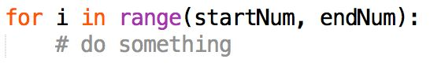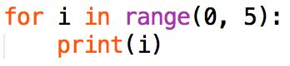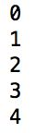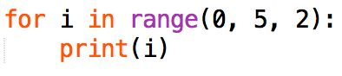
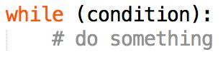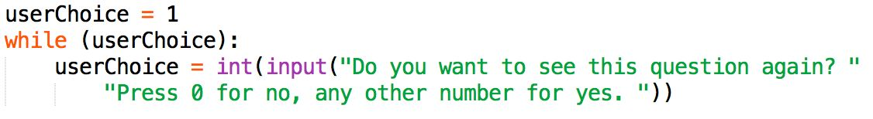

While loops
A while loop in python uses the following syntax:
As long as condition is true, the code within the while loop will run. Consider the following code:
Entering ‘0’ will terminate the loop, but any other number will cause the loop to run again.
Note how we have to initialize the condition before the loop starts. Setting u serChoice equal to 1 ensures that the while loop will run at least once.
Also note that we must “cast” the input to type int. By default, input() returns a string value. A string value will always evaluate as true. Consequently, we must turn it into an integer to have its “truth” evaluated within the while condition.
Converting For into While It’s possible to use a while loop instead of a for loop. Let’s rewrite the second for loop example from above as a while loop:
This accomplishes the same as output as above, but with more lines of code. Notice how you must manually initialize i to equal 0 and then manually increment i by 2.
Debugging Tip: Inserting print statements into your loops is a quick way to debug your code if something isn’t working.
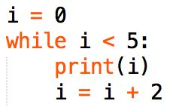
Recitation Activity (Due by Sunday 5PM):
You have three friends who want to rent a room in your house. The amount they are willing to pay you depends on the length of their stay.
Bill will pay you a flat rate of $100 dollars every day.
John will pay you $1000 dollars the first day and half as much each subsequent day, meaning on the first day he will pay $1000, the second day he will pay $500, on the third day he will pay $250 etc.
Kate will pay $0.01 on the first day and then twice as much on each subsequent day, meaning on the first day she will pay $0.01, on the second day she will pay $0.02, on the third day she will pay $0.04 etc.
You need to write a program that takes the input from a user consisting of number of days a person will rent your room. You will print a string of the name of which tenant will pay the most. For example: when number of days entered = 1, you would print the string “John”
Name your file Lastname_Firstname.py

