CMSC140

Project 4 consists of two C++ applications.

Concepts tested by applications in this project

- Loops
- File processing
- Previously mastered course topics

Beverage Orders

A high-end coffee shop has just hired you as their senior programmer. They have tasked you to design and implement two C++ applications allowing employees to take orders from its customers and to determine weekly sales.

Application #1: Create an application allowing employees to take orders and then tally up the total costs from its customers.

The coffee shop offers the following items on its menu:
- Coffee
- Tea
- Soda
- Juice
- Manager Special (store manager offers a drink of their choice to customers)

The application must be able to:
- Accept one or more drinks in a single order; use a sentinel value to terminate an order
- Once an order has been placed, tally up the total cost of the order

Application #2: Create another application to process an input file, weekly_sales.txt, and tally up its weekly sales total. The data file consists of 7 entries representing the sales from last week.

If the input file does not exist, prompt user to try again.

Project Requirements/Specification

- Proper formatting must be utilized. For example, currency format was be used for any order amount.
- Data validations
  - When an order for coffee is placed, the application should accept ‘c’ or ‘C’. See sample run.
  - When an invalid menu item is entered, the application should ignore it. ‘w’ or ‘W’ should be ignored.
- If the weekly sales data file is not available, display an appropriate error message. DON’T crash the program.
- Be sure to thoroughly test both applications – valid and invalid test cases must be included.
- Be sure to review the provided rubric so that you understand the project’s expectations in regard to documentation, CMSC140, and programming requirements.
- Not clear or need clarifications? Seek help from your instructor. “I did not know …” or “I did not understand …” is not going to cut it.

In addition to completing the applications, a write-up is required. At a minimal, the write-up should include:
- Project Design / Algorithm
  - A list of detailed steps to capture the design of each application
  - Students should complete this step first, and then write your code
- Flow Chart
- Test Plan/ Test Cases (be sure to include a table of your test cases(see template below). Your instructor will look for them)
  - I want to see your “thinking,” as to how you are testing your program.
- Screen shots capturing all your test cases
- Any assumptions that you are making
- Lessons Learned: Highlights of your learning experience. Very important, as your instructor is interested in what you have done, how you did it, etc.
  - Anything else that you want to share with the instructor

Submission Requirements

Academic Integrity Policy reminder – Each submitted project will be compared against others’ submissions from current and previous semesters.

Deliverables (items to submit):
- Two C++ source files (i.e. Project4App1.cpp, and project4App2.cpp)
- A Word document that includes a flowchart (can be an image) OR pseudo code algorithm for each program, your test plans and screen snapshots of program outputs
- LastNameFirstName_AssignmentX_Moss.zip (a compressed file containing only the two source files as listed in No. 1 above)

You should include one block comment at the top of each program containing the course name, the project number, your name, the date and platform/compiler that you used to develop the project as listed below

/* Class: CMSC140 CRN
* Instructor:
* Student Name:
* Project [number]
* Description: (Give a brief description for the project)
* Due Date:
* I pledge that I have completed the programming assignment independently.
I have not copied the code from a student or any source.
I have not given my code to any student.
Print your Name here: __________

******** Algorithm or Pseudo Code*********************
* Input:
* 1.
* 2.
* 3.
* (more as needed)
* Output:
* 1.
* 2.
* (more as needed)
* Process:
* 1.
* 2.
* 3.
* 4.
* 5.
* (more as needed)
**************************************
*/

Notes:
- If program does not compile, project will get grade “0”. Contact your instructor prior to the project submission due date, if you have compilation issues.
- Proper naming conventions: All constants, except 0 and 1, should be named. Constant names should be all upper-case, variable names should begin in lower case, but subsequent words should be in title case. Variable and method names should be descriptive of the role of the variable or method. Single letter names should be avoided.
- Documentation: The documentation requirement for all programming projects is one block comment at the top of the program containing the course name, the project number, your name, the date and platform/compiler that you used to develop the project. If you use any code or specific algorithms that you did not create, a reference to its source should be made in the appropriate comment block. Additional comments should be provided as necessary to clarify the program.
Indentation: It must be consistent throughout the program and must reflect the control structure

Sample Runs

Below are sample runs for the 1st applications. Yours should be similar but should not be exactly the same.

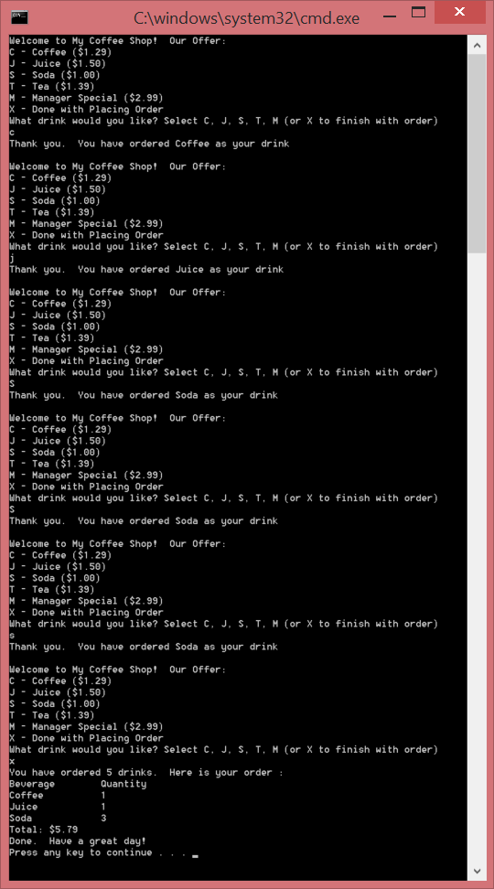
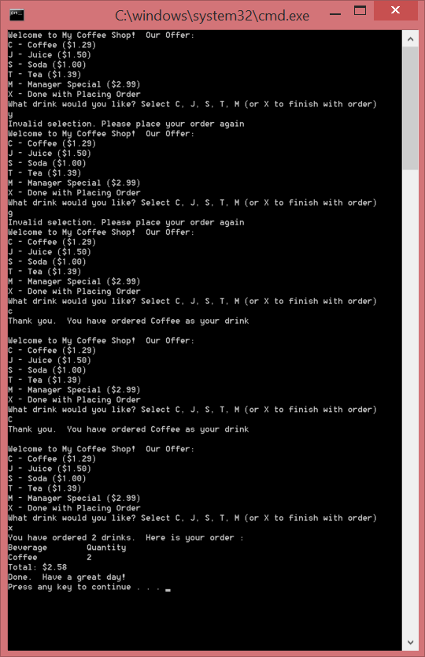
Instructor’s comment: Each order must also be saved to an output file.

Here are the sample runs for the 2nd applications. Yours should be similar but should not be exactly the same.

About to process weekly sales
There are 7 entries, and the total was $628.83

About to process weekly sales
Could not open file. Exiting program.

Test Plan Template (Each Test Case should have a supporting screenshot)

Input | Actual input | Expected Output | Actual Output | Did Test Pass?

