- Which graph shows the function below?
y = (⅓)(x -­ 1)2 + 2

A.
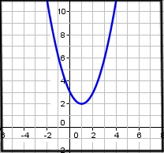
B.
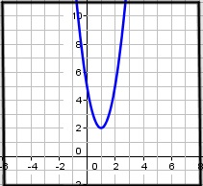
C.
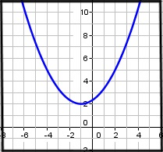
D.
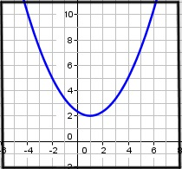

- Which of the following functions is shown in the graph below?
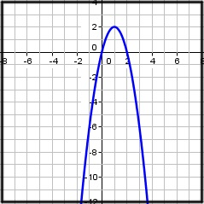

y = (x ­- 1)2 + 2

y = -2(x -­ 1)2 + 2

y = 2(x + 1)2 + 2

y = (x + 1)2 + 2

- Which of the following shows the following equation in vertex form?
y = ­-4x2 + 16x + 11

-y = ­4(x ­- 4)2 ­ - 53

y = ­-4(x + 4)2 ­- 53

y = ­-4(x -­ 2)2 + 27

y = ­-4(x + 4)2 + 75

- Which of the following shows the following equation in vertex form?
y = x2 ­- 8x + 18

y = (x ­- 4)2 + 2

y = (x ­- 8)2 -­ 46

y = (x ­- 4)2 + 34

y = (x ­- 8)2 + 2

- Describe the translation from the graph of y = x2 if you are given the function below:
y = (x ­- 3)2+ 2

The graph is translated three units to the left and two units up.

The graph is translated three units to the left and two units down.

The graph is translated three units to the right and two units down.

The graph is translated three units to the right and two units up.

- Which of the following functions is shown in the graph below?
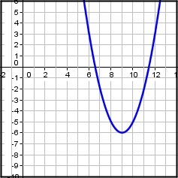

y = (x - 6)2 ­- 9

y = (x + 9)2 ­- 6

y = (x + 6)2 + 9

y = (x -­ 9)2 ­- 6

- Which correctly identifies the values of the parameters a, h, and k for the function below?
f(x) = 2(x ­- 3)2 + 4

a = 2, h = ­-3, k = 4

a = 2, h = 3, k = 4

a = ­-2, h = 3, k = -­4

a = 2, h = 3, k = -­4

- Which graphs shows the graph of the function below?
y = (x ­- 2)2 + 4
A.
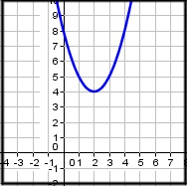
B.
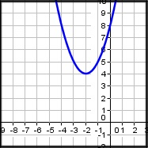
C.
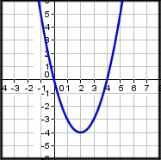
D.
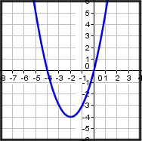

- Describe the translation from the graph of y = x2 if you are given the function below:
y = (x + 2)2 ­ - 4

The graph is translated to the right 2 units and down 4 units.

The graph is translated to the left 2 units and down 4 units.

The graph is translated to the left 2 units and up 4 units.

The graph is translated to the right 2 units and up 4 units.

- Which of the following equations shows a parabola in vertex form.

y = 2x2 + 3x ­- 4

y ­- 4 = 2(x2 + 2)

y = ­-(x ­- 5)2 ­- 3

y = 2(x2 + 1)-­ 2

