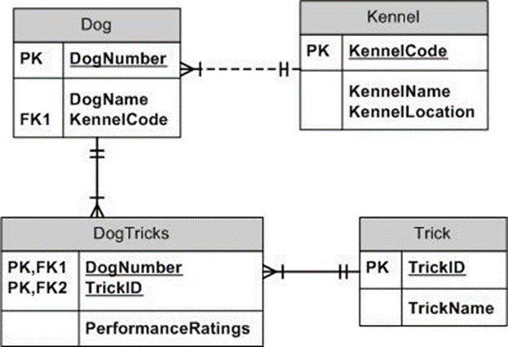

Maximum Cardinalities

Minimum Cardinalities

