In Section 4.1, we studied the amount formula A = P(1 + r)^{n}. If we are interested in the principal P that must be invested today to grow to a specified amount A in the future, then the principal is called the present value of the investment. We can find a formula for present value by solving the amount formula for P:
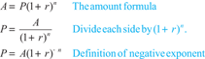
Page 270
Present Value Formula
The present value P that will amount to A dollars after n years with interest compounded annually at annual interest rate r is given by the formula
EXAMPLE 6
Using the present value formula
A new parent wants to have $20,000 in his child's college fund when his infant is ready for college in 18 years. How much must he invest now at 8% compounded annually to achieve this goal?
Solution
Use n = 18, A = $20,000, and r = 0.08 in the present value formula:
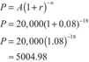
An investment today of $5004.98 will amount to $20,000 in 18 years.

