Homeland Security
Write 250 words each with proper in text citation, APA, reference, and free from Plagiarism. Then follow the below Rubric when writing

READ before before answering the question below.
12.2 Growth without Reason
From its inception, DHS was running on a diﬀerent clock than its governmental counterparts. Aside from its origination, it could change like a chameleon. Today’s threat was tomorrow’s agenda item, only lower on the list. DHS could consume, like a ravenous beast, most of its competing agencies, even those with a historically diﬀerent approach. Surprising about bureaucracies growing, self-perpetuating, and feeding on mission to develop other parts of the bureaucratic puzzle. Yet this journey is neither trek nor run, but a propulsion that simply knows no bounds. FEMA’s inclusion in DHS is an excellent illustration of this phenomenon. In FEMA the natural disaster sets the tone the hurricane, the earthquake, the ﬁre, and so on. That is what FEMA was intended to direct its energies toward. Even so, FEMA would be subsumed into the DHS model. Some have wondered whether this tendency to simply swallow any event resem-bling a disaster has been good for DHS or FEMA. It is a question worth asking, and in the hubbub of growth and bureaucratic delirium, a pandemic of frenzy if there ever was one, one must stop and smell the roses. To grow and evolve is natural. To grow without much thought is mindless. Maybe FEMA’s responses to hurricane damage are not really the building blocks of DHS. Maybe earthquakes are ﬂat out diﬀerent and do not beneﬁt from the DHS mentality. While not perfect, the generally positive signs in the planning in advance of and response in the wake of Hurricane Sandy in the fall of 2012 indicate that FEMA may in fact be able to operate and function successfully within DHS. Only time will tell. As you read through the pages o this chapter, you have witnessed growth in both form and substance. You have witnessed the absorption o departments at a pace never seen before. You have gleaned that the term infrastructure means more than brick and mortar—that the FDA has a homeland plan just as the National Monuments Agency does. Everyone has a plan. Everyone combats terrorism. Page by page you have read about new plans, new stratagems, new policies, new mergers, and realignments. You can get dizzy reading about these changes. And one other thing you can be sure that what is here likely will be diﬀerent in a short time. I contend that more is not always more. Sometimes more is less. Fewer results, less eﬃciency, less coordination. Is it possible to take on too many agencies, too much responsibility, and thus lose the focus of what is truly important or necessary? As an example, does the hiring of 60,000 new border agents throwing sheer numbers at the problem automatically guarantee a more secure border? Revisiting policy and enforcing current laws on the books would take care of many of the issues. We build fences to keep people out, but illegal immigration is still a consistent problem. While border security is necessary, a more holistic policy solution would include: (1) increased border security in conjunction with encouraging legitimate immigration and naturalization and (2) a more consistent policy on illegal immigrants within the country. Establishing a reliable, eﬃcient process for those individuals and families, who are in the country now and want to become U.S. citizens, would help alleviate some of the strain on the system, set the proper tone, and provide a clear and consistent path to obtaining citizenship. Why do our agencies neglect targeting those that should be targeted and continue to search the 9-year-old child’s Sponge Bob bag, or the coat of an 80-year-old grandmother? These are just singular, but simple and reﬂective examples of a department that does things in ways that belie notions of eﬃciency and targeted focus. A DHS that operates like the agency at present will not last into the next century. It will not be nimble enough to last. Even DHS knows this reality. In 2010, DHS announced a three old mission concerning how it will unfold in the decade to come: ﬁrst, it will need to consolidate duplicitous operations; second, it will need to stream-line these bulky and cumbersome systems, and lastly, it will need to be open to the world. The talk of change is in the air and whether the nature and sheer size of DHS can adapt remains unclear. DHS is well-meaning when it relays:
We have taken signiﬁcant steps to create a uniﬁed and integrated Department that will enhance our performance by focusing on:
• Accountability
• Eﬃciency
• Transparency, and
• Leadership development
The future of homeland security can be prosperous and highly eﬀective it can help prevent attacks and thwart the terrorist who haunts our way of life. Ultimately, it can provide levels of security and safety at costs more aligned with reality and the mission of government in general.

12.3 Curbing Expansionism in Mission
To have any chance at a prosperous future, DHS will have to simplify. There is too much under its roof, and much of what sits under its tent does not belong. DHS’s mission is to:
• Prevent terrorist attacks within the United States
• Reduce the vulnerability of the United States to terrorism
• Minimize the damage, and assist in the recovery, from terrorist attacks that do occur within the United States
• Carry out all functions of entities transferred to the Department, including by acting as a local point regarding natural and man-made crises and emergency planning
• Ensure that the function of the agencies and subdivisions within the Department that are not related directly to securing the homeland are not diminished or neglected except by a speciﬁc explicit Act of Congress • Monitor connection between illegal drug traﬃcking and terrorism, coordinate eﬀorts to sever such connections, and otherwise contribute to eﬀorts to interdict illegal drug traﬃcking 6 The simplicity of the mission a secure America through deterrence and prevention of terrorism and secure borders—causes one to pause on the expansionist mentality that has occurred with at the growth of DHS. The agencies in table 12.1 became part of DHS in 2003. The table lays out the ﬁrst expansionist event in the history of DHS. Just for the sake of argument, does the merger and consolidation make sense in all cases? Can the Secret Service not carry out its mission without being tethered to DHS? What about the Energy Security and Assurance Program? Does DHS have the expertise to handle the subject matter? And the Plum Island Infectious Disease Center for Animals would it not make better sense to leave Plum Island with the Department of Agriculture? Does it seem likely that a terrorist event would occur with livestock? Noted already was the suitability of the FEMA merger. Why would hurricane response assist in DHS’s mission? It is the author’s view that DHS is struggling with its own identity, from its initial manifestation to its subsequent transformations. Instead of being attentive to its basic mission of security and counterterrorism, it has wandered into peripheral territory, only partially touching upon questions of security. The net eﬀect of this expansionism has been the dilution of other services and functions in government. Some departments are underfunded budget-wise and adapting to missions, some of which, are tangential to their overall purpose. For DHS to survive into the future, it may require shedding functions that stand far aﬁeld from its ultimate end or purpose. William L. Waugh Jr. notes in “The Future of Homeland Security and Emergency Management”: Mission problems were expected with the integration of non-terrorism pro-grams into a department focused on the terrorist threat. FEMA, in particular, has responsibilities unrelated to dealing with terrorism, such as the National Flood Insurance Program and the National Earthquake Hazard Reduction Program. Other DHS components also have diverse non-terrorism responsibilities, not least of which are the U.S. Coast Guard’s responsibilities related to oil spills, boating safety, and air-sea rescue. 7 It is a legitimate critique, for why does DHS involve itself in ﬂood insurance, geospatial maps, and computer security breaches? Are these activities consistent with mission or causing stress internally and externally? To be sure, the ﬁnancial stress alone, the budgetary demands of new obligations, has either drained historic budgets or added to tightness in existing budgets.
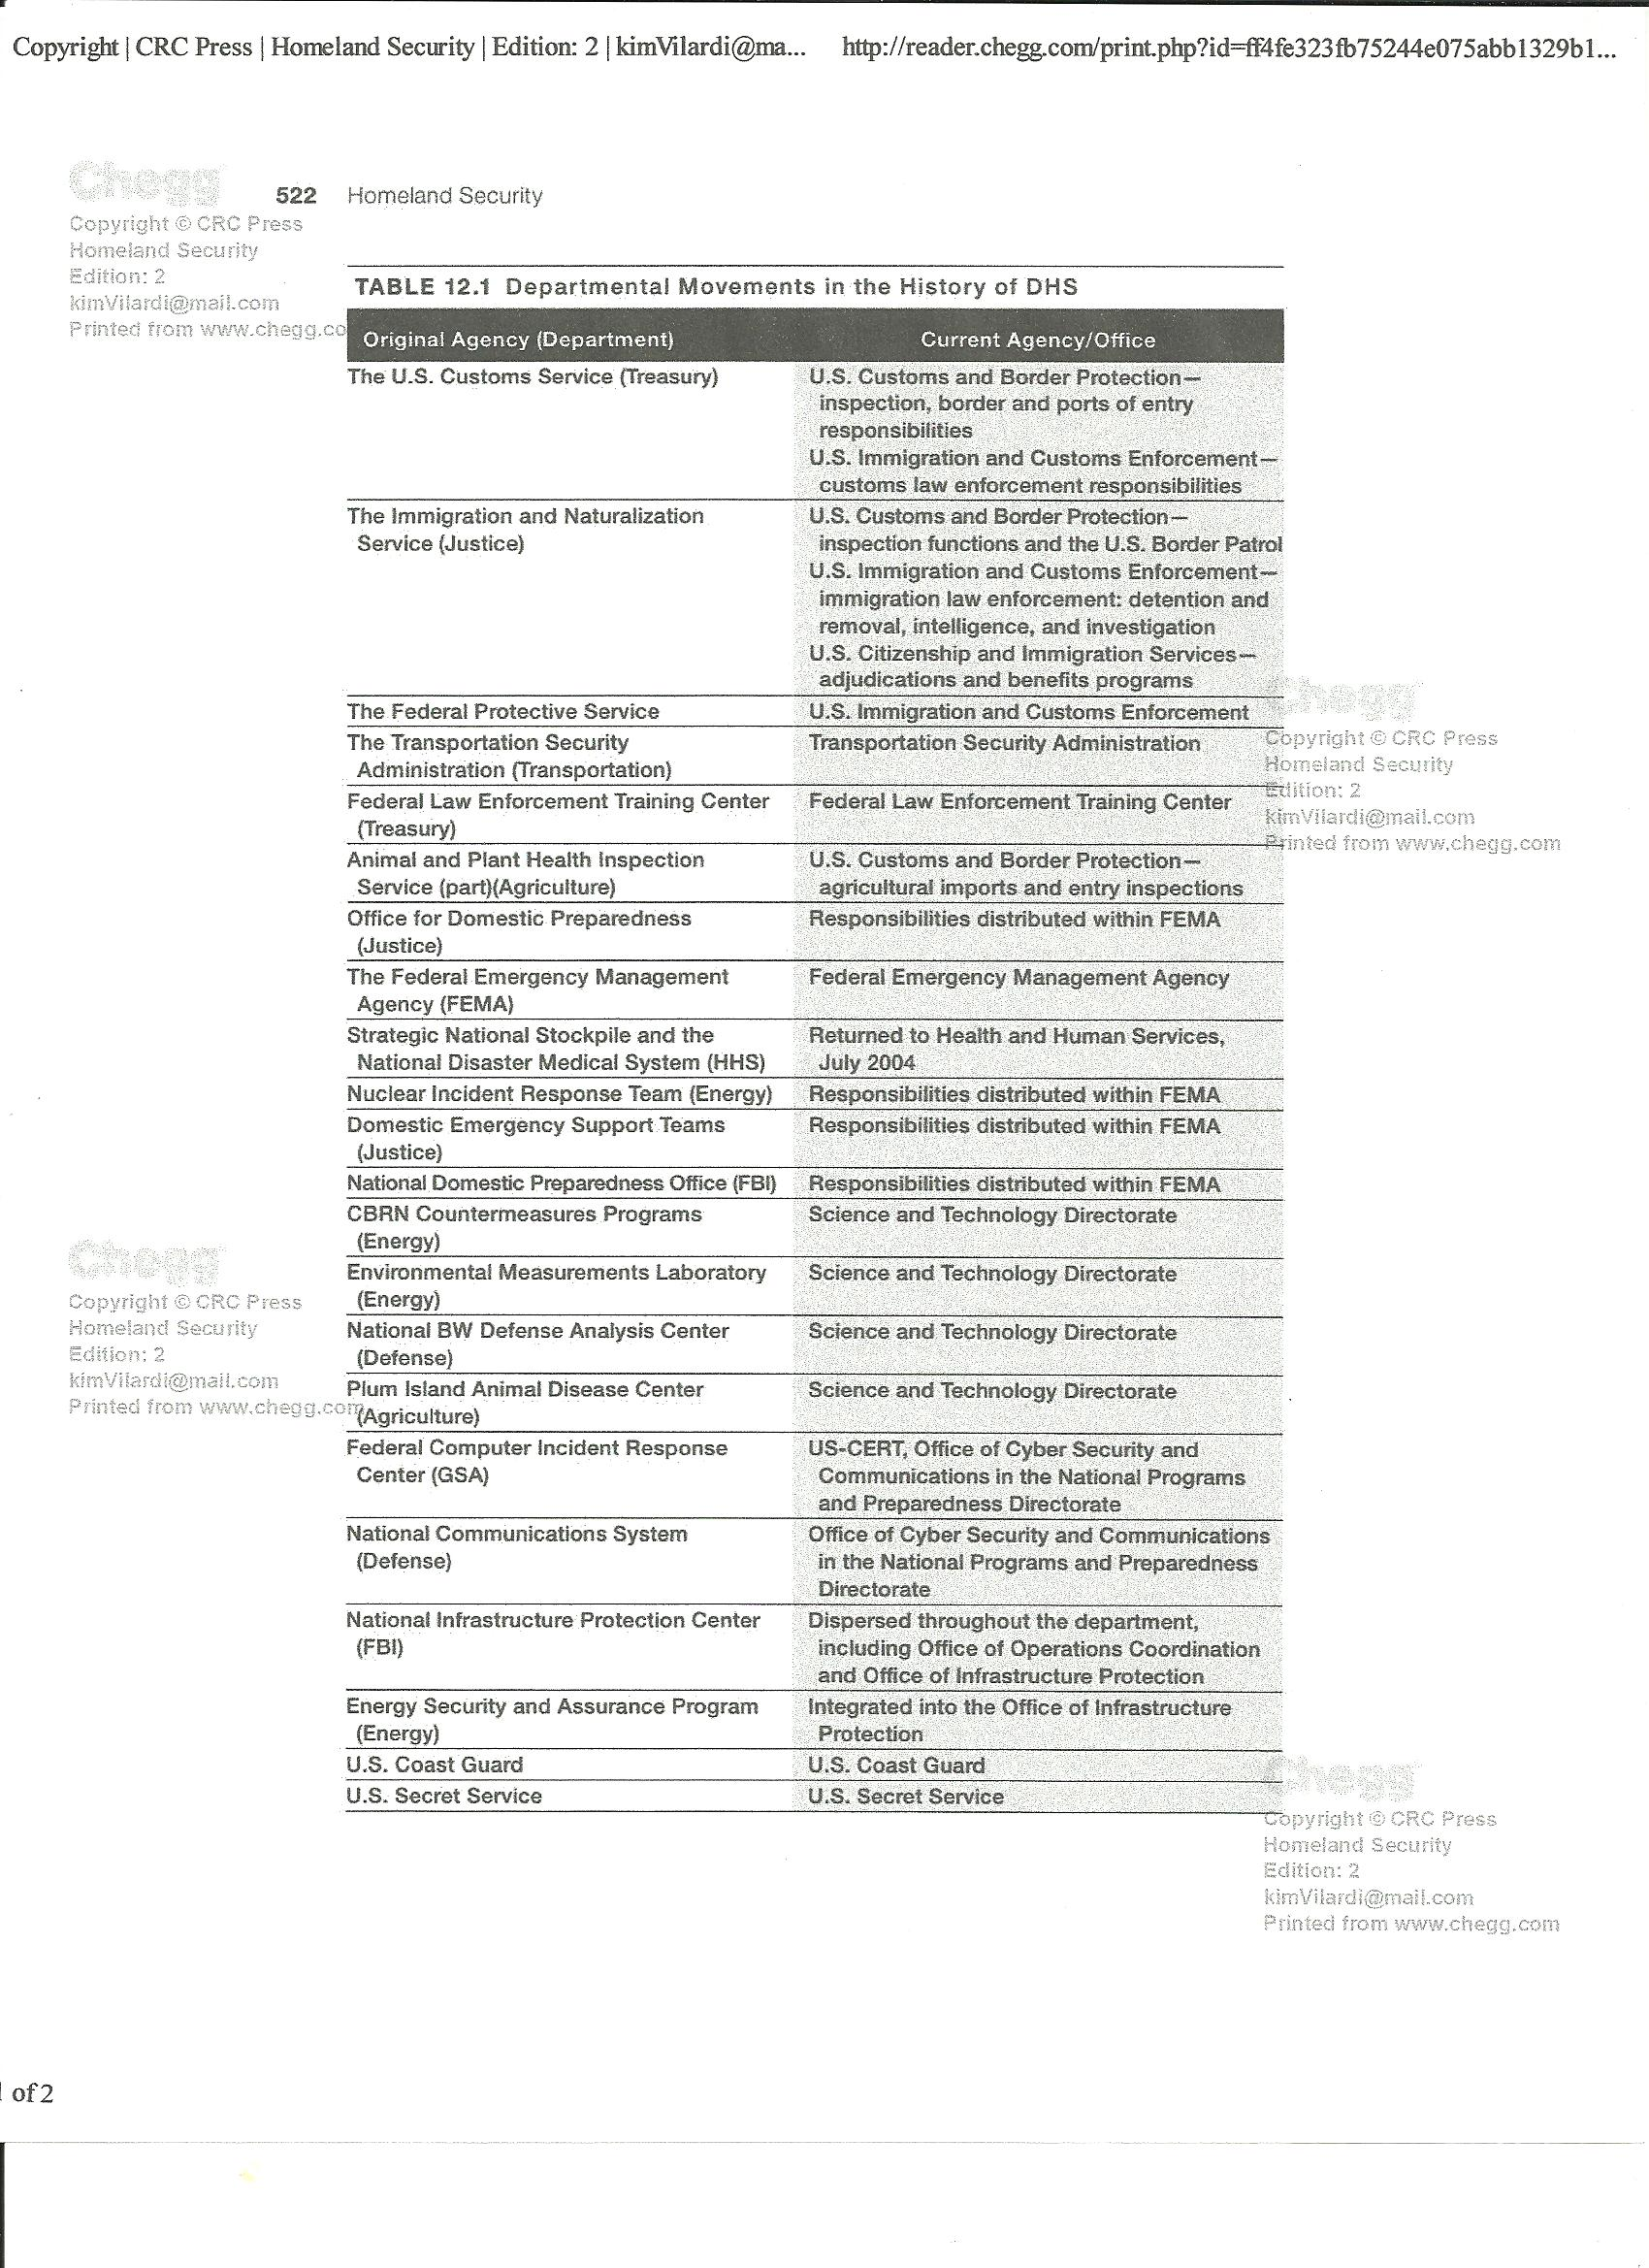 By 2005, departmental changes were being referred to as structural adjustments. Change continued its unabated pace with new recommendations for the department. New oﬃces, directors, realignments, and mergers continued without reservation. For example, a new director of operations coordination was implemented. The director’s primary function was to improve coordination and eﬃciency of operations. By this time, DHS was tackling so many functions that it was feeling the pressure and stress of nonaligned functions. Why else would DHS need a director of operations coordination? In general, DHS continues to realign itself and is trying to serve many masters. For the future health of the Agency, DHS may need to adhere to a different model that sticks to the fundamentals of what the department can and should do. To that end, what the future holds remains to be seen.

Question:
After reading Chapter 12 offer your thoughts and reasoning on the following:
Growth without reason – Closely examine section 12.2 and the contentions of the author. Do you agree or disagree with the author? Write 250 words
DHS: Curbing Expansionism in Mission. Closely examine section 12.3 and the suggestions of the author. Do you agree or disagree with the author? Write 250 words

Please answer all questions with good solution and proper in text citation and Reference.

Discussion Questions Rubric
Competency | Exceeds Expectation | Meets Expectation | Does Not Meet Expectation | No Evidence
Points: 14 | 14 Points | 11-13 Points | 8-10 Points | 7 and Below
General | Timeliness: (6)  Initial post completed by midnight (MST) on Thursday.  Minimum Words: (4)  Each initial response post contains at least 150 words each.  Each follow up responses contains at least 200 words  Grammar & Syntax: (4)  Each post is free of spelling, syntax and grammar errors. | Timeliness: (3-6)  Initial post completed by midnight (MST) on Thursday.  Each initial post that is posted late without instructor excuse receives a three (3) point deduction each.  Minimum Words: (1-4)  Each initial response post contains at least 150 words each.  Each follow up responses contains at least 200 words  Each post below the minimum number of words receives a one (1) point deduction.  Grammar & Syntax: (1-4)  All postings combined contain no more than 3 spelling, syntax or grammar errors. Each error equals one (1) point. | Timeliness: (0-6)  Initial post completed by midnight (MST) on Thursday.  Each initial post that is posted late without instructor excuse receives a three (3) point deduction each.  Minimum Words: (0-4)  Each initial response post contains 149 or less words each.  Each follow up response contains 199 words or less  Each post below the minimum number of words receives a one (1) point deduction.  Grammar & Syntax: (0-4)  All postings combined contain no more than 3 spelling, syntax or grammar errors. Each error equals one (1) point. | Timeliness: (0-6)  Initial post completed by midnight (MST) on Thursday.  Each initial post that is posted late without instructor excuse receives a three (3) point deduction each.  Minimum Words: (0-4)  Each initial response post contains 149 or less words each.  Each follow up response contains 199 words or less  Each post below the minimum number of words receives a one (1) point deduction.  Grammar & Syntax: (0-4)  All postings combined contain no more than 3 spelling, syntax or grammar errors. Each error equals one (1) point.
Points: 36 | 36 Points | 29-35 Points | 21-28 Points | 20 and Below
Content | Relevant: (12)  Each initial response relates to the specific question stated and each subsequent response to another student is substantive and applicable to the initial response of the specific student response being addressed.  Major Points: (12)  Major points are identified and clearly stated and supported.  Understandable: (12)  The initial response or follow up response is logically sound and comprehensive. | Relevant: (6-12)  Each initial response relates to the specific question stated and each subsequent response to another student is substantive and applicable to the initial response of the specific student response being addressed.  Each non-relevant post will receive a three (3) point deduction.  Major Points: (6-12)  Major points are identified and clearly stated and supported.  Each post without stated major points will receive a three (3) point deduction.  Understandable: (6-12)  The initial response or follow up response is logically sound and comprehensive.  Each post, which is unable to be understood will receive a three (3) point deduction | Relevant: (0-12)  Each initial response relates to the specific question stated and each subsequent response to another student is substantive and applicable to the initial response of the specific student response being addressed.  Each non-relevant post will receive a three (3) point deduction.  Major Points: (0-12)  Major points are identified and clearly stated and supported.  Each post without stated major points will receive a three (3) point deduction.  Understandable: (0-12)  The initial response or follow up response is logically sound and comprehensive.  Each post, which is unable to be understood will receive a three (3) point deduction | Relevant: (0-12)  Each initial response relates to the specific question stated and each subsequent response to another student is substantive and applicable to the initial response of the specific student response being addressed.  Each non-relevant post will receive a three (3) point deduction.  Major Points: (0-12)  Major points are identified and clearly stated and supported.  Each post without stated major points will receive a three (3) point deduction.  Understandable: (0-12)  The initial response or follow up response is logically sound and comprehensive.  Each post, which is unable to be understood will receive a three (3) point deduction

Discussion Question (1 Unit Discussion Question) Rubric
Competency | Exceeds Expectation | Meets Expectation |  | Does Not Meet Expectation | No Evidence
Points:  11 | 11 Points | 9-10 Points |  | 7-8 Points | 6 and Below
General | Timeliness: (5)  Initial post completed by midnight (MST) on Thursday.  Minimum Words: (3)  Each initial response post contains at least 150 words each.  Each follow up responses contains at least 200 words  Grammar & Syntax: (3)  Each post is free of spelling, syntax and grammar errors. | Timeliness: (5)  Initial post completed by midnight (MST) on Thursday.  Minimum Words: (1-3)  Each initial response post contains at least 150 words each.  Each follow up responses contains at least 200 words  Each post below the minimum number of words receives a one (1) point deduction.  Grammar & Syntax: (1-3)  All postings combined contain no more than 3 spelling, syntax or grammar errors. Each error equals one (1) point. |  | Timeliness: (5)  Initial post completed by midnight (MST) on Thursday.  Minimum Words: (1-3)  Each initial response post contains 149 or less words each.  Each follow up response contains 199 words or less  Each post below the minimum number of words receives a one (1) point deduction.  Grammar & Syntax: (1-3)  All postings combined contain no more than 3 spelling, syntax or grammar errors. Each error equals one (1) point. | Timeliness: (0-5)  Initial post completed by midnight (MST) on Thursday.  Each initial post that is posted late without instructor excuse receives a three (5) point deduction each.  Minimum Words: (1-3)  Each initial response post contains 149 or less words each.  Each follow up response contains 199 words or less  Each post below the minimum number of words receives a one (1) point deduction.  Grammar & Syntax: (1-3)  All postings combined contain no more than 3 spelling, syntax or grammar errors. Each error equals one (1) point.
Points:  39 | 39 Points | 31-38 Points | 23-30 Points |  |  | 22 and Below
Content | Relevant: (13)  Each initial response relates to the specific question stated and each subsequent response to another student is substantive and applicable to the initial response of the specific student response being addressed.  Major Points: (13)  Major points are identified and clearly stated and supported.  Understandable: (13)  The initial response or follow up response is logically sound and comprehensive. | Relevant: (8-13)  Each initial response relates to the specific question stated and each subsequent response to another student is substantive and applicable to the initial response of the specific student response being addressed.  Each non-relevant post will receive a five (5) point deduction if the initial response and four (4) point deduction if a follow up response.  Major Points: (8-13)  Major points are identified and clearly stated and supported.  Each post without stated major points will receive a five (5) point deduction if the initial response and four (4) point deduction if a follow up response.  Understandable: (8-13)  The initial response or follow up response is logically sound and comprehensive.  Each post, which is unable to be understood will receive a five (5) point deduction if the initial response and four (4) point deduction if a follow up response. | Relevant: (4-13)  Each initial response relates to the specific question stated and each subsequent response to another student is substantive and applicable to the initial response of the specific student response being addressed.  Each non-relevant post will receive a five (5) point deduction if the initial response and four (4) point deduction if a follow up response.  Major Points: (4-13)  Major points are identified and clearly stated and supported.  Each post without stated major points will receive a five (5) point deduction if the initial response and four (4) point deduction if a follow up response.  Understandable: (4-13)  The initial response or follow up response is logically sound and comprehensive.  Each post, which is unable to be understood will receive a five (5) point deduction if the initial response and four (4) point deduction if a follow up response. |  |  | Relevant: (0-13)  Each initial response relates to the specific question stated and each subsequent response to another student is substantive and applicable to the initial response of the specific student response being addressed.  Each non-relevant post will receive a five (5) point deduction if the initial response and four (4) point deduction if a follow up response.  Major Points: (0-13)  Major points are identified and clearly stated and supported.  Each post without stated major points will receive a five (5) point deduction if the initial response and four (4) point deduction if a follow up response.  Understandable: (0-13)  The initial response or follow up response is logically sound and comprehensive.  Each post, which is unable to be understood will receive a five (5) point deduction if the initial response and four (4) point deduction if a follow up response.

Core Assessment Rubric
Competency | Exceeds Expectation | Meets Expectation | Does Not Meet Expectation | No Evidence
Points: 40 | 36-40 Points | 28-35 Points | 24-27 Points | 23 and Below
Evaluation  Outcomes  1-6 | The research paper demonstrates a thorough appraisal of the researched information. The paper is presented as a congruous and thoughtful exposition of ideas. | The research paper demonstrates a satisfactory appraisal of the researched information. The paper is presented as a thoughtful exposition of ideas. | The research paper demonstrates a minimal appraisal of the researched information. The paper is presented as a disparate exposition of ideas. | The research paper demonstrates no appraisal of the researched information. The paper is presented as an incongruous exposition of ideas.
Points: 30 | 27-30 Points | 21-26 Points | 18-20 Points | 17 and Below
Synthesis  Outcomes  1-6 | The research paper is a consolidated integration of the fundamental principles of homeland security. Extends research well beyond minimum requirements. | The report presents a basic compilation of fundamental principles of homeland security, but integration of research themes is weak. | The report responds to some individual issues of homeland security, but with insufficient consolidation of ideas. | No evidence of combining researched material into a consistent whole.
Points: 30 | 27-30 Points | 21-26 Points | 18-20 Points | 17 and Below
Analysis  Outcomes  1-6 | Research paper completely examines the fundamental principles of homeland security. It analyzes key elements using 8 or more course-external sources. | Research paper examines the fundamental principles of homeland security, but may miss a few points. It analyzes key elements using 6-7 course-external sources. | Research paper fails to satisfactorily examine the fundamental principles of homeland security. It analyzes key elements using 1-5 course-external sources. | Research paper fails to examine the fundamental principles of homeland security. It uses no course-external sources.
Points: 30 | 27-30 Points | 21-26 Points | 18-20 Points | 17 and Below
Application  Outcomes  1-6 | Research paper applies multiple instances and exceptional understanding of terminology and concepts specific to the course core learning outcomes throughout. | Research paper applies sufficient and satisfactory use of terminology and concepts specific to the course core learning outcomes throughout. | Research paper applies minimal use of terminology and concepts specific to the course core learning outcomes throughout. | Research paper fails to demonstrate an understanding of terminology and concepts specific to the course core learning outcomes.
Points: 40 | 36-40 Points | 28-35 Points | 24-27 Points | 23 and Below
Content of Communication  Outcomes  1-6 | Research paper conveys complete and exceptional information on one selected organization of the Department of Homeland Security. | Research paper conveys sufficient information on one selected organization of the Department of Homeland Security. | Research paper conveys minimal information on one selected organization of the Department of Homeland Security. | Research paper conveys no information on one selected organization of the Department of Homeland Security. .
Points: 30 | 27-30 Points | 21-26 Points | 18-20 Points | 17 and Below
Technical Skill in Communicating  Outcomes  1-6 | Research paper contains all required technical components: 8 pages in length (excluding required cover sheet or title page and reference page), typed, double-spaced. Written in APA Style, including in-text source citations. Contains fewer than five grammatical or spelling errors. | Research paper contains most required technical components. Contains more than five grammatical or spelling errors but errors do not detract from understanding. Written in APA Style, but may have a few formatting errors. | Research paper contains few required technical components. Contains more than five grammatical or spelling errors that detract from understanding. APA Style usage is barely evident. | Research paper contains no required technical components. There are so many errors in the APA writing convention, in the paper presentation, or in grammar and/or spelling that it is difficult to read.

