Math 009 Introductory Algebra Name______________________________
Final Examination: Spring, 2017, US1 Instructor __________________________
Answer Sheet
Instructions:
This is an open-book exam. You may refer to your text and other course materials as you work on the exam and you may use a calculator. Record your answers and show your work on this document. You must show your work to receive credit: answers given with no work shown will not receive credit. You may type your work using plain-text formatting or an equation editor, or you may hand-write your work and scan it. If you choose to scan your work, note that most scanners have a setting that will allow you to create one PDF document from all of the pages of your Answer Sheet – please make use of this option if it is available on your scanner. Whether you type your work or write it by hand, show work neatly and correctly, following standard mathematical conventions. Each step should follow clearly and completely from the previous step. If necessary, you may attach extra pages.
You must complete the exam individually. Neither collaboration nor consultation with others is allowed. Your exam will receive a zero grade unless you complete the following honor statement.
Academic Integrity and Honor Statement

I understand the required conditions, the possibility of failure of this Final Exam, this Math 009 class, and/or disciplinary action by the University of Maryland University College if academic integrity is violated in taking this Math 009 Final Exam. I hereby certify that I have taken this Math 009 Final Exam alone, without receiving or giving any help/consultation on this Final Exam.

Name (PLEASE PRINT)_____________________________________
Signature________________________________________________
UMUC Student Number_____________________________________
Date_____________________________________________________
Problem Number | Solution
1 | WORK:  ANSWER:
2 | WORK:  ANSWER:
3 | WORK:  ANSWER:
4 | WORK:  ANSWER:
5 | WORK:  ANSWER:
6 | WORK:  ANSWER:
7 | WORK:  ANSWER:
8 | WORK:  ANSWER:
9 | WORK:  ANSWER:
10 | WORK:  ANSWER:
11 | WORK:  ANSWER:
12 | WORK:  ANSWER:
13 | WORK:  ANSWER:
14 | WORK:  ANSWER:
15 | WORK:  ANSWER:
16 | WORK:  ANSWER:
17 | Use the “drag and drop” line and points to graph your line.  WORK:  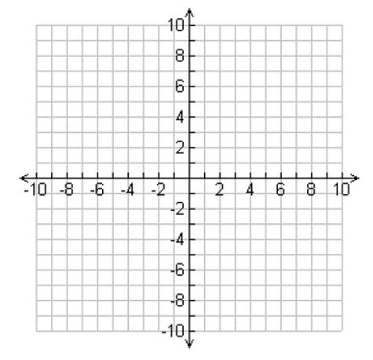  ANSWER:
18 | WORK:  ANSWER:
19 | WORK:  ANSWER:
20 | WORK:  ANSWER:
21 | WORK:  ANSWER:
22 | WORK:  ANSWER:
23 | WORK:  ANSWER:
24 | WORK:  ANSWER:
25 | WORK:  ANSWER:

