- Which of the following functions is graphed below?
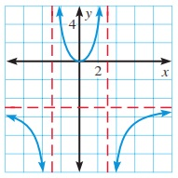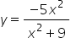
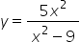
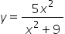
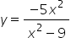

- What is the horizontal asymptote of the graph of the following function?
Y = 10x² -1
X³ +8

y=-10
y=0
y=2
y=10

- Which of the following functions has a graph with a slant asymptote?

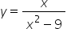
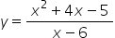
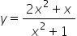
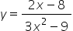

- Identify the equations of the vertical asymptotes of the following function.
F(x) = 3
X²-7x+10

x​ = -5, ​x​ = -2
x​ = 5, ​x​ = 2
x​ = -5, ​x​ = 2
x​ = 5, ​x​ = -2

- Identify all holes in the function below.
F(x) = x²-4x-5
X²+3x+2

x​ = -2
x​ = -1
x​ = 5
x​ = 1
- Identify vertical asymptotes in the function below.
F(x) = x² – 8x +7
X² + 2x -3

x​ = -3
x​ = 1, ​x​ = -3
x​ = 1
x​ = 7

- Which of the following graphs shows the function below?
F(x) = x²-2x-15
x-5

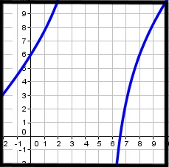

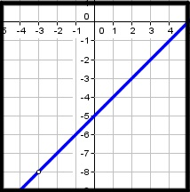
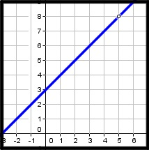
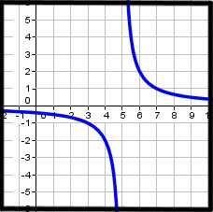
- Which of the following functions is shown in the graph below?
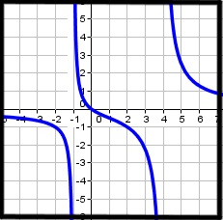
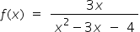

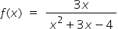

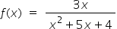

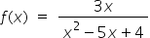

- Which of the following functions is shown in the graph below?
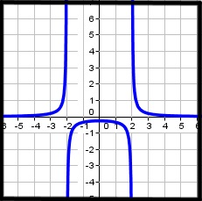
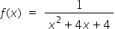
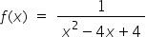
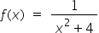
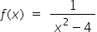
- Which of the following functions is shown in the graph below?
