MAT1222 - Algebra

Module 02 Written Assignment

Instructions: Complete the two problems given below. You need to show ALL of your work and steps. You will also need to explain in English how you solved it and found the answer.

- Jane takes a job at the local Marcy's department store. Her job pays $8.00 per hour. The graph below shows how much Jane earns for working from 0 to 40 hours in a week.

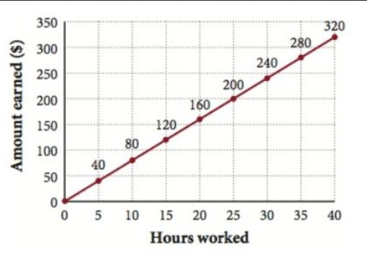

Using this graph above, answer the following questions in complete sentences with explanations on how you found your answers.

- List three ordered pairs that lie on the line graph.
Give answer and explanation here.
- How much will she earn if she works 40 hours a week?
Give answer and explanation here.
- If her check for one week is $240, how many hours did she work?
Give answer and explanation here.
- She works 35 hours one week, but her paycheck before deductions are subtracted is for $260. Is this correct? Explain.
Give answer and explanation here.

- Lukas is going on a trip to Florida for Vacation. The number of hours, $h,$ he’s driven and the distance, $d,$ he’s driven from his home is given in the graph below. Give the linear equation that would represent how far he’s driven.

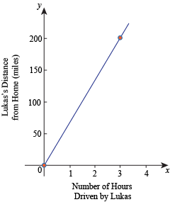

- Solve the problem in the area below. Include all of your steps (you may insert a picture of your work below).
Show work here
- Explain all of your steps in English below. Make sure you are thoroughly explaining yourself in DETAIL!
Include an explanation here
- Interpret your answer in a conclusion statement below. (Hint: Answer the question in the word problem.)
Conclusion statement here.

