Exam 2
When Spheres-R-Us ships bags of golf balls, the number of balls in each bag must be within 6 balls of 300. Write a compound inequality and an absolute value inequality for an acceptable number of golf balls b in each bag.

A.
;

B.
;

C.
;

D.
;

Feedback:Great job!

Question 2 of 20
5.0/ 5.0 Points
To which set of numbers does the number below belong?

A. natural numbers

B. rational numbers

C. integers

D. irrational numbers

Feedback:Great job!

Question 3 of 20
0.0/ 5.0 Points
Solve the inequality. Graph the solution.
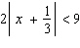

A.
< x <
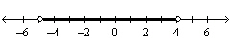

B.
< x <
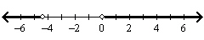

C.
x < or x >
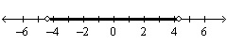

D.
x < or x >
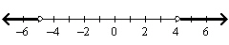

Feedback:Please refer to: Lesson 1-6, pp. 41-46, Example Problem 4, Problems 25-30

Question 4 of 20
0.0/ 5.0 Points
What inequality represents the sentence below?
The product of a number and 5 is no more than 8.

A.

B.
5n < 8

C.

D.
5n > 8

Feedback:Please refer to: Lesson 1-5, pp. 33-37, Example Problem 1, Problems 10-13

Question 5 of 20
5.0/ 5.0 Points
Evaluate the expression for the given value of the variable(s).
5a + 5b; a = -6, b = -5

A.
-55

B.
55

C.
5

D.
-5

Feedback:Great job!

Question 6 of 20
5.0/ 5.0 Points
Insert <, >, or = to make the sentence true.

A. =

B. <

C. >

Feedback:Great job!

Question 7 of 20
5.0/ 5.0 Points
Combine like terms. What is a simpler form of the expression?
-3(-4y + 3) + 7y

A.
19y - 9

B.
10y

C.
-19y + 3

D.
-19y - 9

Feedback:Great job!

Question 8 of 20
0.0/ 5.0 Points
So lve the inequality. Graph the solution set.
26 + 6b 2(3b + 4)

A.
all real numbers
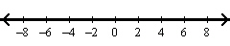

B.
b 1 1/2
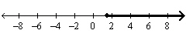

C.
no solutions
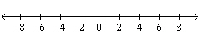

Feedback:Please refer to: Lesson 1-5, pp. 33-37, Example Problem 2, Problems 14-23

Question 9 of 20
0.0/ 5.0 Points
Name the property of real numbers illustrated by the equation.
-4(x + 3) = -4x - 12

A. Commutative Property of Addition

B. Associative Property of Addition

C. Associative Property of Multiplication

D. Distributive Property

Feedback:Please refer to: Lesson 1-2, pp. 11-14, Example Problem #4, Problems 35-40

Question 10 of 20
0.0/ 5.0 Points
Insert <, >, or = to make the sentence true.

A. <

B. >

C. =

Feedback:Please refer to: Lesson 1-2, pp. 11-14, Example Problem #3, Problems 23-34

Question 11 of 20
0.0/ 5.0 Points
Solve the problem by writing an inequality.
If the perimeter of a rectangular picture frame must be less than 200 in., and the width is 36 in., what must the height h of the frame be?

A. h < 64 in.

B. h < 128 in.

C. h > 64 in.

D. h > 128 in.

Feedback:Please refer to: Lesson 1-5, pp. 33-37, Example Problem 3, Problems 24-27

Question 12 of 20
0.0/ 5.0 Points
Evaluate the expression for the given value of the variable(s).

A. 19

B. 17

C. -11

D. 21

Feedback:Please refer to: Lesson 1-3, pp. 18-21, Example Problem 3, Problems 16-19

Question 13 of 20
0.0/ 5.0 Points
Name the property of real numbers illustrated by the equation.
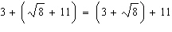

A. Associative Property of Multiplication

B. Commutative Property of Multiplication

C. Distributive Property

D. Associative Property of Addition

Feedback:Please refer to: Lesson 1-2, pp. 11-14, Example Problem #4, Problems 35-40

Question 14 of 20
0.0/ 5.0 Points
Name the property of real numbers illustrated by the equation.

A.
Closure Property

B.
Commutative Property of Multiplication

C.
Commutative Property of Addition

D.
Associative Property of Addition

Feedback:Please refer to: Lesson 1-2, pp. 11-14, Example Problem 4, Problems 35-40

Question 15 of 20
5.0/ 5.0 Points
Graph the number below on a number line.

A.
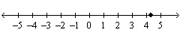

B.
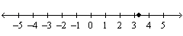

C.
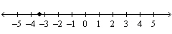

D.
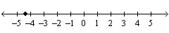

Feedback:Great job!

Question 16 of 20
5.0/ 5.0 Points
What is the sum of the solutions of ?

A. 2

B.
1 1/2

C. -2

D. 0

Feedback:Great job!

Question 17 of 20
5.0/ 5.0 Points
Solve the equation. Check for extraneous solutions.

A.
x = or x =

B.
x = or x =

C.
x =

D.
x =

Feedback:Great job!

Question 18 of 20
0.0/ 5.0 Points
Evaluate the expression for the given value of the variable(s).
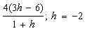

A. 32

B. 48

C. -48

D. 30

Feedback:Please refer to: Lesson 1-3, pp. 18-21, Example Problem 3, Problems 16-19

Question 19 of 20
0.0/ 5.0 Points
A furniture maker uses the specification for the width w in inches of a desk drawer.
Write the specification as an absolute value inequality.

A.

B.

C.

D.

Feedback:Please refer to: Lesson 1-6, pp. 41-46, Example Problem 6, Problems 37-42

Question 20 of 20
0.0/ 5.0 Points
Solve the inequality. Graph the solution set.
2r – 9 – 6

A.
r
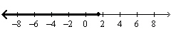

B.
r
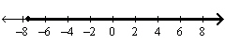

C.
r

D.
r
