Exam 6
What is the inverse of the given function? y = 3x + 9

A. y= 3x-3

B. y=3x+3

C. y = 1/3x + 3

D. y=1/3x-3

Question 2 of 20
0.0/ 5.0 Points
Is relation t a function? Is the inverse of relations t a function?
Relation t
x | 0 | 1 | 2 | 3
﻿﻿y | -2 | 1 | 10 | 2

A.
Relation t is not a function. The inverse of relation t is not a function.

B.
Relation t is not a function. The inverse of relation t is not a function.

C.
Relation t is not a function. The inverse of relation t is a function.

D.
Relation t is a function. The inverse of relation t is a function.

Question 3 of 20
0.0/ 5.0 Points
What is the inverse of the given relation?
y = 4x - 8

A.
y = 4x - 2

B.
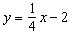

C.
y = 4x + 2

D.
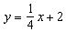

Question 4 of 20
0.0/ 5.0 Points
Let f(x) = -5x - 4 and g(x) = 6x - 7. Find f(x) + g(x)

A. -11x = 3b

B. x - 11

C. x + 3

D. -11x - 11

Feedback:Please refer to:
Lesson 6-6. Example 1

Question 5 of 20
0.0/ 5.0 Points
Let f(x) = x² + 6 and 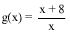 . Find ( g o f)( -7)

A.
63
55

B.
-57
7

C.
384
7

D.
295
49

Question 6 of 20
0.0/ 5.0 Points
A store is offering a 25% discount on all items. Also, employees get a 10% employee discount. If you are an employee which discount would you want to be applied first to save the most money?

A. 25%

B. 10%

C. It doesn’t matter which discount is applied first, the result is the same.

D. Not enough information is given

Question 7 of 20
0.0/ 5.0 Points
Graph y = -4x² - 2 and its inverse.

A.
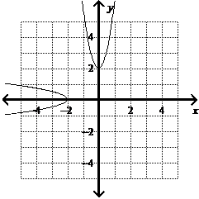

B.
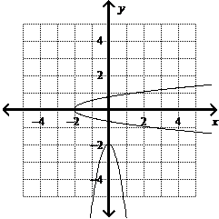

C.
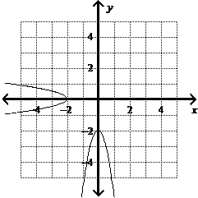

D.
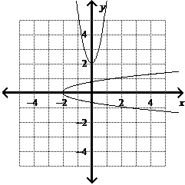

Question 8 of 20
0.0/ 5.0 Points
Let f(x) = -2x - 7 and g(x) = -4x + 3. Find (f o g)(-5)

A.
-9

B.
23

C.
3

D.
-53

Question 9 of 20
0.0/ 5.0 Points
Let f(x) = 3x - 6 and g(x) = x - 2. Find and its domain

A. 3; all real numbers except x = 2

B.
3; all real numbers

C. 3; all real numbers except x = 3

D. 1; all real numbers

Question 10 of 20
0.0/ 5.0 Points
For the function f(x) = x + 9, find (f o f⁻¹)(5)

A. 5

B. 25

C. 14

D. -5

Question 11 of 20
0.0/ 5.0 Points
What is the inverse of the given function? y = 7x² - 3.

A.
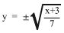

B.
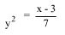

C.
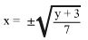

D.
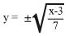

Question 12 of 20
0.0/ 5.0 Points
Let f(x) = -3x - 4 and g(x) = 2x - 6. Find

A. 28

B. -20

C. 17

D. 56

Question 13 of 20
0.0/ 5.0 Points
f(x) = x² - 16 and g(x) = x+4. Find and its domain

A.
x - 4; all real numbers except x ≠ -4

B.
x - 4; all real numbers except x ≠ 4

C.
x + 4; all real numbers except x ≠ 4

D.
x + 4; all real numbers except x ≠ 4

Question 14 of 20
0.0/ 5.0 Points
For the function f(x) = (8-2x)² ,find f⁻¹ . Determine whether f⁻¹ is a function.

A.
f⁻¹(x) = 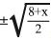; f⁻¹ is not a function

B.
f⁻¹(x) = 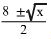;f⁻¹ is not a function

C.
f⁻¹(x) = 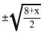;f⁻¹ is a function

D.
f⁻¹(x) = 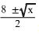;f⁻¹ is a function

Question 15 of 20
0.0/ 5.0 Points
Let f(x) = x + 2 and g(x) = x² Find ( g o f)(-5)

A.
9

B. -10

C.
-3

D.
49

Question 16 of 20
0.0/ 5.0 Points
find f ⁻¹

A.
f⁻¹ (x) = x² +25; y> 5

B.
f⁻¹ (x) = x² +25; y> 25

C.
f ⁻¹ (x) = (x + 5)²; y > 5

D.
f ⁻¹ (x) = x² + 5; y > 5

Question 17 of 20
0.0/ 5.0 Points
Let f(x) = 4x - 5 and g(x) = 6x - 3. Find f(x) - g(x).

A. -2x - 8

B. -2x - 2

C. 2x + 5

D. 2x - 5

Feedback:Please refer to:
Lesson 6-6. Example 1

Question 18 of 20
5.0/ 5.0 Points
Let f(x) = 3x + 2 and g(x) =7x + 6. Find f ·g and its domain.

A.
21x² +32x + 12; all real numbers except x = -6/7

B.
21x² + 32x + 12; all real numbers

C.
6x² + 4x + 42; all real numbers

D.
6x² + 4x + 42; all real numbers except x = 2/3

Feedback:Great job!

Question 19 of 20
5.0/ 5.0 Points
For the function f(x) = x² -12, find (f o f⁻¹)(4)

A. 0

B. 4

C. 10

D. 6

Question 20 of 20
0.0/ 5.0 Points
Is relation t a function? Is the inverse of relations t a function?
Relation t
x | 0 | 2 | 4 | 6
y | -8 | -7 | -4 | -4

A.
Relation t is a function. The inverse of relation t is not a functions

B. Relation t is not a function. The inverse of relation t is not a function.

C.
Relation t is a function. The inverse of relation t is a function.

D. Relation t is not a function. The inverse of relation t is a function

