Exam 5

What is the simplest form of the radical expression?

A.

B.

C.

D. not possible to simplify

Feedback:
Please refer:
Lesson 6-3, pg. 375, Example Problem 1, Problems #10-15

Question 2 of 20
0.0/ 5.0 Points

What is the simplest form of the expression?
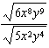

A.
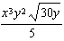

B.
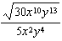

C.

D. none of these

Feedback:Please refer to:
Lesson 6-2, pg. 369, Example Problem 4, Problems #37-42

Question 3 of 20
0.0/ 5.0 Points
The area of a circular trampoline is 112.07 square feet. What is the radius of the trampoline? Round to the nearest hundredth.

A. 35.67 feet

B. 10.59 feet

C. 5.97 feet

D. 3.37 feet

Feedback:Please refer to:
Lesson 6-3, pg. 375, Example Problem 2, Problems #16

Question 4 of 20
0.0/ 5.0 Points

What is a simpler form of the radical expression?

A.

B.

C.

D.

Feedback:Please refer to:
Lesson 6-1 and 6-2, pg. 363, 386, Example Problem 3 and Example Problem 2 , Problems #26-29, and #19-27

Question 5 of 20
0.0/ 5.0 Points
What is the simplest form of the expression?

A.

B.

C.

D.

Question 6 of 20
0.0/ 5.0 Points
Find all the real fourth roots of 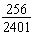.

A.
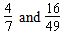

B.
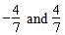

C.
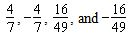

D.

Feedback:Please refer to:
Lesson 6-1, pg.362, Example Problem 1,2, Problems #10-25

Question 7 of 20
0.0/ 5.0 Points
Graph the equation.

A.
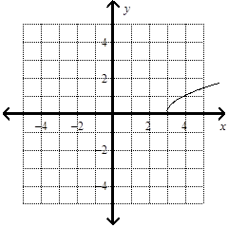

B.
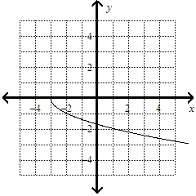

C.
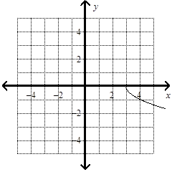

D.
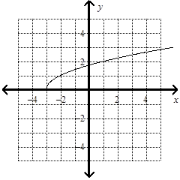

Feedback:Please refer to:
Lesson 6-8, pg. 415-416, Example Problem 3, Problems #21-23

Question 8 of 20
5.0/ 5.0 Points

What is the solution of the equation?

A. 44

B. -2

C. 28

D. 36

Feedback:Great job!

Question 9 of 20
0.0/ 5.0 Points

What is the solution of the equation? Eliminate any extraneous solutions.

A. -4

B. -9

C. -9 and -4

D. 9 and -4

Feedback:Please refer to:
Lesson 6-5, pg.393, Example Problem 4, Problems #26-34

Question 10 of 20
0.0/ 5.0 Points

How can you write the expression with rationalized denominator?
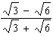

A.
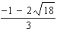

B.
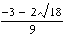

C.

D.

Feedback:Please refer to:
Lesson 6-3, pg. 377, Example Problem 6, Problems #33-36

Question 11 of 20
5.0/ 5.0 Points
Find all the real cube roots of 0.000027.

A. 0.0009 and -0.0009

B. 0.03

C. 0.03 and -0.03

D. 0.0009

Feedback:Great job!

Question 12 of 20
0.0/ 5.0 Points

Find the real-number root.

A. no real number root

B. 1.6

C. -1.6

D. -1.28

Feedback:Please refer to:
Lesson 6-1, pg. 362, Example Problem 2, Problems #22-25

Question 13 of 20
0.0/ 5.0 Points
What is the solution of ?

A.
x = 0 and x = -16

B.
x = 16 and x = -16

C.
x = 0 and x = 16

D.
x = 0

Feedback:Please refer to:
Lesson 6-5, pg. 394, Example Problem 5, Problems #35-44

Question 14 of 20
0.0/ 5.0 Points

Multiply and simplify if possible.

A.

B.

C.

D. not possible

Feedback:Please refer to:
Lesson 6-2, pg. 367, Example Problem 1, Problems #10-18

Question 15 of 20
0.0/ 5.0 Points
A garden has width and length . What is the perimeter of the garden in simplest radical form?

A.
units

B. 91 units

C.
units

D.
units

Feedback:Please refer to:
Lesson 6-3, pg. 375, Example Problem 2, Problems #16

Question 16 of 20
0.0/ 5.0 Points
Find all the real square roots of .

A.
no real root

B.

C.
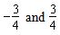

D.

Feedback:Please refer to:
Lesson 6-1, pg.362, Example Problem 1,2, Problems #10-25

Question 17 of 20
5.0/ 5.0 Points

What is the product of the radical expression?
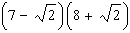

A.

B.

C.

D.

Feedback:Great job!

Question 18 of 20
5.0/ 5.0 Points

What is the solution of the equation?

A. 14

B. 2

C. 38

D. 26

Feedback:Great job!

Question 19 of 20
0.0/ 5.0 Points

What is the simplest form of the expression?

A. none of these

B.

C.

D.

Feedback:Please refer to:
Lesson 6-1 and 6-2, pg. 363, 386, Example Problem 3 and Example Problem 2 , Problems #26-29, and #19-27

Question 20 of 20
0.0/ 5.0 Points

What is the solution of the equation? Eliminate any extraneous solutions.

A.

B.

C.

D.

