Exam 3
y > |x-1| + 3

A.
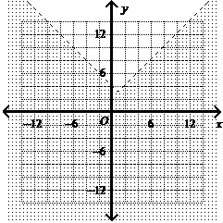

B.
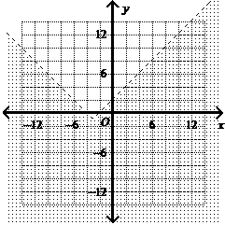

C.
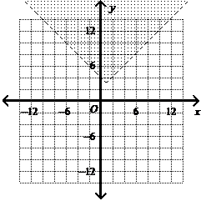

D.
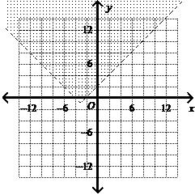

Question 2 of 20
0.0/ 5.0 Points
The function f(x) = -6x. The graph of g(x) is f(x)vertically stretched by a factor of 7 and reflected in the x-axis. What is the function rule for g(x)?

A.
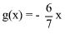

B.

g(x) = -42x

C.
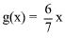

D.

g(x) = 42x

Feedback:
Please refer to: Lesson 2-6, p. 102, Example Problem 4, Problems 26-29

Question 3 of 20
5.0/ 5.0 Points
What is the graph of the inequality?
4x + 2y ≤ 6

A.
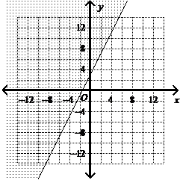

B.
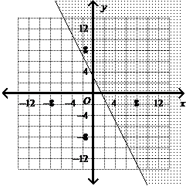

C.
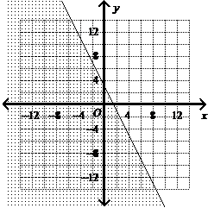

D.
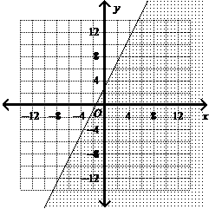

Feedback:Great job!

Question 4 of 20
5.0/ 5.0 Points
The function f(x) is represented by the table below. What are the corresponding values of g(x) for the transformation g(x) = 6f(x)?
x | f (x)
–7 | 8
–3 | 3
0 | –1
2 | 7
10 | 5

A.
x g(x)
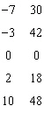

B.
x g(x)
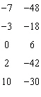

C.
x g(x)
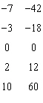

D.
x g(x)
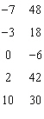

Feedback:Great job!

Question 5 of 20
5.0/ 5.0 Points
Write an equation for the following transformation of y = x: a vertical compression by a factor of

A. y = -4x

B.
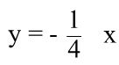

C. y = 4x

D.
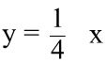

Feedback:Great job!

Question 6 of 20
5.0/ 5.0 Points
Let g(x) be the reflection of f(x) = x² +3 in the x-axis. What is the function rule for g(x)?

A. g(x) = -x² - 3

B. g(x) = -x² + 3

C. g(x) = x² - 3

D. g(x) = x² + 3

Question 7 of 20
0.0/ 5.0 Points
What is the graph of the inequality?
-3y ≥ 6x -3

A.
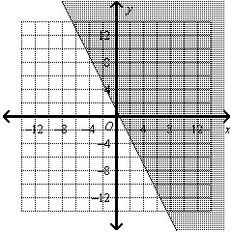

B.
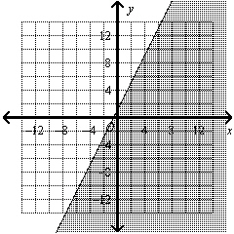

C.
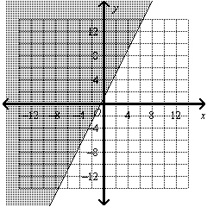

D.
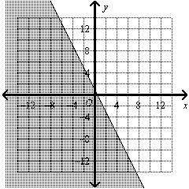

Question 8 of 20
0.0/ 5.0 Points
Find the function rule for g(x). The function f(x) = x² . The graph of g(x) is f(x) translated to the right 8 units and down 7 units. What is the function rule for g(x)?

A.
g(x) = (x + 7)² + 8

B.
g(x) = (x - 7)² - 8

C.
g(x) = (x + 8)² + 7

D.
g(x) = (x - 8)² - 7

Question 9 of 20
5.0/ 5.0 Points
If a function, f(x) is shifted to the left 4 unit(s), what function represents the transformation?

A. f(x) + 4

B. f(x) - 4

C. f(x-4)

D. f(x+4)

Feedback:Great job!

Question 10 of 20
5.0/ 5.0 Points
Which answer choice represents:
y ≥ |x+2| + 5

A.
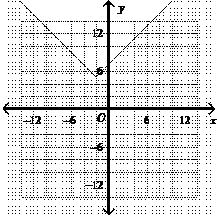

B.
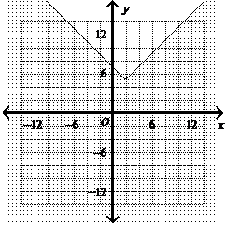

C.
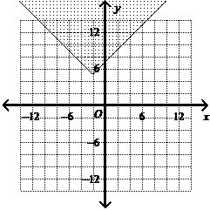

D.
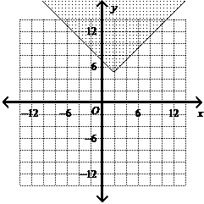

Question 11 of 20
0.0/ 5.0 Points
The graph shows the projected altitude f(x) (in thousands of feet) of an airplane scheduled to depart an airport at noon. If the plan leaves two hour(s) late, what function represents this transformation?
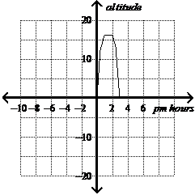

A.
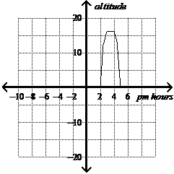

B.

C.
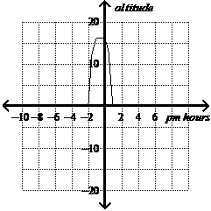

D.

Feedback:Please refer to: Lesson 2-6, p. 100, Example Problem 2, Problems 19-25

Question 12 of 20
0.0/ 5.0 Points
Write an inequality for the graph.
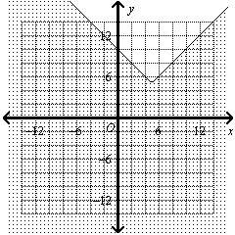

A.
y ≤ |x – 5| – 5

B.
y ≥ |x – 5| + 5

C.
y ≤ |x + 5| + 5

D.
y ≤ |x – 5| + 5

Question 13 of 20
0.0/ 5.0 Points
What transformations change the graph of f(x) to the graph of g(x)?
f(x) = 3x² g(x) = 9x² - 4

A.
The graph of g(x) is the graph of f(x) stretched vertically by a factor of 3 and translated up 4 units.

B.
The graph of g(x) is the graph of f(x) stretched vertically by a factor of 1/3 and translated up 4 units.

C.
The graph of g(x) is the graph of f(x) stretched vertically by a factor of 3 and translated down 4 units.

D.
The graph of g(x) is the graph of f(x) stretched vertically by a factor of 1/3 and translated down 4 units.

Feedback:Please refer to: Lesson 2-6, p. 103, Example Problem 5, Problems 30-33

Question 14 of 20
0.0/ 5.0 Points
What is the graph of the absolute value inequality?
|x + 5| ≥ y – 2

A.
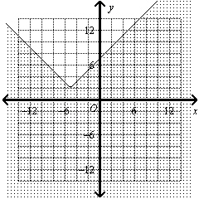

B.
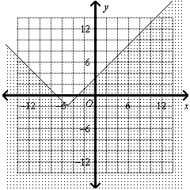

C.
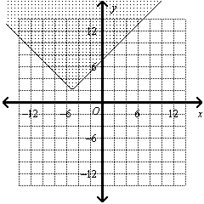

D.
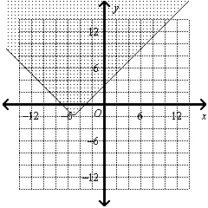

Question 15 of 20
5.0/ 5.0 Points
What is the graph of y = x - 3 (shown below) translated up 2 units?
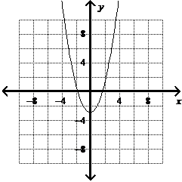

A.
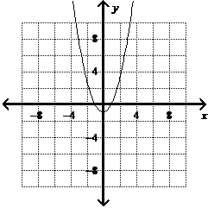

B.
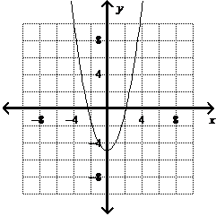

C.
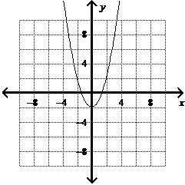

D.
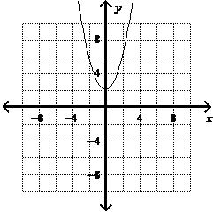

Feedback:Great job!

Question 16 of 20
5.0/ 5.0 Points
The function f(x) = x². The graph of g(x) is f(x) translated to the left 6 units and down 5 units. What is the function rule for g(x)?

A. g(x) = (x + 6)² - 5

B. g(x) = (x - 5)² + 6

C. g(x) = (x - 6)² + 5

D. g(x) = (x + 5)² - 6

Question 17 of 20
0.0/ 5.0 Points
What transformations change the graph of f(x) to the graph of g(x)?

f(x) = x² g(x) = (x+5)² - 9

A.
The graph of g(x) is the graph of f(x) translated to the left 5 units and down 9 units.

B. The graph of g(x) is the graph of f(x) translated to up 5 units and right 9 units.

C. The graph of g(x) is the graph of f(x) translated to down 5 units and left 9 units.

D. The graph of g(x) is the graph of f(x) translated to the right 5 units and up 9 units.

Feedback:Please refer to: Lesson 2-6, p. 103, Example Problem 5, Problems 30-33

Question 18 of 20
0.0/ 5.0 Points
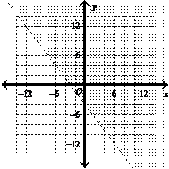
Write the inequality for the graph above.

A.
-3x - 4y > 12

B.
-3x - 4y < 12

C.
-4x - 3y > 12

D.
-4x - 3y < 12

Question 19 of 20
5.0/ 5.0 Points
An electronics store makes a profit of $33 for every portable DVD player sold and $88 for every DVD recorder sold. The manager’s target is to make at least $264 a day on sales of the portable DVD players and DVD recorders. Write and graph an inequality that represents the number of both kinds of DVD players that can be sold to reach or beat the sales target. Let prepresent the number of portable DVD players and r represent the number of DVD recorders.

A.
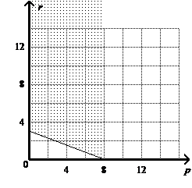
33p + 88r ≥ 264

B.
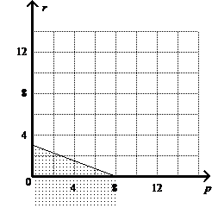

33p + 88r ≥ 264

C.
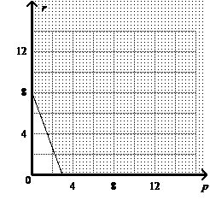

33p + 88r ≥ 264

D.
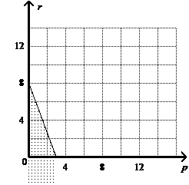

33p + 88r ≥ 264

Feedback:Great job!

Question 20 of 20
5.0/ 5.0 Points
Which of the following describes the translation of
y = |x| to y = |x + 7| - 2

A.
y = |x|
translated 2 units to the left and 7 units down

B.
y = |x|
translated 7 units to the right and 7 units down

C.
y = |x|
translated 2 units to the right and 7 units up

D.
y = |x|
translated 7 units to the left and 2 units down

