Exam 4
Identify the maximum or minimum value and the domain and range of the graph of the function
y = 2(x + 2)² - 3

A.
minimum value: 3
domain: all real numbers 3
range: all real numbers

B.
maximum value: -3
domain: all real numbers ≤ 3
range: all real numbers

C.
maximum value: 3
domain: all real numbers
range: all real numbers ≤ 3

D.
minimum value: -3
domain: all real numbers
range: all real numbers ≥ -3

Feedback:Please refer to: Lesson 4-1, p. 196, Example Problem 3, Problems 23-28

Question 2 of 20
0.0/ 5.0 Points
Graph each function. How is each graph a translation of f(x) = x ² ?
y = (x + 3)² + 4

A.
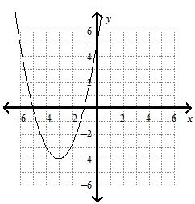
f(x) translated down 4 unit(s) and translated to the left 3 unit(s)

B.
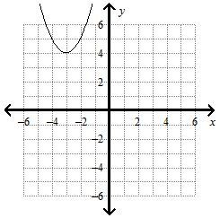

f(x) translated up 4 unit(s) and translated to the left 3 unit(s)

C.
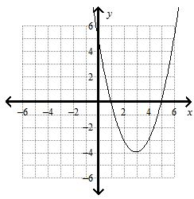
f(x) translated down 4 unit(s) and translated to the right 3 unit(s)

D.
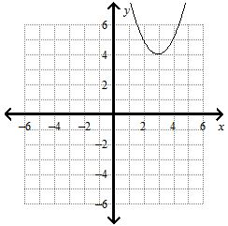

f(x) translated down 4 unit(s) and translated to the right 3 unit(s)

Feedback:Please refer to: Lesson 4-1, p. 196, Example Problem 2, Problems 15-22

Question 3 of 20
5.0/ 5.0 Points
Use the Quadratic Formula to solve the equation.
-2x² - 5x + 5 = 0

A.
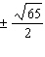

B.
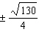

C.
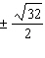

D.
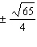

Feedback:Great job!

Question 4 of 20
0.0/ 5.0 Points
Use the vertex form to write the equation of the parabola.
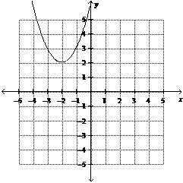

A.
y = 3(x-2)² + 2

B.
y = 3(x-2)² -2

C.
y = 3(x+2)² + 2

D.
y = 3(x+2)² -2

Feedback:Please refer to: Lesson 4-2, p. 202, Example Problem 2, Problems 17-25

Question 5 of 20
0.0/ 5.0 Points
What is the expression in factored form?
9x² - 12x + 4

A.
(3x + 2)²

B.
(-3x - 2)²

C.
(3x - 2)²

D. (-3x + 2)(3x - 2)

Feedback:Please refer to: Lesson 4-4, p. 218, 220, Example Problems 3 and 4, Problems 32-46

Question 6 of 20
0.0/ 5.0 Points
Which of the equations is graphed below?
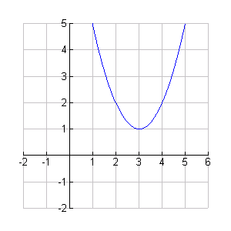

A.
y = x² + 3x + 2

B.
y = x² + 6x + 10

C.
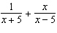y = x² - 6x + 10

D.
y = -x² + 6x - 10

Feedback:Please refer to: Lesson 4-2, P. 204, Example Problem 2, Problems 17-25

Question 7 of 20
0.0/ 5.0 Points
Which of the following shows the equation y = x² + 8x + 14 in vertex form?

A.
y = (x+8)² + 14

B.
y = (x+4)² -2

C.
y = (x+4)² -28

D.
y = (x-8)² + 14

Feedback:Please refer to: Feedback: Lesson 4-2 p. 204, Example Problem 3, Problems 26-31

Question 8 of 20
0.0/ 5.0 Points
Identify the vertex and the axis of symmetry of the graph of the function y = 2(x+2)² - 4

A.
vertex: (-2, -4);
axis of symmetry: x = -2

B.
vertex: (2, 4);
axis of symmetry: x = 2

C.
vertex: (-2, 4);
axis of symmetry: x = -2

D.
vertex: (2, -4);
axis of symmetry: x = 2

Feedback:Please refer to: Lesson 4-2, p. 202, Example Problem 1, Problems #8-16

Question 9 of 20
0.0/ 5.0 Points
Graph each function. How is each graph a translation of f(x) = x ² ?
y = (x - 2)²

A.
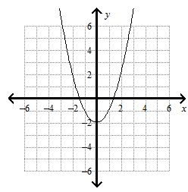
f(x) translated down 2 unit(s)

B.
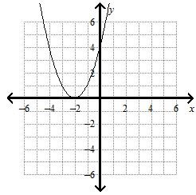
f(x) translated to the left 2 unit(s)

C.
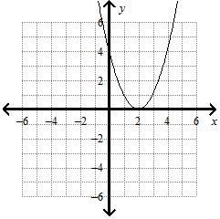

f(x) translated to the right 2 unit(s)

D.
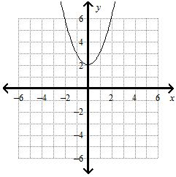

Feedback:Please refer to: Lesson 4-1, p. 196, Example Problem 2, Problems 15-22

Question 10 of 20
0.0/ 5.0 Points
Solve the equation.
x² + 18x + 81 = 25

A. 14, 4

B. –4, –14

C. 14, –14

D. –4, 4

Feedback:Please refer to: Lesson 4-5, p. 226, Example Problem 1, Problems 9-17

Question 11 of 20
0.0/ 5.0 Points
The function y = -16t ² + 486 models the height y in feet of a stone t seconds after it is dropped from the edge of a vertical cliff. How long will it take the stone to hit the ground? Round to the nearest hundredth of a second.

A. 11.02 seconds

B. 0.25 seconds

C. 7.79 seconds

D. 5.51 seconds

Feedback:Please refer to: Lesson 4-5, p. 228, Example Problem 4, Problems 36

Question 12 of 20
5.0/ 5.0 Points
The axis of symmetry of the graph of y = -(x+4)² -6 is

A. x = 6

B.
x = -4

C. x = -6

D. x = 4

Feedback:Great job!

Question 13 of 20
0.0/ 5.0 Points
Simplify the number using the imaginary unit i.

A. 12

B. -12

C. 12i

D. 144i

Feedback:Please refer to: Lesson 4-8, p. 249, Example Problem 1, Problems #8-12

Question 14 of 20
5.0/ 5.0 Points
What is the graph of the function?
f(x) = 2x ²

A.
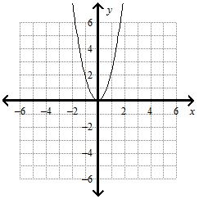

B.
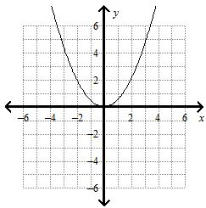

C.
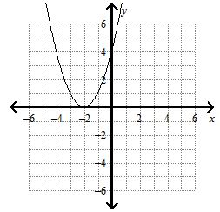

D.
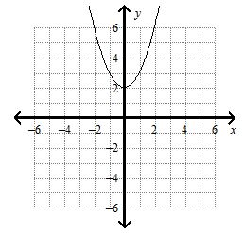

Feedback:Great job!

Question 15 of 20
0.0/ 5.0 Points
Solve by graphing.
x² +2x - 8 = 0

A.
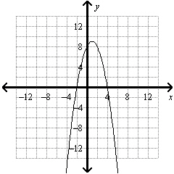
–2, 4

B.
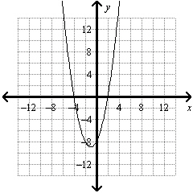
2, –4

C.
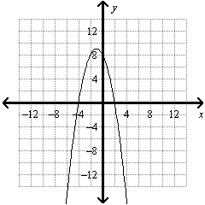
2, –4

D.
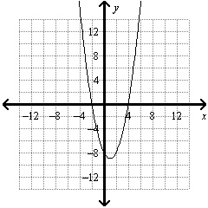
–2, 4

Feedback:Please refer to: Lesson 4-5, p. 227, Example Problem 3, Problems 27-35

Question 16 of 20
0.0/ 5.0 Points
What is the vertex of the graph of
y = 1/3 (x-9)² + 5

A.
(3,5)

B.
(9,5)

C. 3, equal to

D. (-9,5)

Feedback:Please refer to: Lesson 4-1, p. 204, Example Problem 3, Problems 23-28

Question 17 of 20
0.0/ 5.0 Points
Simplify the expression.
(3 + i) - (2 - 2i)

A. 1 + 3i

B. 5 - i

C. 4i

D. -1 - 3i

Feedback:Please refer to: Lesson 4-8, p. 250, Example Problem 3b, Problems #18-26

Question 18 of 20
5.0/ 5.0 Points
What is the graph of the function?
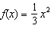

A.
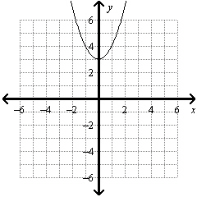

B.
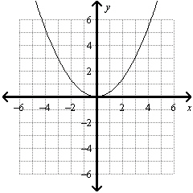

C.
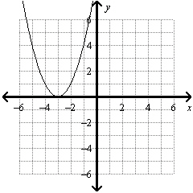

D.
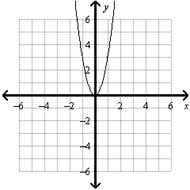

Feedback:Great job!

Question 19 of 20
0.0/ 5.0 Points
What is the expression in factored form?
x² + 14x + 48

A. (x + 6)(x + 8)

B. (x + 8)(x - 6)

C. (x + 6)(x - 8)

D. (x - 8)(x - 6)

Feedback:Please refer to: Lesson 4-4, p. 217, Example Problem 1, Problems #14-31

Question 20 of 20
0.0/ 5.0 Points
What value completes the square for the expression?
x² - 18x

A. 9

B. -9

C. 81

D. -81

