Does Your Child Have Asthma?
An Educational Brochure
Shahara S. Stanfield, RN BSN
Walden University

Does Your Child Have Asthma?
Asthma is a long-term (chronic) disease that inflames and narrows the airways. It causes shortness of breath, wheezing, chest tightness and coughing that usually occurs early morning or night. The disease affects more that 25 million people with about 7 million being children (NHLBI). I chose asthma because it is a disease that negatively affects many children. Families need education about how to effectively manage asthma and the public needs education about the environmental triggers for those who have it.
Asthma is difficult to diagnose before the age of five, risk factors for asthma include allergies, eczema (allergic skin condition), and parent(s) that has asthma. The most important aspects of the management of asthma are avoiding triggers, following the appropriate medication regimen, and having an asthma action plan. The morbidity of children with asthma leads to many missed days of school and increased visits to emergency rooms. This brochure presents essential facts about asthma and provides reliable resources for individuals to obtain more detailed information regarding asthma, its effects, and management of symptoms.
Providing educational per a medium such as a brochure helps teach the public without overwhelming the reader. There are suggested guidelines to follow when creating a health literature. Health literacy is lower in the general population, so the material should be presented at a fifth-grade reading level. The number of key points should be limited and common language should be used in clear, concise sentences, using at least a 12-point font. Additional guidelines include using headings, presenting information in bullet point format, and presenting additional resources for the reader to access for more information (Sandridge, 2016).

Conclusion
Health literacy is the degree in which patients can comprehend verbal and written information related to their care so they can make informed decisions about diagnostic test and treatments (Sandridge, 2016). Providing educational material to the public contributes to the overall health of communities because knowledge is essential to promoting and maintaining health.

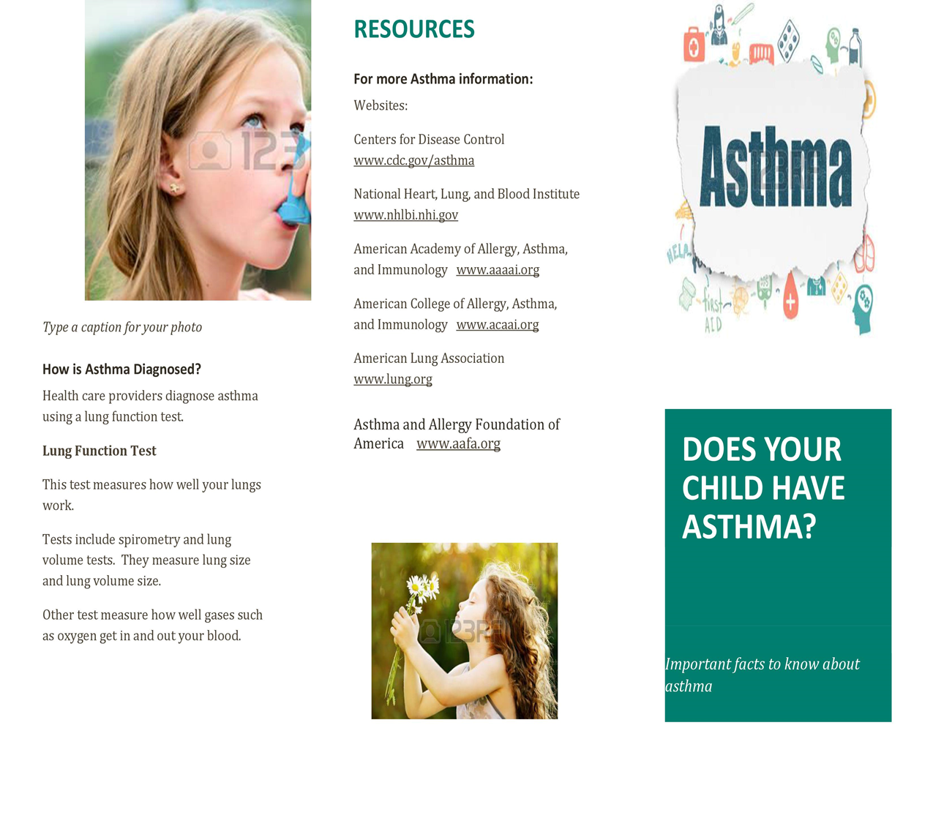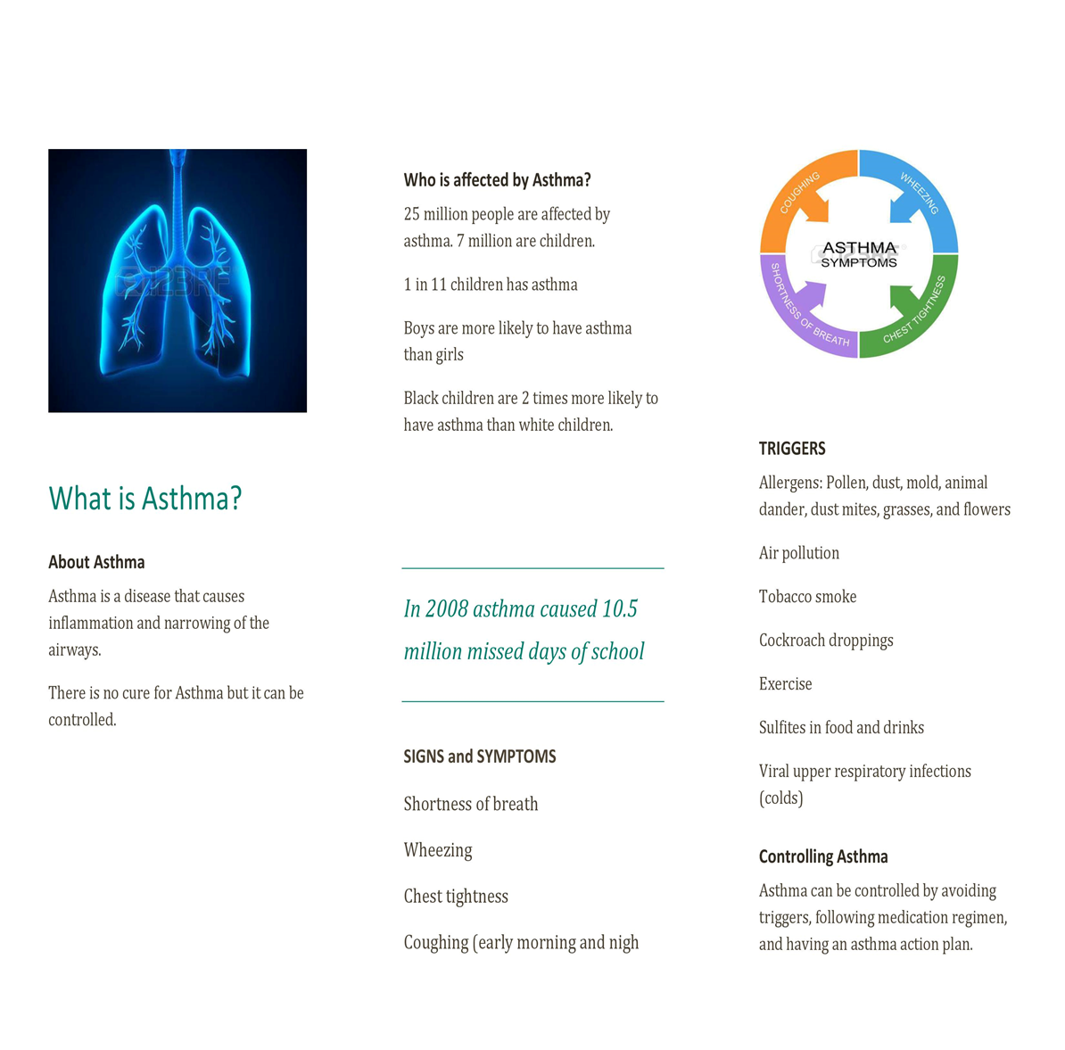
ASTHMA FACTS

References

Centers for Disease Control (n.d.). Asthma’s Impact on the Nation. Retrieved from https://www.cdc.gov/asthma/impacts_nation/asthmafactsheet.pdf

National Heart, Lung, and Blood Institute (n.d.). What is Asthma? Retrieved from https://www.nhlbi.nih.gov/health/health-topics/topics/asthma

Sandridge, T.G.(2016). Using Brochures to Teach Clinical Communication Skills. Radiologic Technology, 8, (2) 222-224.

