Name:

Date:

# Graded Assignment

## Semester Test, Part 2

Answer the questions below. When you are finished, submit this assignment to your teacher by the due date for full credit.

Total score: ____ of 40 points

(Score for Question 1: ___ of 10 points)

1. The Park Commission proposed the following rate increases for bike rentals.

**Proposed Bike Rental Rate Increase**

| **Fees** | **Current Rate** | **Increased Rate** |
| --- | --- | --- |
| **Initial Charge** | $6 | $10 |
| **Hourly Rate** | $4 | $5 |

1. Write a variable expression showing the total cost to rent a bike at the current rate. Write a variable expression showing the total cost to rent a bike at the increased rate. Define the variable.
2. Use the variable expressions to calculate the cost to rent a bike for 6 hours at the current rate and at the increased rate. Show all your work.
3. Calculate the percent increase in the total cost to rent a bike for 6 hours if the proposed rates are approved. Show all your work.
4. Jerome paid $42 for a bike rental at the current rate. Write and solve an equation to determine the number of hours he rented the bike. Show all your work.

Answer:

(Score for Question 2: ___ of 8 points)

1. A system of equations is shown below.



1. Find the solution to the system of equations using either substitution or the linear combination method. Show all your work.
2. Explain and show the graphical meaning of the solution. Be sure to label the solution on your graph.

Answer:

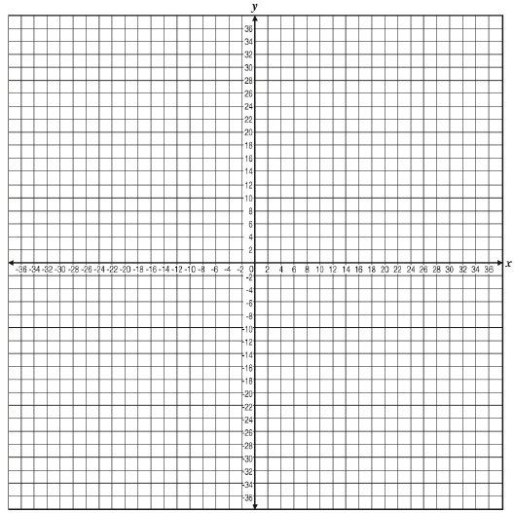

(Score for Question 3: ___ of 12 points)

1. Lawrence has two part-time jobs, one at a movie theater and one at a pet store. He is paid by the hour at each job. Last week, he worked 10 hours at the movie theater and 8 hours at the pet store and earned a total of $152.50. The week before, he worked 8 hours at the movie theater and 12 hours at the pet store and earned a total of $171.00.
2. Determine how much Lawrence earns per hour at the pet store. Show all of your work.
3. Next week, Lawrence wants to earn at least $168.00. He is scheduled to work 6 hours at the pet store. Write and solve an inequality to find the minimum number of hours he needs to work at the movie theater in order to earn at least $168.00. Show all of your work.

Answer:

(Score for Question 4: ___ of 10 points)

1. Consider the quadratic function .
2. Find the x-intercepts of the graph of . Show all your work.
3. Find the y-intercept of the graph of . Show all your work.
4. Find the coordinates of the vertex of the graph of . Show all your work.
5. Sketch the graph of  on the grid. Label the vertex and the points containing the x- and y-intercepts with ordered pairs.

Answer:

